Unit 5 Lesson 3: More Movement

1 Moving a Graph (Warm up)

Student Task Statement
How can we translate the graph of $A$ to match one of the other graphs?
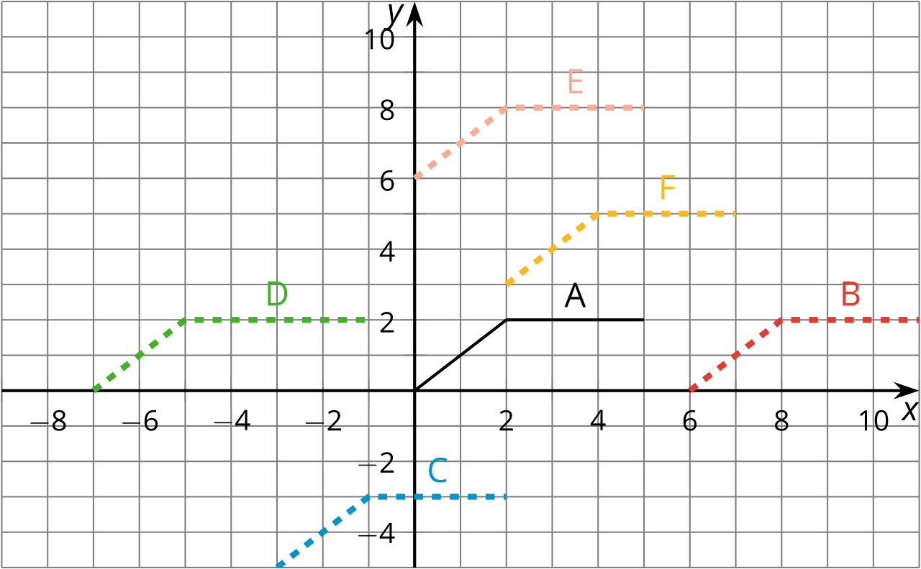

2 New Hours for the Kitchen

Student Task Statement
Remember the bakery with the thermostat set to ${65}^{∘}\text{F}$? At 5:00 a.m., the temperature in the kitchen rises to ${85}^{∘}\text{F}$ due to the ovens and other kitchen equipment being used until they are turned off at 10:00 a.m. When the owner decided to open 2 hours earlier, the baking schedule changed to match.
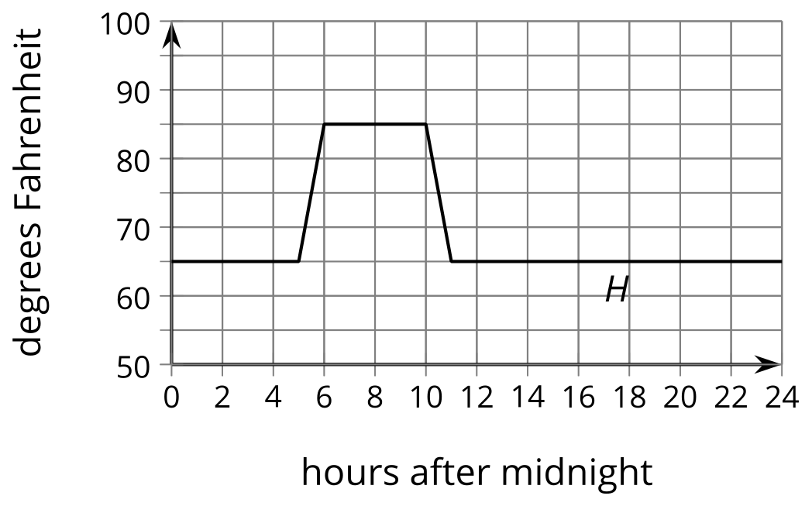
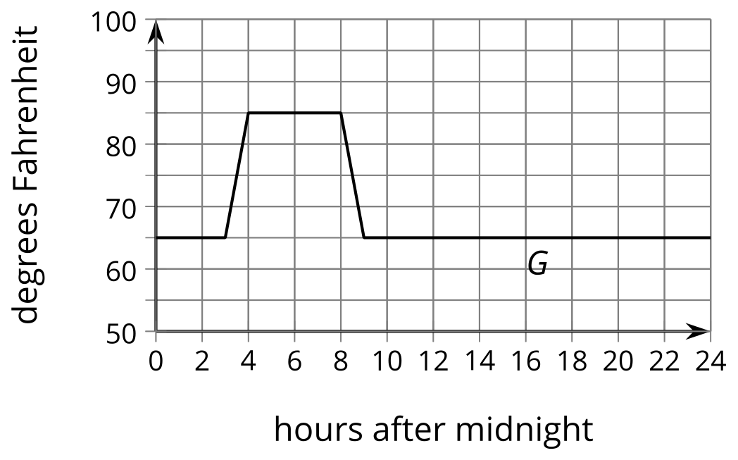
- Andre thinks, “When the bakery starts baking 2 hours earlier, that means I need to subtract 2 from $x$ and that $G\left(x\right)=H\left(x−2\right)$.” How could you help Andre understand the error in his thinking?
- The graph of $F$ shows the temperatures after a change to the thermostat settings. What did the owner do?
- 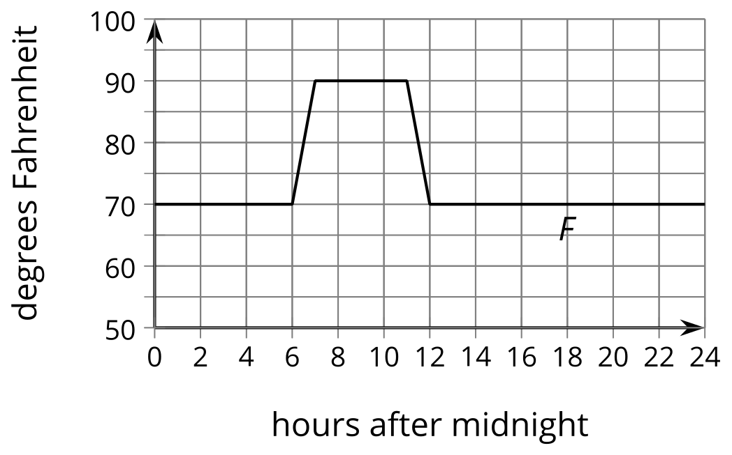
- Write an expression for $F$ in terms of the original baking schedule, $H$.

3 Thawing Meat

Student Task Statement
A piece of meat is taken out of the freezer to thaw. The data points show its temperature $M$, in degrees Fahrenheit, $t$ hours after it was taken out. The graph $M=G\left(t\right)$, where $G\left(t\right)=\text{-}62{\left(0.85\right)}^{t}$, models the shape of the data but is in the wrong position.
$t$ | $M$
0 | 13.1
0.41 | 22.9
1.84 | 29
2.37 | 36.1
2.95 | 36.8
3.53 | 38.8
3.74 | 40
4.17 | 42.2
4.92 | 45.8
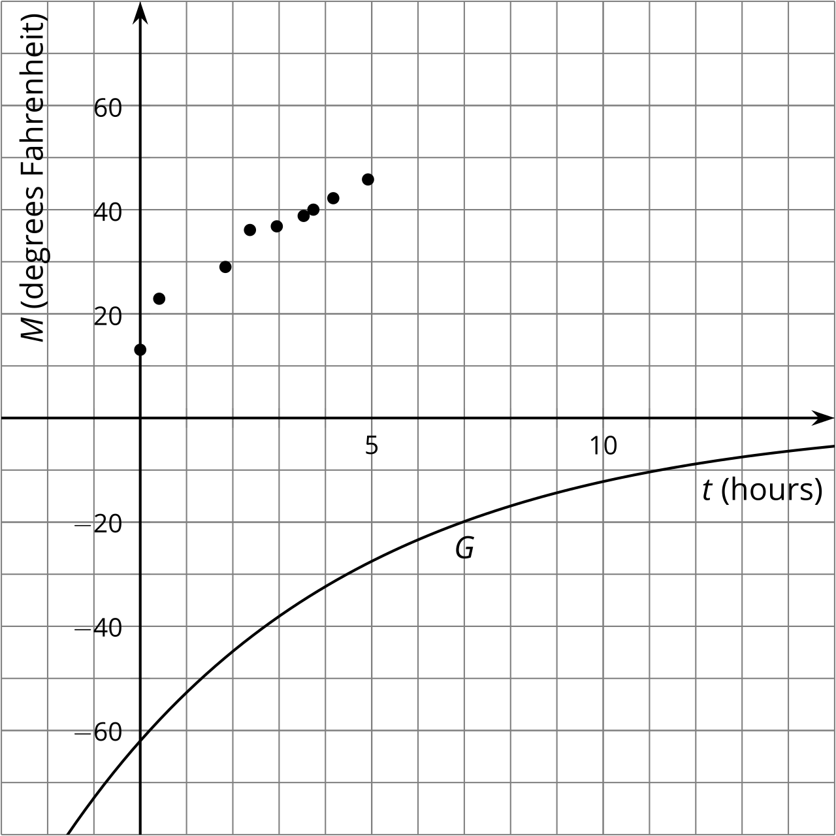
Jada thinks changing the equation to $J\left(t\right)=\text{-}62{\left(0.85\right)}^{t}+75.1$ makes a good model for the data. Noah thinks $N\left(t\right)=\text{-}62{\left(0.85\right)}^{\left(t+1\right)}+68$ is better.
- Without graphing, describe how Jada and Noah each transformed the graph of $G$ to make their new functions to fit the data.
- Use technology to graph the data, $J$ and $N$, on the same axes.
- Whose function do you think best fits the data? Be prepared to explain your reasoning.

Images for Activity Synthesis
© CC BY 2019 by Illustrative Mathematics®

