Unit 7 Lesson 13: Definition of Scientific Notation

1 Number Talk: Multiplying by Powers of 10 (Warm up)

Student Task Statement
Find the value of each expression mentally.
$123⋅10,​000$
$\left(3.4\right)⋅1,​000$
$\left(0.6\right)⋅100$
$\left(7.3\right)⋅\left(0.01\right)$

2 The “Science” of Scientific Notation

Images for Launch
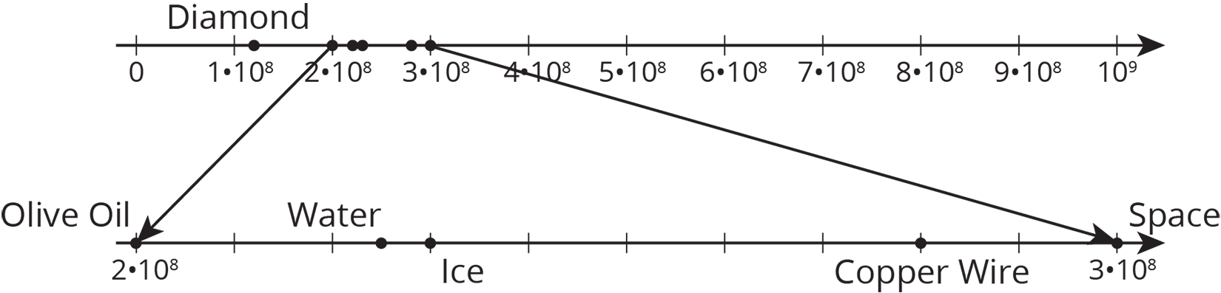

Student Task Statement
The table shows the speed of light or electricity through different materials.
material | speed (meters per second)
space | 300,000,000
water | $2.25×{10}^{8}$
copper (electricity) | 280,000,000
diamond | $124×{10}^{6}$
ice | $2.3×{10}^{8}$
olive oil | $0.2×{10}^{9}$
Circle the speeds that are written in scientific notation. Write the others using scientific notation.

3 Scientific Notation Matching

Student Task Statement
Your teacher will give you and your partner a set of cards. Some of the cards show numbers in scientific notation, and other cards show numbers that are not in scientific notation.
- Shuffle the cards and lay them facedown.
- Players take turns trying to match cards with the same value.
- On your turn, choose two cards to turn faceup for everyone to see. Then:
  - If the two cards have the same value and one of them is written in scientific notation, whoever says “Science!” first gets to keep the cards, and it becomes that player’s turn. If it’s already your turn when you call “Science!”, that means you get to go again. If you say “Science!” when the cards do not match or one is not in scientific notation, then your opponent gets a point.
  - If both partners agree the two cards have the same value, then remove them from the board and keep them. You get a point for each card you keep.
  - If the two cards do not have the same value, then set them facedown in the same position and end your turn.
- If it is not your turn:
  - If the two cards have the same value and one of them is written in scientific notation, then whoever says “Science!” first gets to keep the cards, and it becomes that player’s turn. If you call “Science!” when the cards do not match or one is not in scientific notation, then your opponent gets a point.
  - Make sure both of you agree the cards have the same value.
If you disagree, work to reach an agreement.
- Whoever has the most points at the end wins.
© CC BY Open Up Resources. Adaptations CC BY IM.

