Lesson 4 Practice Problems
- Angle $B$ is an acute angle in a right triangle. What is a reasonable approximation for angle $B$ if the ratio for the opposite leg divided by the hypotenuse is 0.67?
- Estimate the values to complete the table.
- 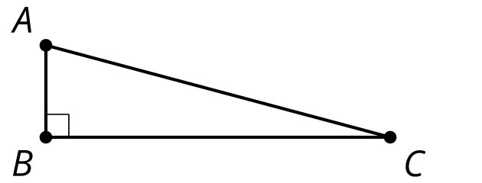
- angle | - adjacent leg $÷$ hypotenuse | - opposite leg $÷$ hypotenuse | - opposite leg $÷$ adjacent leg
- $A$
- $C$ | - 0.97 | - 0.26 | - 0.27
- Priya says, “I know everything about a right triangle with a 30 degree angle and a hypotenuse with length 1 cm. Here, look.“
  - The other angle is 60 degrees.
  - The leg adjacent to the 30 degree angle is 0.866 cm long.
  - The side opposite the 30 degree angle is 0.5 cm long.
- Han asks, “What would happen if a right triangle with a 30 degree angle has a hypotenuse that is 2 cm instead?“
- Help them find the missing angles and side lengths in the new triangle. Explain or show your reasoning.
- Triangle $ABC$ is equilateral.
  - What is the value of $x$?
  - What is the measure of angle $B$?
- 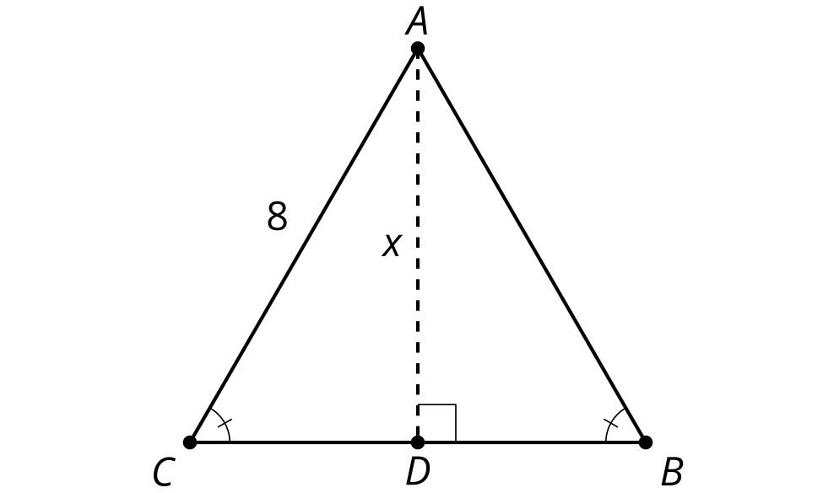
- (From Unit 4, Lesson 3.)
- An equilateral triangle has side length 8 units. What is the area?
  - $16\sqrt{3}$ square units
  - 24 square units
  - $24\sqrt{3}$ square units
  - 32 square units
- (From Unit 4, Lesson 3.)
- What is the length of the square’s side?
- 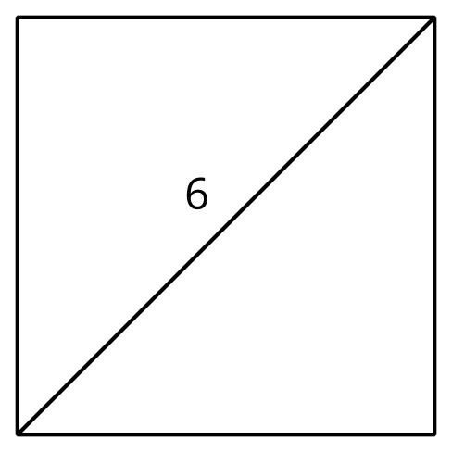
  - 3 units
  - $\frac{6}{\sqrt{2}}$ units
  - $6\sqrt{2}$ units
  - 12 units
- (From Unit 4, Lesson 2.)
- A step has a height of 6 inches. A ramp starts 5 feet away from the base of the step, making a ${5.7}^{∘}$ angle with the ground. What can you say about the angle the ramp would make with the ground if the ramp starts closer to the step?
  - The angle would decrease.
  - The angle would increase.
  - The angle would stay the same.
  - We cannot determine anything about the angle.
- (From Unit 4, Lesson 1.)
- The quilt is made of squares with diagonals.
- The length of $BD$ is 4.
  - Find the length of $AE$.
  - Find the area of square $ABCD$.
- 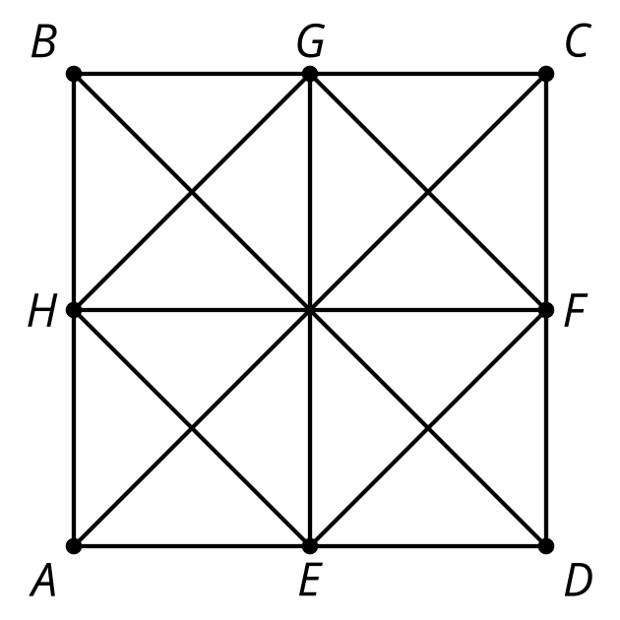
- (From Unit 3, Lesson 12.)
© CC BY 2019 by Illustrative Mathematics®

