Lesson 21 Practice Problems
- The triangles here are each obtained by applying rigid motions to triangle 1.
- 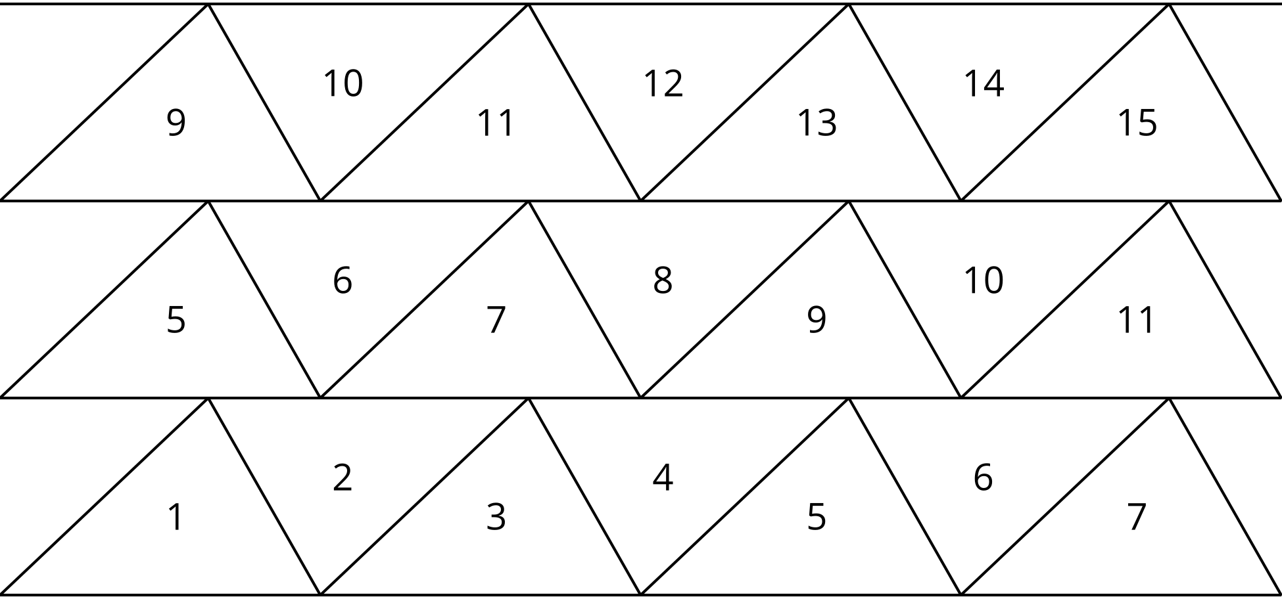
  - Which triangles are translations of triangle 1? Explain how you know.
  - Which triangles are not translations of triangle 1? Explain how you know.
- The quadrilateral is a parallelogram. Find the measure of angles 1, 2, and 3.
- 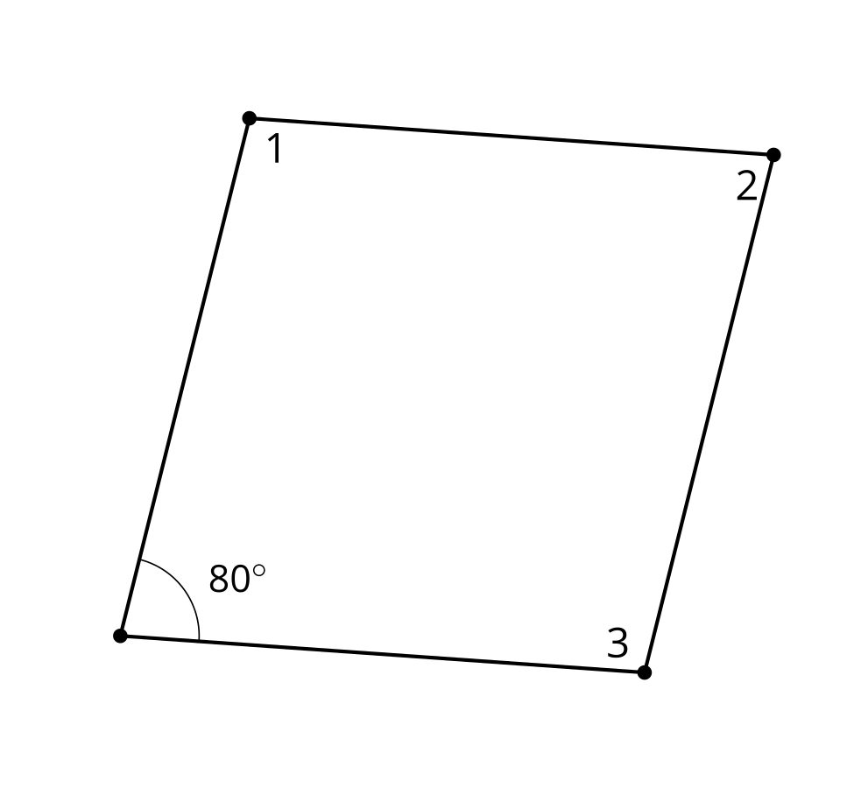
- In the figure shown, lines $f$ and $g$ are parallel. Select the angle that is congruent to angle 1.
- 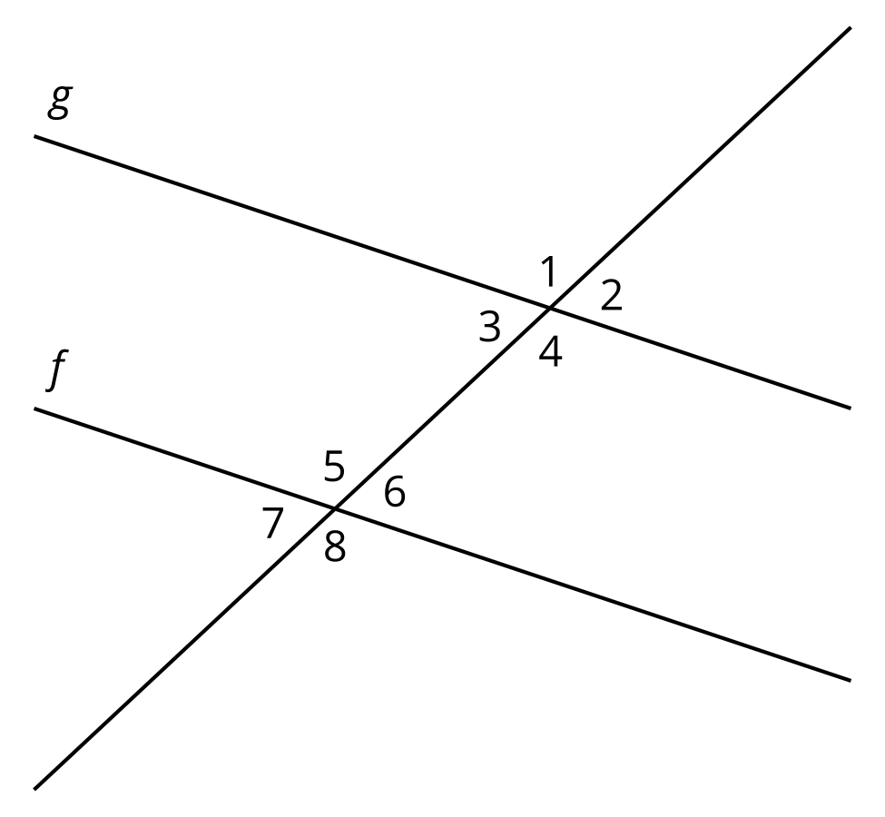
  - Angle 2
  - Angle 6
  - Angle 7
  - Angle 8
- (From Unit 1, Lesson 20.)
- Angle $BDE$ is congruent to angle $BAC$. Name another pair of congruent angles. Explain how you know.
- 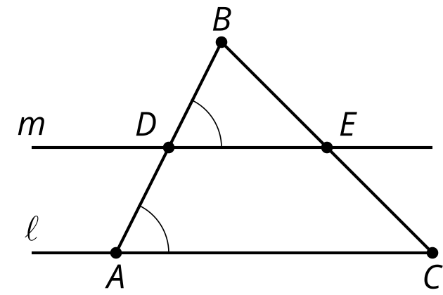
- (From Unit 1, Lesson 20.)

  - Describe a transformation that could be used to show that corresponding angles are congruent.
  - Describe a transformation that could be used to show that alternate interior angles are congruent.
- (From Unit 1, Lesson 20.)
- Lines $AD$ and $EC$ meet at point $B$.
- Which of these must be true? Select all that apply.
- 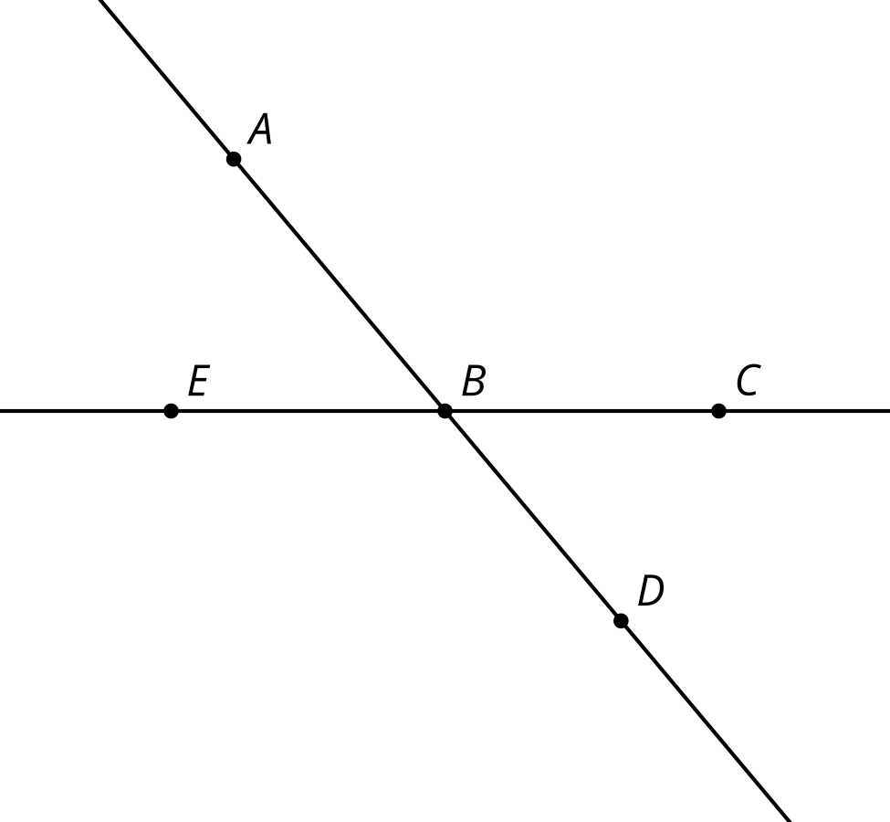
  - A 180 degree clockwise rotation using center $B$ takes $D$ to $A$.
  - The image of $D$ after a 180 degree rotation using center $B$ lies on ray $BA$.
  - If a 180 degree rotation using center $B$ takes $C$ to $E$ then it also takes $E$ to $C$.
  - Angle $ABC$ is congruent to angle $DBE$.
  - Angle $ABE$ is congruent to angle $ABC$.
- (From Unit 1, Lesson 19.)
- Points $E$, $B$, and $C$ are collinear. Explain why points $A$, $B$, and $D$ are collinear.
- 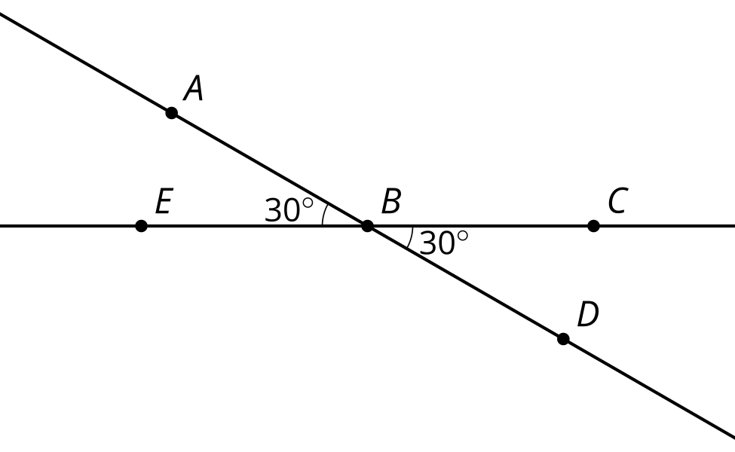
- (From Unit 1, Lesson 19.)

  - Draw the image of figure $ACTS$ after a clockwise rotation around point $C$ using angle $CTS$ and then a translation by the directed line segment $CT$.
  - Describe another sequence of transformations that will result in the same image.
- 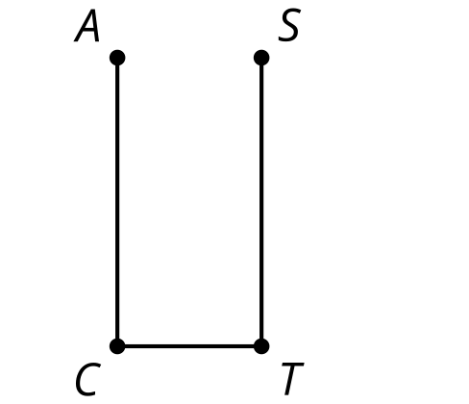
- (From Unit 1, Lesson 18.)
- Triangle $ABC$ is congruent to triangle $A^{′}B^{′}C^{′}$. Describe a sequence of rigid motions that takes $A$ to $A^{′}$, $B$ to $B^{′}$, and $C$ to $C^{′}$.
- 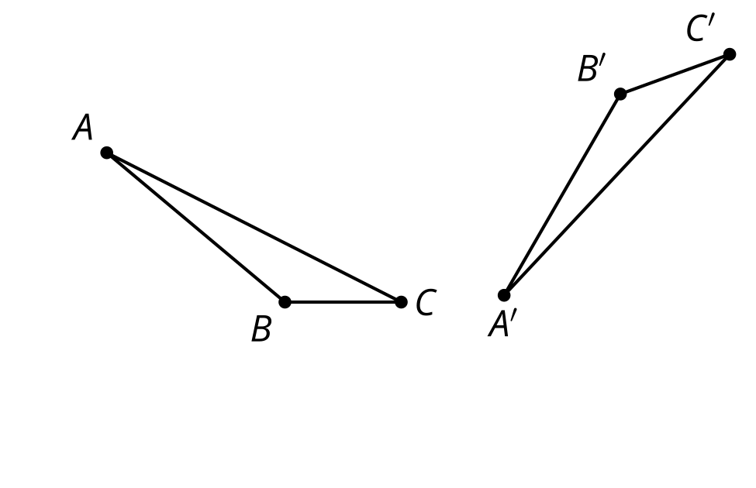
- (From Unit 1, Lesson 17.)
© CC BY 2019 by Illustrative Mathematics®

