Unit 2 Lesson 10: Introducing Graphs of Proportional Relationships

1 Notice These Points (Warm up)

Student Task Statement
- Plot the points $\left(0,10\right),\left(1,8\right),\left(2,6\right),\left(3,4\right),\left(4,2\right)$.
- 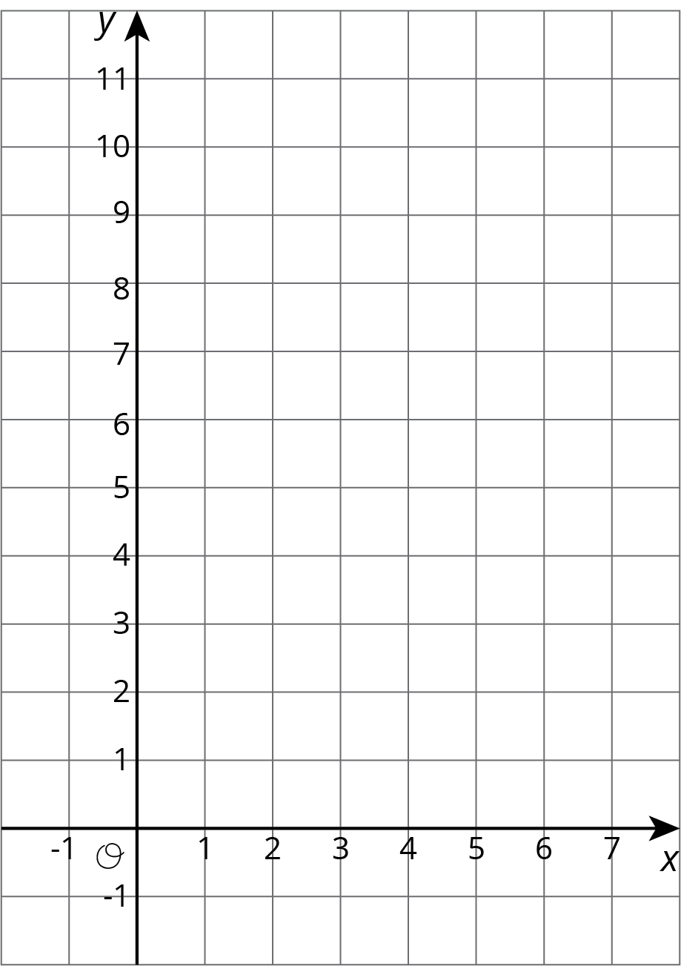
- What do you notice about the graph?

2 T-shirts for Sale

Student Task Statement
Some T-shirts cost $8 each.
$x$ | $y$
1 | 8
2 | 16
3 | 24
4 | 32
5 | 40
6 | 48
- Use the table to answer these questions.
  - What does $x$ represent?
  - What does $y$ represent?
  - Is there a proportional relationship between $x$ and $y$?
- Plot the pairs in the table on the coordinate plane.
- What do you notice about the graph?

3 Matching Tables and Graphs

Student Task Statement
Your teacher will give you papers showing tables and graphs.
- Examine the graphs closely. What is the same and what is different about the graphs?
- Sort the graphs into categories of your choosing. Label each category. Be prepared to explain why you sorted the graphs the way you did.
- Take turns with a partner to match a table with a graph.
  - For each match you find, explain to your partner how you know it is a match.
  - For each match your partner finds, listen carefully to their explanation. If you disagree, work to reach an agreement.
- Pause here so your teacher can review your work.
- Trade places with another group. How are their categories the same as your group's categories? How are they different?
- Return to your original place. Discuss any changes you may wish to make to your categories based on what the other group did.
- Which of the relationships are proportional?
- What have you noticed about the graphs of proportional relationships? Do you think this will hold true for all graphs of proportional relationships?
© CC BY Open Up Resources. Adaptations CC BY IM.

