Lesson 17 Practice Problems
- Quadrilateral $ABCD$ is congruent to quadrilateral $A^{′}B^{′}C^{′}D^{′}$. Describe a sequence of rigid motions that takes $A$ to $A^{′}$, $B$ to $B^{′}$, $C$ to $C^{′}$, and $D$ to $D^{′}$.
- 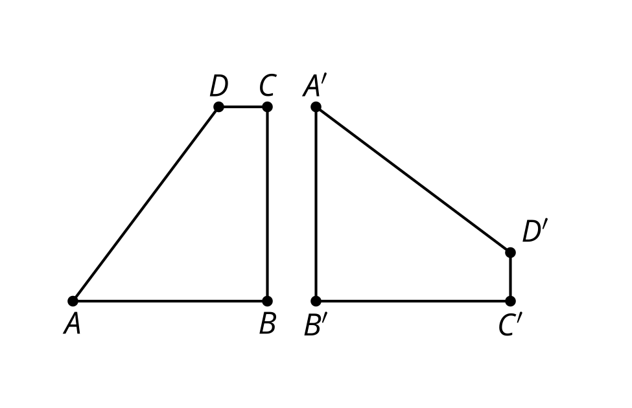
- Select all transformations that must take any point $A$ to any point $B$.
  - Rotation of ${180}^{∘}$around $A$
  - Rotation of ${180}^{∘}$around $B$
  - Rotation of ${180}^{∘}$around the midpoint of segment $AB$
  - Reflection across the line $AB$
  - Reflection across the perpendicular bisector of segment $AB$
  - Translation by the directed line segment $AB$
  - Translation by the directed line segment $BA$
- Triangle $ABC$ is congruent to triangle $A^{′}B^{′}C^{′}$. Describe a sequence of rigid motions that takes $A$ to $A^{′}$, $B$ to $B^{′}$, and $C$ to $C^{′}$.
- 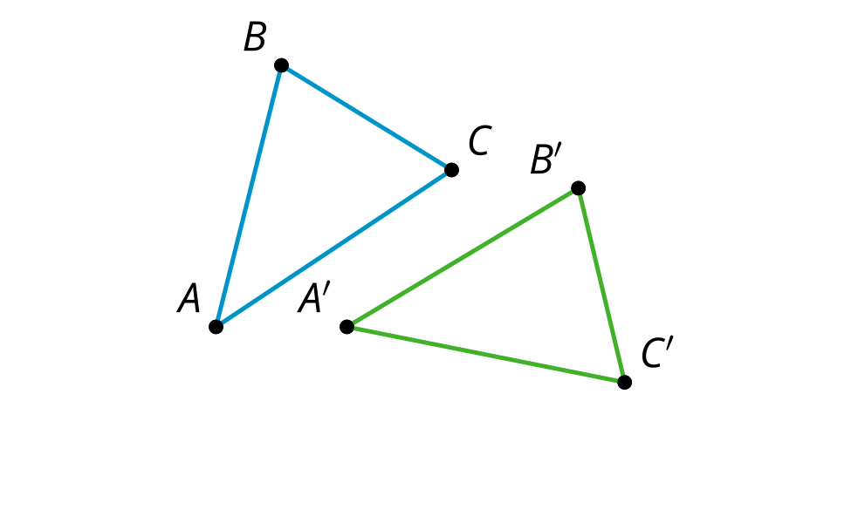

- A triangle has rotation symmetry that can take any of its vertices to any of its other vertices. Select all conclusions that we can reach from this.
  - All sides of the triangle have the same length.
  - All angles of the triangle have the same measure.
  - All rotations take one half of the triangle to the other half of the triangle.
  - It is a right triangle.
  - None of the sides of the triangle have the same length.
  - None of the angles of the triangle have the same measure.
- (From Unit 1, Lesson 16.)
- Select all the angles of rotation that produce symmetry for this flower.
- 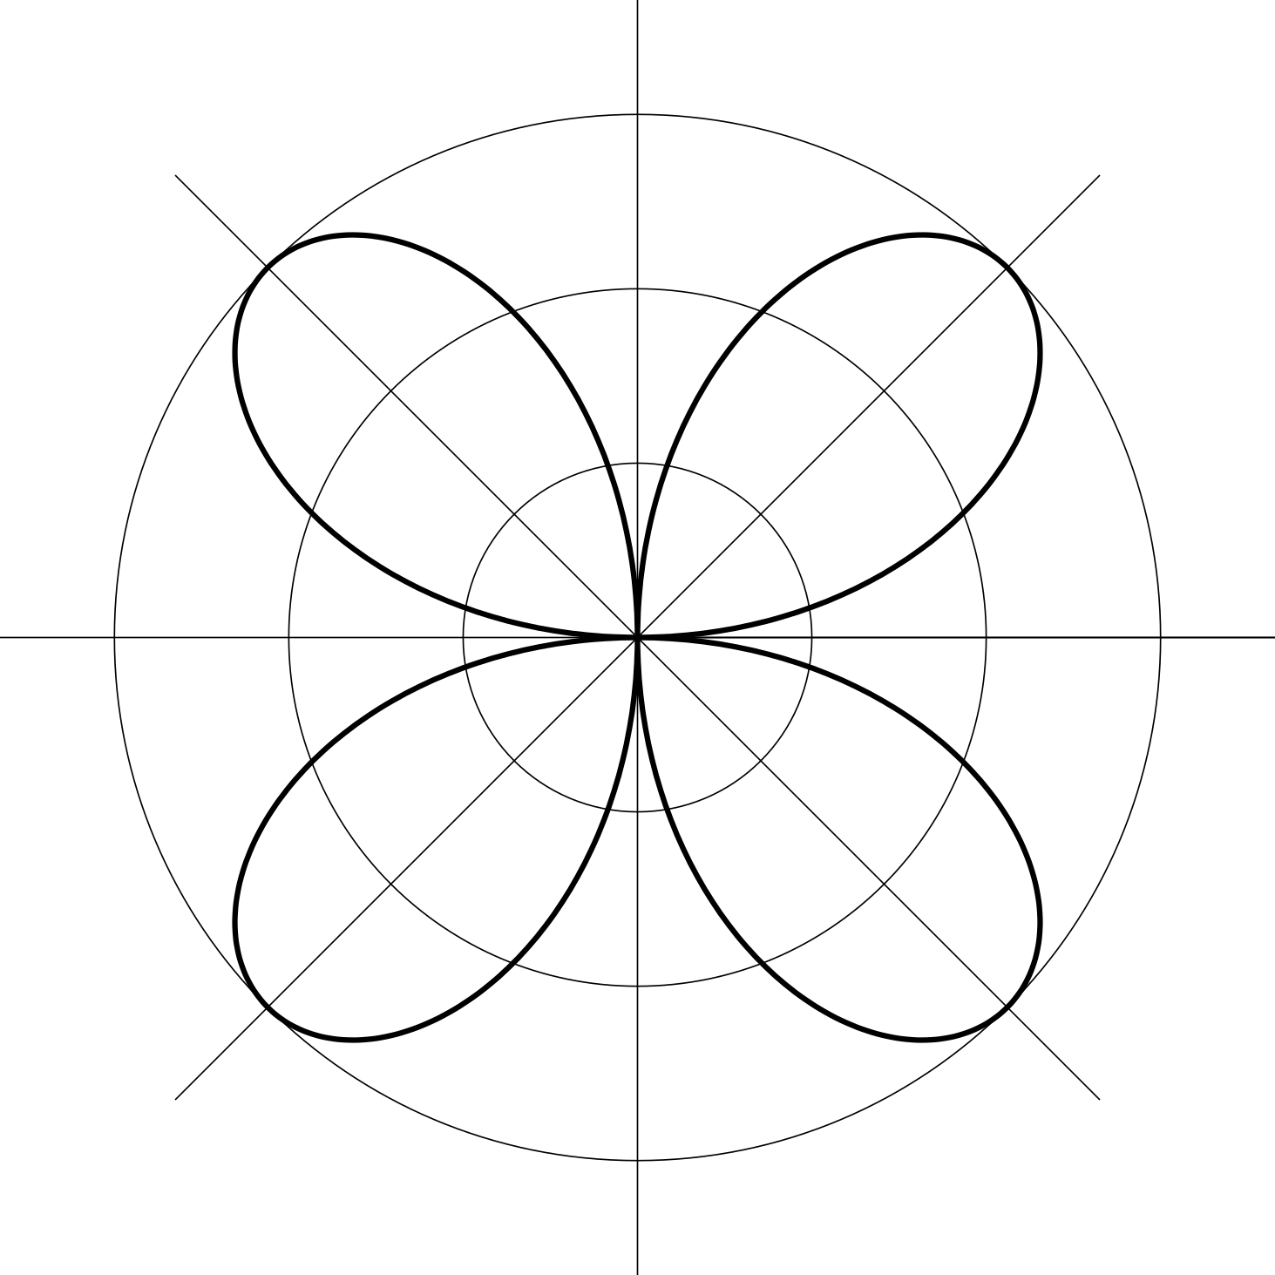
  - 30
  - 45
  - 60
  - 90
  - 120
  - 135
  - 180
- (From Unit 1, Lesson 16.)
- A right triangle has a line of symmetry. Select all conclusions that must be true.
  - All sides of the triangle have the same length.
  - All angles of the triangle have the same measure.
  - Two sides of the triangle have the same length.
  - Two angles of the triangle have the same measure.
  - No sides of the triangle have the same length.
  - No angles of the triangle have the same measure.
- (From Unit 1, Lesson 15.)
- In quadrilateral $BADC$, $AB=AD$ and $BC=DC$. The line $AC$ is a line of symmetry for this quadrilateral. Based on the line of symmetry, explain why angles $ACB$ and $ACD$ have the same measure.
- 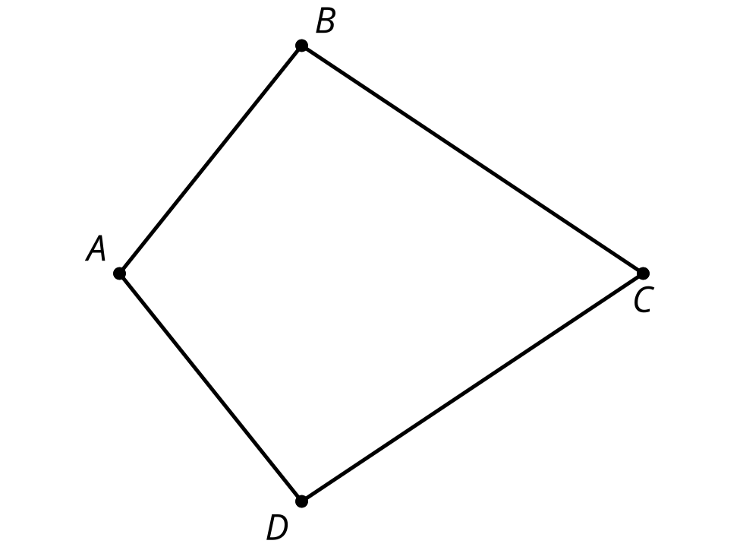
- (From Unit 1, Lesson 15.)
- Which of these constructions would construct a line of reflection that takes the point $A$ to point $B$?
  - Construct the midpoint of segment $AB$.
  - Construct the perpendicular bisector of segment $AB$.
  - Construct a line tangent to circle $A$ with radius $AB$.
  - Construct a vertical line passing through point $A$ and a horizontal line passing through point $B$.
- (From Unit 1, Lesson 11.)
- Here is triangle $POG$. Match the description of the rotation with the image of $POG$ under that rotation.
- 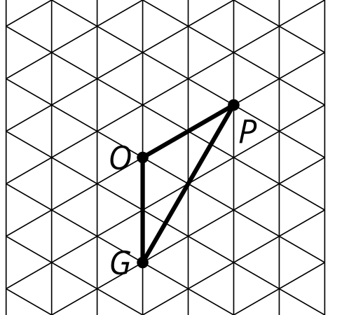
  - Rotate 300 degrees clockwise around $O$.
  - Rotate 60 degrees clockwise around $O$.
  - Rotate 60 degrees clockwise around $P$.
  - Rotate 240 degrees counterclockwise around $O$.
  - 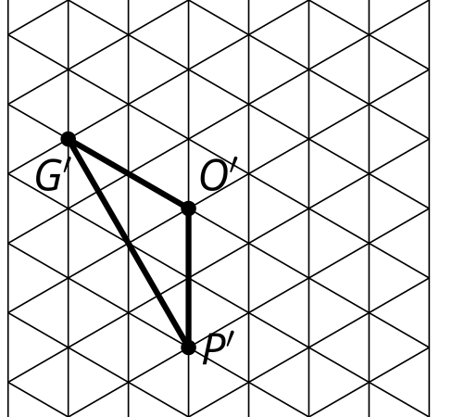
  - 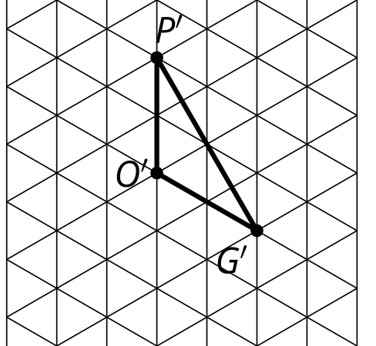
  - 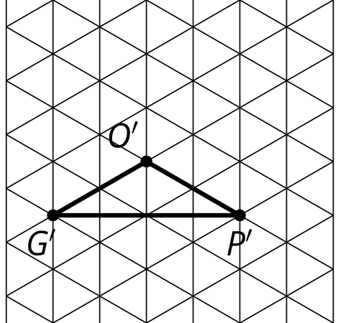
  - 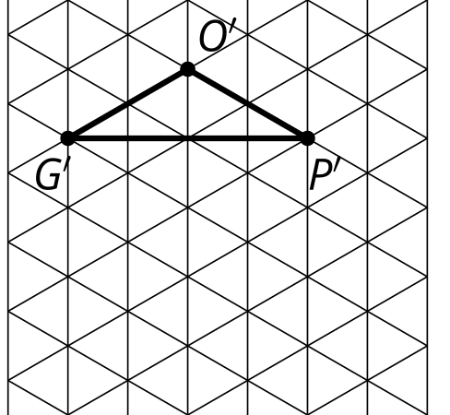
- (From Unit 1, Lesson 13.)
© CC BY 2019 by Illustrative Mathematics®

