Lesson 5: Variability and MAD
Let's use mean and MAD to describe and compare distributions.

5.1: Shooting Hoops (Part 1)
Elena, Jada, and Lin enjoy playing basketball during recess. Lately, they have been practicing free throws. They record the number of baskets they make out of 10 attempts. Here are their data sets for 12 school days.
Elena
4
5
1
6
9
7
2
8
3
3
5
7
Jada
2
4
5
4
6
6
4
7
3
4
8
7
Lin
3
6
6
4
5
5
3
5
4
6
6
7
- Calculate the mean number of baskets each player made, and compare the means. What do you notice?
- What do the means tell us in this context?

5.2: Shooting Hoops (Part 3)
The tables show Elena, Jada, and Lin’s basketball data from an earlier activity. Recall that the mean of Elena’s data, as well as that of Jada and Lin’s data, was 5.
- Record the distance between each of Elena’s scores and the mean.
- Elena | - 4 | - 5 | - 1 | - 6 | - 9 | - 7 | - 2 | - 8 | - 3 | - 3 | - 5 | - 7
- distance from 5 | - 1 |  |  | - 1
- Now find the average of the distances in the table. Show your reasoning and round your answer to the nearest tenth.
- This value is the mean absolute deviation (MAD) of Elena’s data.
- Elena’s MAD: _________
- Find the mean absolute deviation of Jada’s data. Round it to the nearest tenth.
- Jada | - 2 | - 4 | - 5 | - 4 | - 6 | - 6 | - 4 | - 7 | - 3 | - 4 | - 8 | - 7
- distance from 5
- Jada’s MAD: _________
- Find the mean absolute deviation of Lin’s data. Round it to the nearest tenth.
- Lin | - 3 | - 6 | - 6 | - 4 | - 5 | - 5 | - 3 | - 5 | - 4 | - 6 | - 6 | - 7
- distance from 5
- Lin’s MAD: _________
- Compare the MADs and dot plots of the three students’ data. Do you see a relationship between each student’s MAD and the distribution on her dot plot? Explain your reasoning.
- 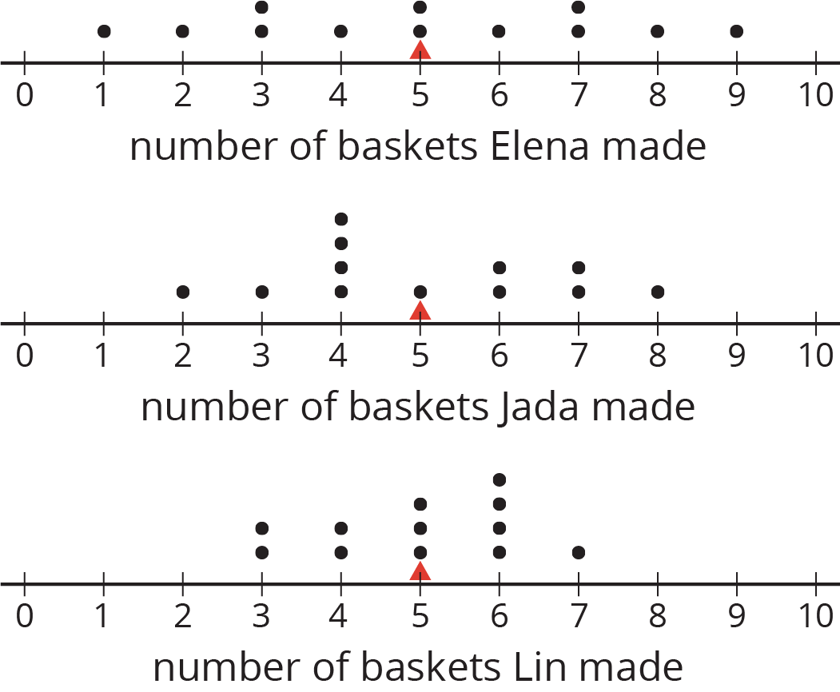

Are you ready for more?
Invent another data set that also has a mean of 5 but has a MAD greater than 2. Remember, the values in the data set must be whole numbers from 0 to 10.

5.3: Which Player Would You Choose?
- Andre and Noah joined Elena, Jada, and Lin in recording their basketball scores. They all recorded their scores in the same way: the number of baskets made out of 10 attempts. Each collected 12 data points.
  - Andre’s mean number of baskets was 5.25, and his MAD was 2.6.
  - Noah’s mean number of baskets was also 5.25, but his MAD was 1.
- Here are two dot plots that represent the two data sets. The triangle indicates the location of the mean.
- 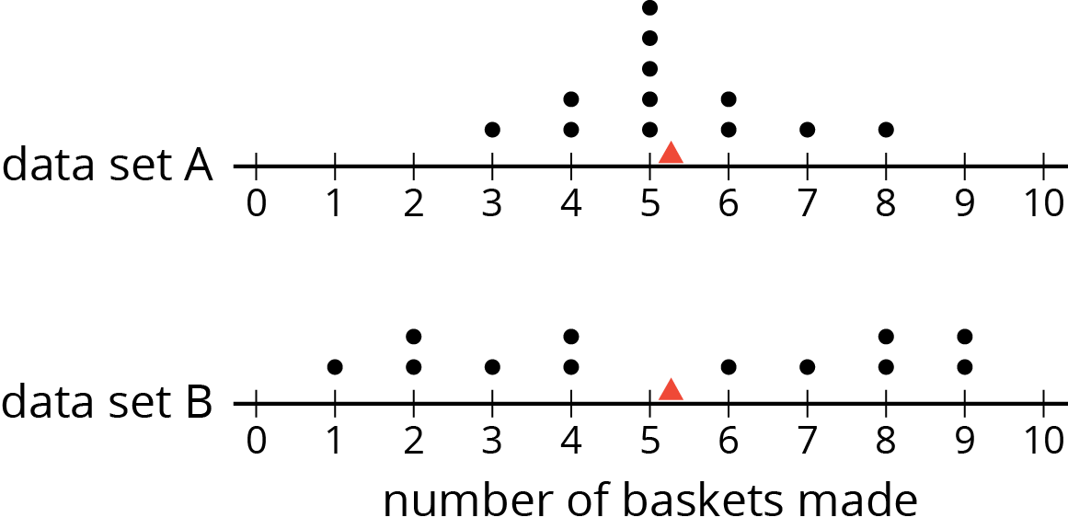
  - Without calculating, decide which dot plot represents Andre’s data and which represents Noah’s. Explain how you know.
  - If you were the captain of a basketball team and could use one more player on your team, would you choose Andre or Noah? Explain your reasoning.
- An eighth-grade student decided to join Andre and Noah and kept track of his scores. His data set is shown here. The mean number of baskets he made is 6.
- eighth‐grade student | - 6 | - 5 | - 4 | - 7 | - 6 | - 5 | - 7 | - 8 | - 5 | - 6 | - 5 | - 8
- distance from 6
  - Calculate the MAD. Show your reasoning.
  - Draw a dot plot to represent his data and mark the location of the mean with a triangle ($Δ$).
  - Compare the eighth-grade student’s mean and MAD to Noah’s mean and MAD. What do you notice?
  - Compare their dot plots. What do you notice about the distributions?
  - What can you say about the two players’ shooting accuracy and consistency?

Are you ready for more?
Invent a data set with a mean of 7 and a MAD of 1.

5.4: Swimmers Over the Years
In 1984, the mean age of swimmers on the U.S. women’s swimming team was 18.2 years and the MAD was 2.2 years. In 2016, the mean age of the swimmers was 22.8 years, and the MAD was 3 years.
- How has the average age of the women on the U.S. swimming team changed from 1984 to 2016? Explain your reasoning.
- Are the swimmers on the 1984 team closer in age to one another than the swimmers on the 2016 team are to one another? Explain your reasoning.
- Here are dot plots showing the ages of the women on the U.S. swimming team in 1984 and in 2016. Use them to make two other comments about how the women’s swimming team has changed over the years.
- 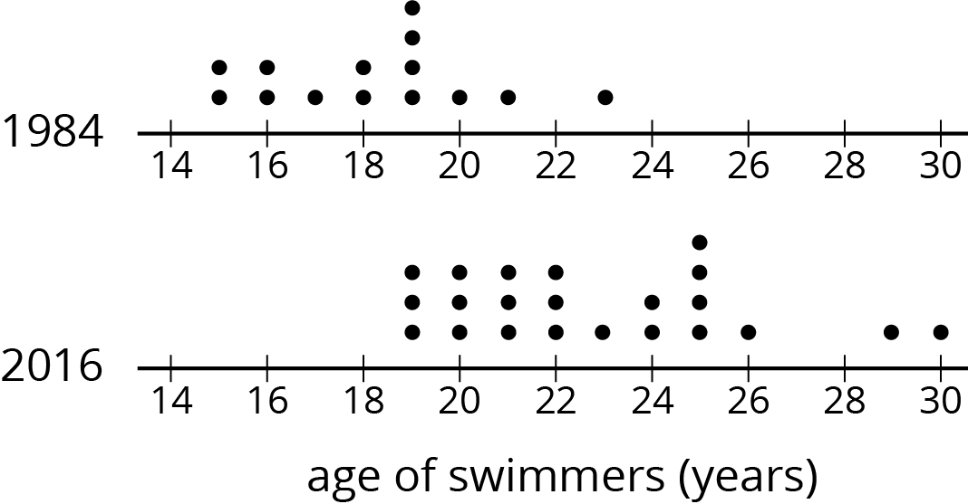

Lesson 5 Summary
We use the mean of a data set as a measure of center of its distribution, but two data sets with the same mean could have very different distributions.
This dot plot shows the weights, in grams, of 22 cookies.
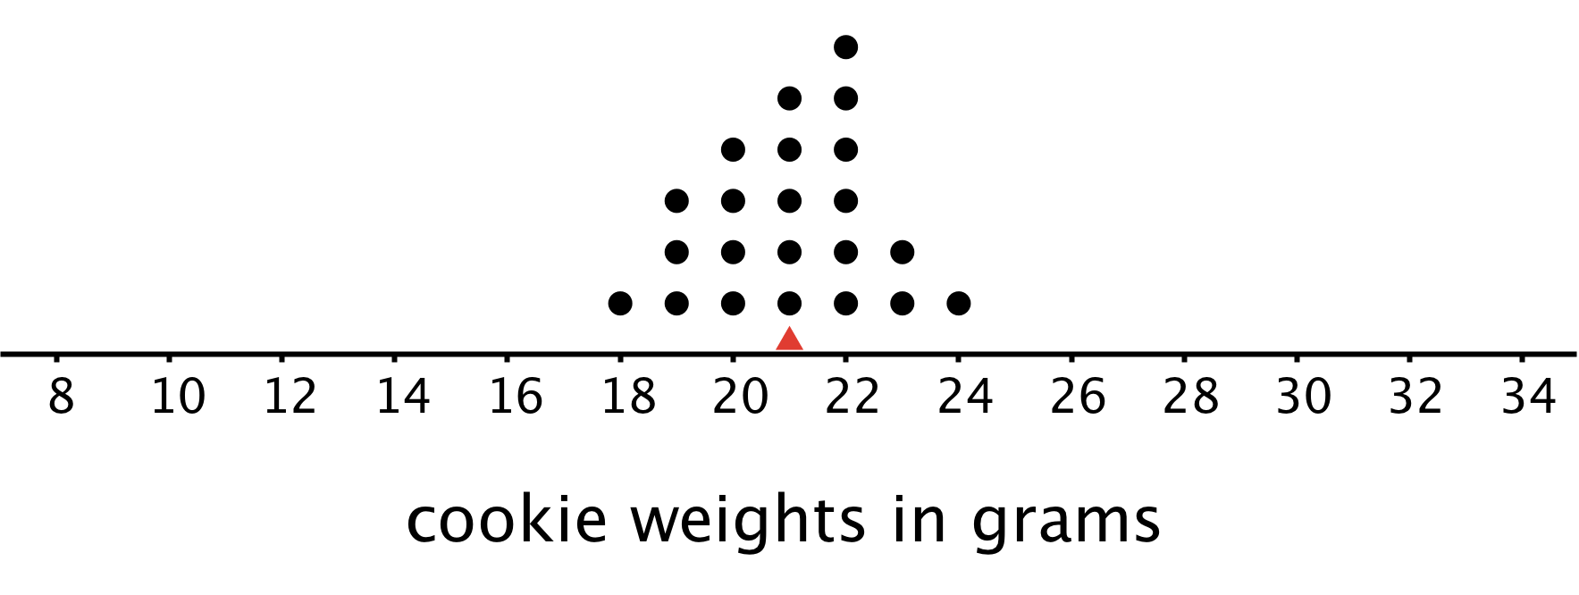
The mean weight is 21 grams. All the weights are within 3 grams of the mean, and most of them are even closer. These cookies are all fairly close in weight.
This dot plot shows the weights, in grams, of a different set of 30 cookies.
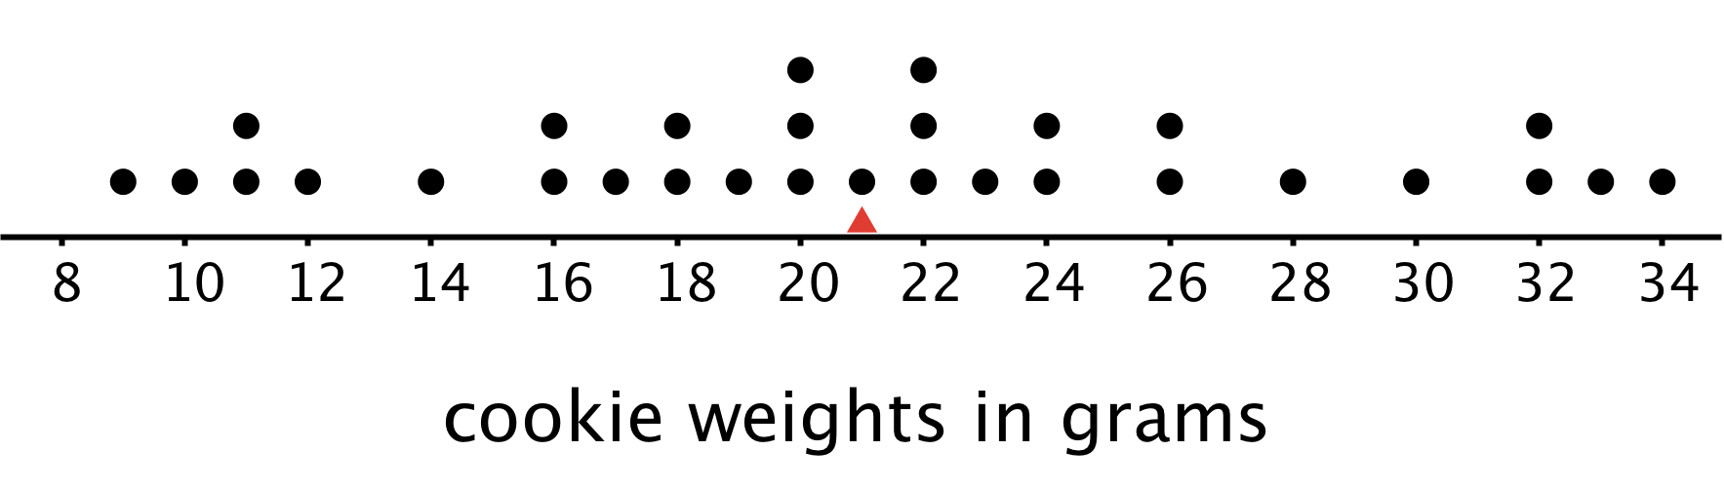
The mean weight for this set of cookies is also 21 grams, but some cookies are half that weight and others are one-and-a-half times that weight. There is a lot more variability in the weight.
There is a number we can use to describe how far away, or how spread out, data points generally are from the mean. This measure of spread is called the mean absolute deviation (MAD).
Here the MAD tells us how far cookie weights typically are from 21 grams. To find the MAD, we find the distance between each data value and the mean, and then calculate the mean of those distances.
For instance, the point that represents 18 grams is 3 units away from the mean of 21 grams. We can find the distance between each point and the mean of 21 grams and organize the distances into a table, as shown.
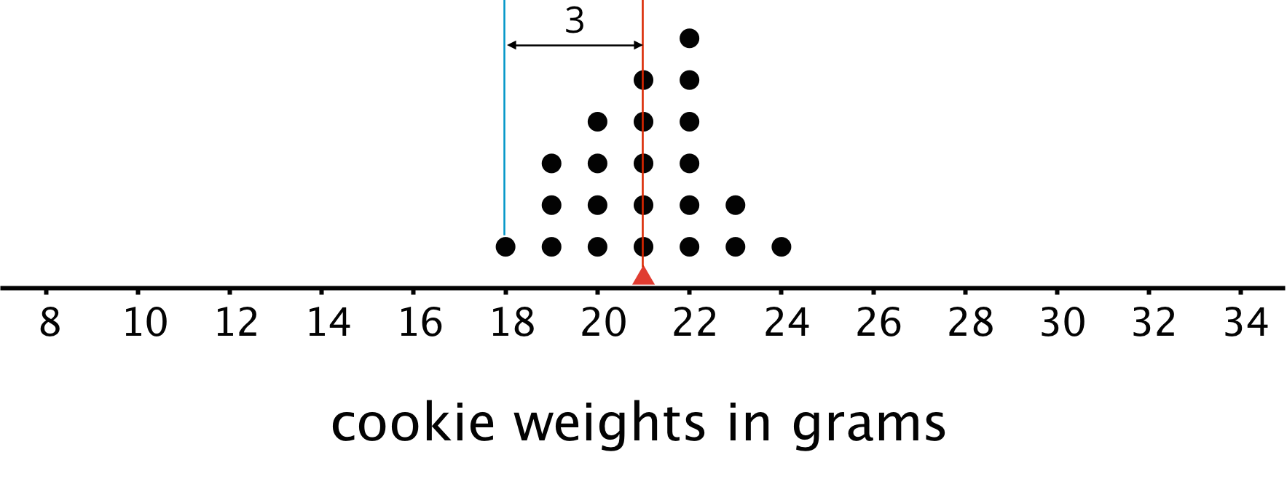
weight in grams | 18 | 19 | 19 | 19 | 20 | 20 | 20 | 20 | 21 | 21 | 21 | 21 | 21 | 22 | 22 | 22 | 22 | 22 | 22 | 23 | 23 | 24
distance from mean | 3 | 2 | 2 | 2 | 1 | 1 | 1 | 1 | 0 | 0 | 0 | 0 | 0 | 1 | 1 | 1 | 1 | 1 | 1 | 2 | 2 | 3
The values in the first row of the table are the cookie weights for the first set of cookies. Their mean, 21 grams, is the mean of the cookie weights.
The values in the second row of the table are the distances between the values in the first row and 21. The mean of these distances is the MAD of the cookie weights.
What can we learn from the averages of these distances once they are calculated?
- In the first set of cookies, the distances are all between 0 and 3. The MAD is 1.2 grams, which tells us that the cookie weights are typically within 1.2 grams of 21 grams. We could say that a typical cookie weighs between 19.8 and 22.2 grams.
- In the second set of cookies, the distances are all between 0 and 13. The MAD is 5.6 grams, which tells us that the cookie weights are typically within 5.6 grams of 21 grams. We could say a typical cookie weighs between 15.4 and 26.6 grams.
The MAD is also called a measure of the variability of the distribution. In these examples, it is easy to see that a higher MAD suggests a distribution that is more spread out, showing more variability.
© CC BY Open Up Resources. Adaptations CC BY IM.

