Lesson 16 Practice Problems
- For each figure, identify any angles of rotation that create symmetry.
- 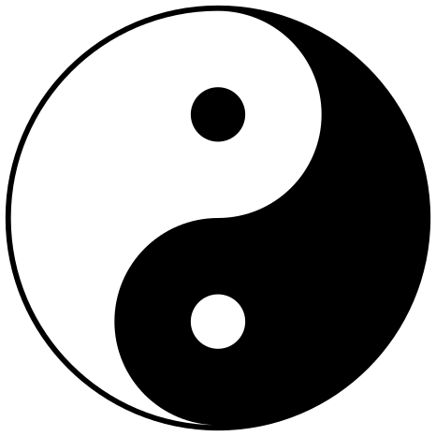
- 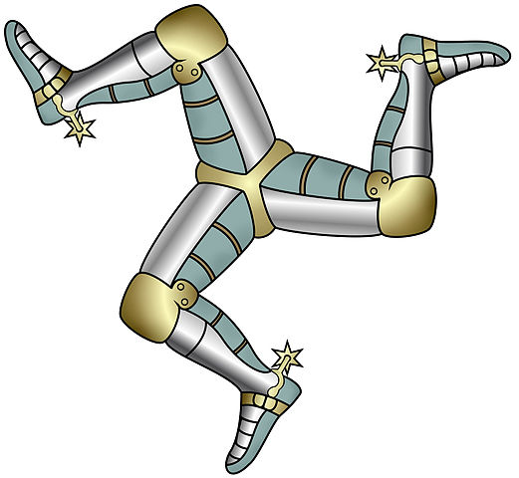

- A triangle has rotation symmetry that can take any of its vertices to any of its other vertices. Select all conclusions that we can reach from this.
  - All sides of the triangle have the same length.
  - All angles of the triangle have the same measure.
  - All rotations take one half of the triangle to the other half of the triangle.
- Select all the angles of rotation that produce symmetry for this flower.
- 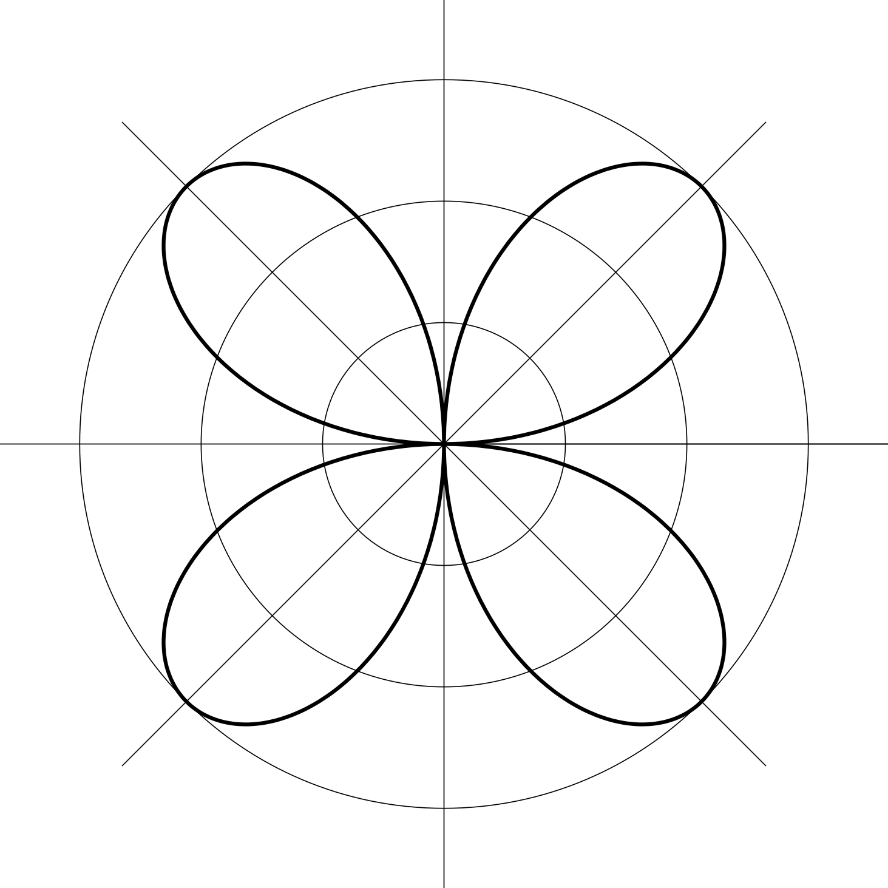
  - 45 degrees
  - 90 degrees
  - 135 degrees
  - 180 degrees
  - 225 degrees
  - 270 degrees
- Identify any lines of symmetry the figure has.
- 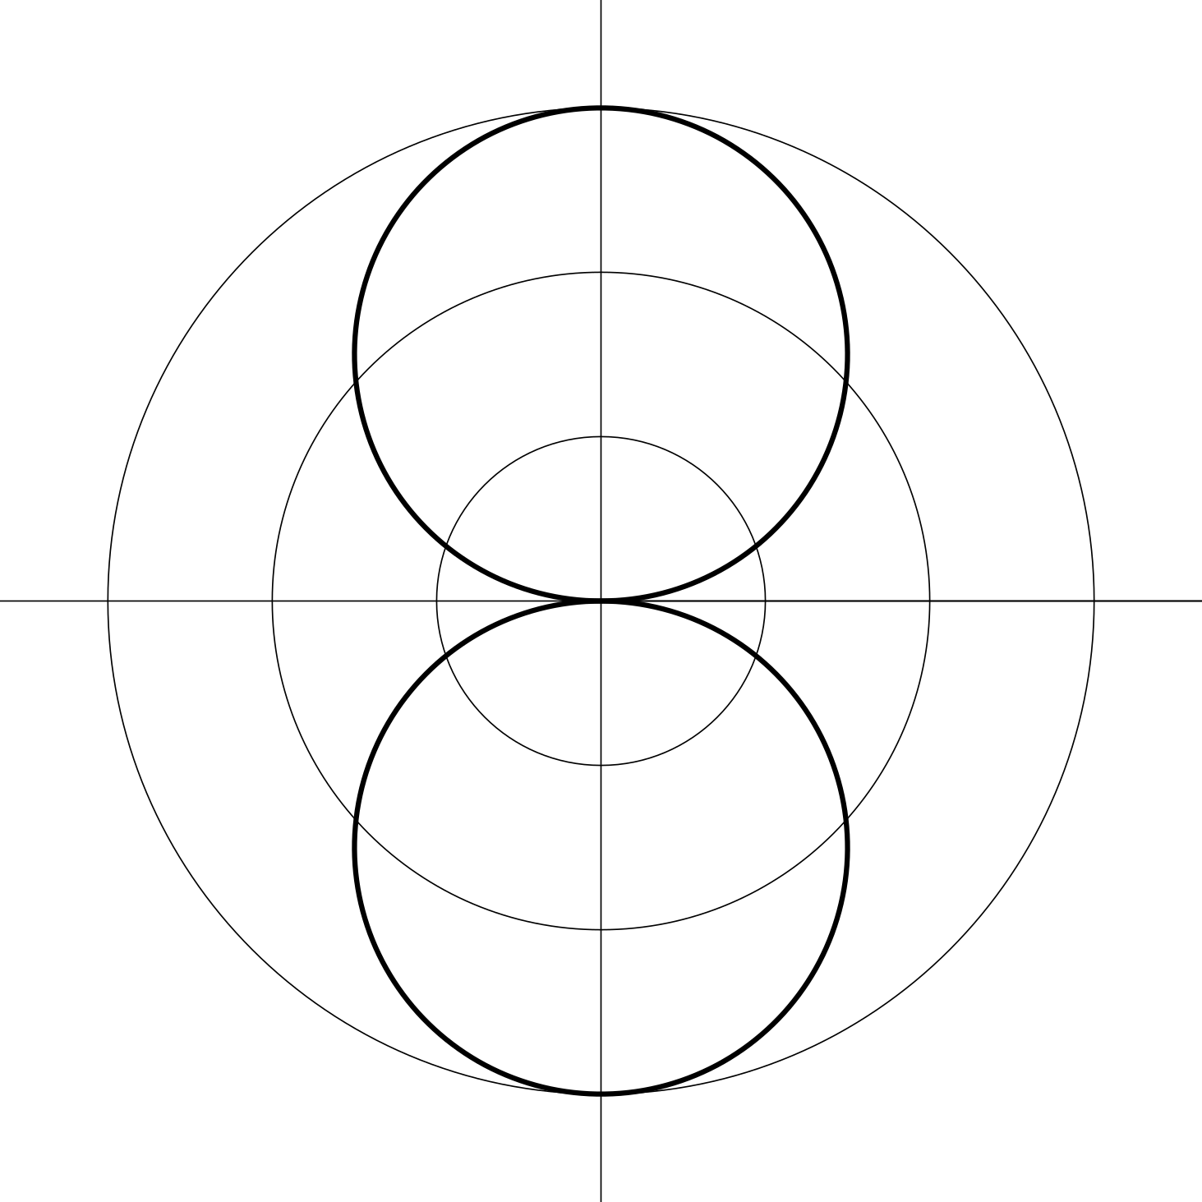
- (From Unit 1, Lesson 15.)
- A triangle has a line of symmetry. Select all conclusions that must be true.
  - All sides of the triangle have the same length.
  - All angles of the triangle have the same measure.
  - No sides of the triangle have the same length.
  - No angles of the triangle have the same measure.
  - Two sides of the triangle have the same length.
  - Two angles of the triangle have the same measure.
- (From Unit 1, Lesson 15.)
- Here are 4 triangles that have each been transformed by a different transformation. Which transformation is not a rigid transformation?
  - 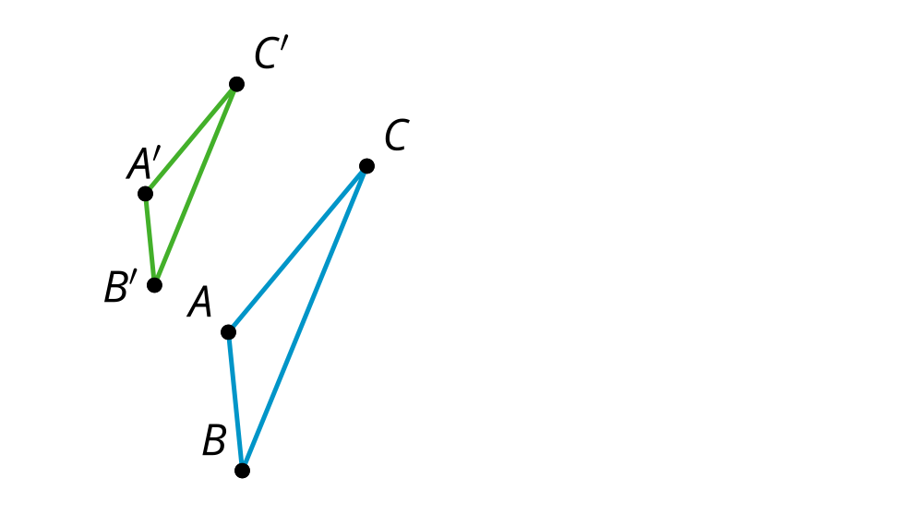
  - 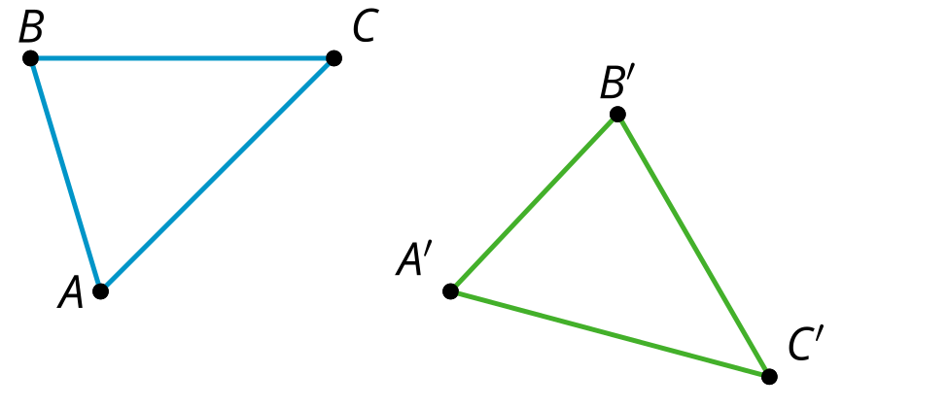
  - 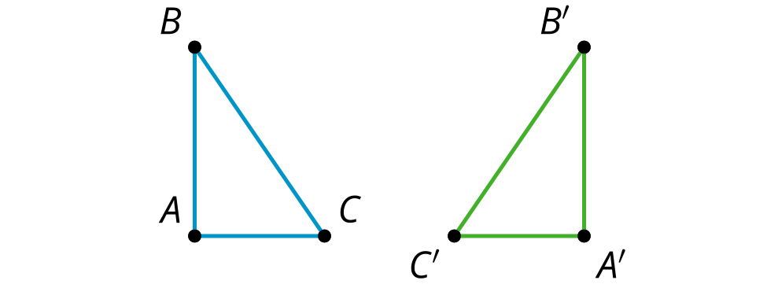
  - 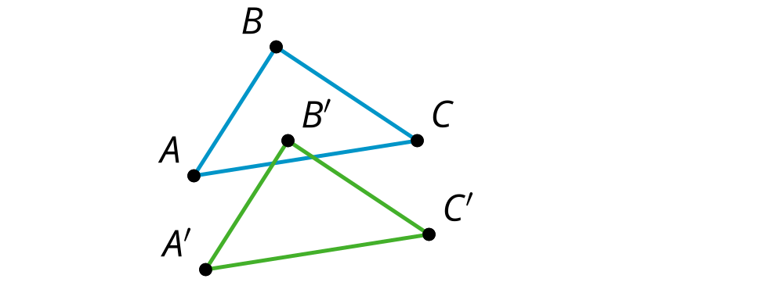
- (From Unit 1, Lesson 10.)
- Match each directed line segment with the translation from Polygon $P$ to Polygon $Q$ by that directed line segment.

- Translation 1
- 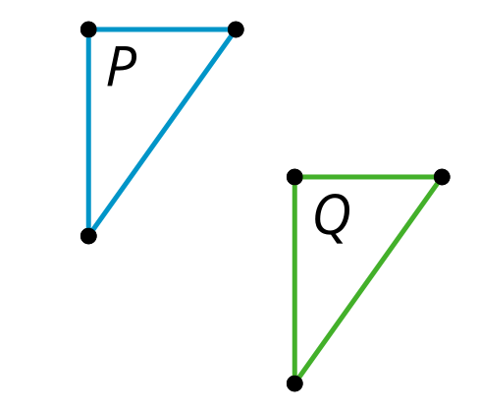

- Translation 2
- 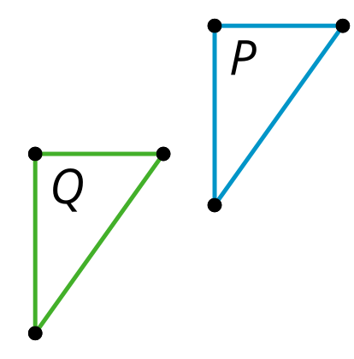

- Translation 3
- 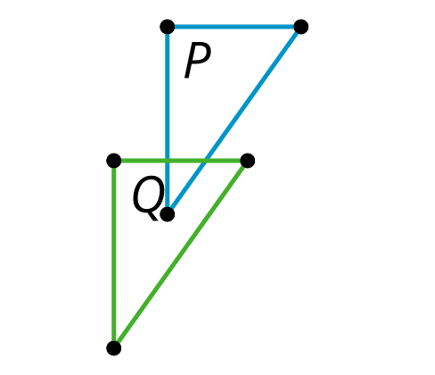

- Translation 4
- 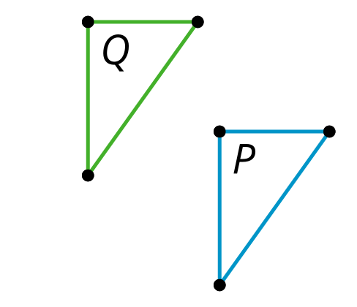
  - 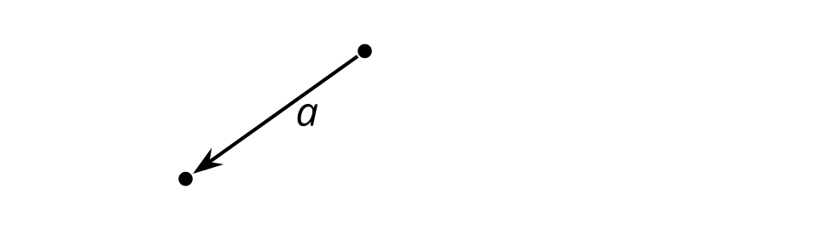

  - Translation 1
  - Translation 2
  - Translation 3
  - Translation 4
- (From Unit 1, Lesson 12.)
© CC BY 2019 by Illustrative Mathematics®

