Unit 5 Lesson 1: Matching up to Data

1 Notice and Wonder: Cooling Down (Warm up)

Student Task Statement
What do you notice? What do you wonder?
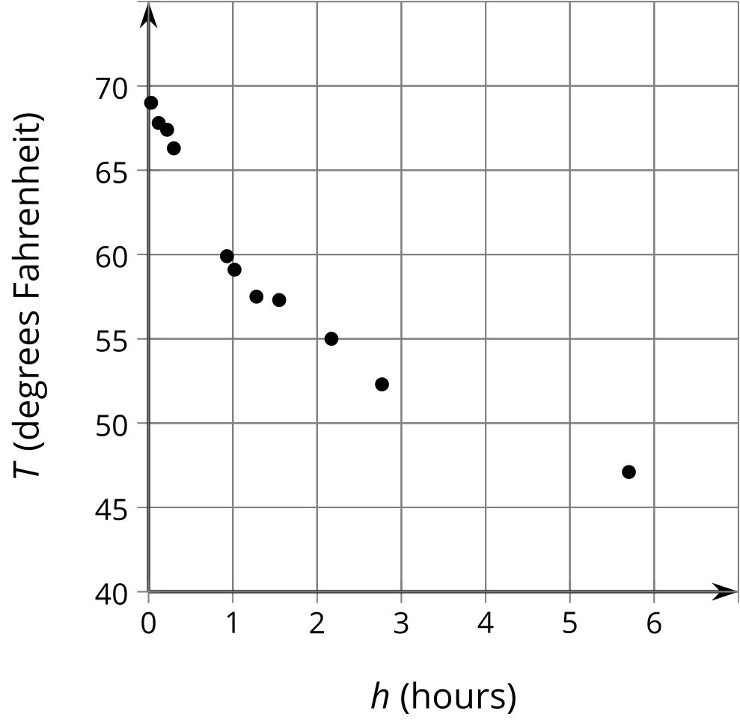

2 Which Function?

Student Task Statement
A bottle of soda water is left outside on a cold day. The scatter plot shows the temperature $T$, in degrees Fahrenheit, of the bottle $h$ hours after it was left outside. Here are 2 functions you can use to model the temperature as a function of time:
$f\left(h\right)=45+\frac{20}{h+0.5}$
$g\left(h\right)=45+33{\left(0.5\right)}^{h+0.5}$
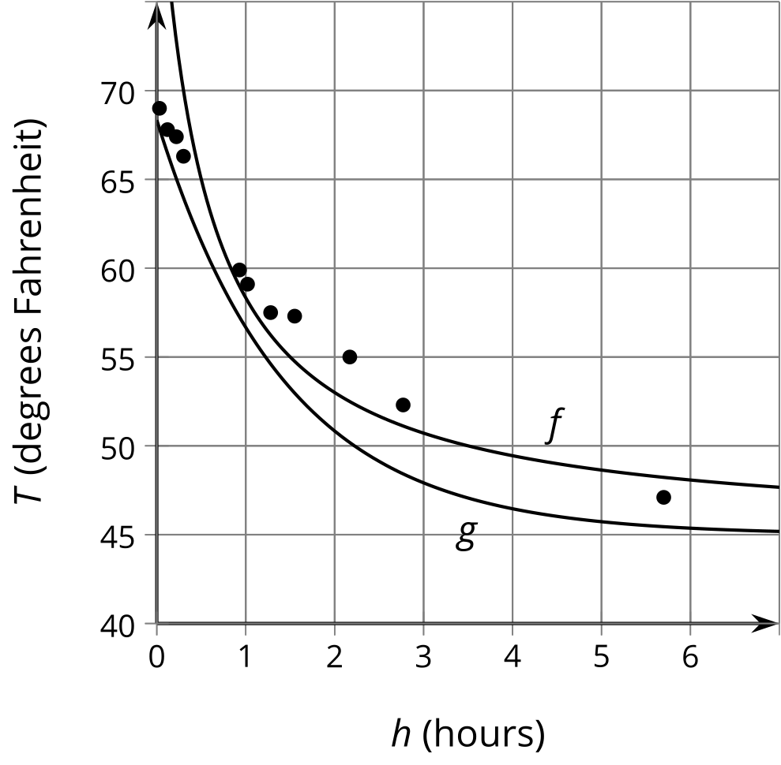
- Which function better fits the shape of the data? Explain your reasoning.
- Where do you see the 45 in the expression for each function on the graph?
- For the function you thought didn’t fit the shape of the data as well, how would you change it to fit better?

3 What Happened to the Graph?

Student Task Statement
Your teacher will give you a card. Take turns describing the transformation of the graph on your card for your partner to draw and drawing the transformed graph from your partner's description.

1. a.
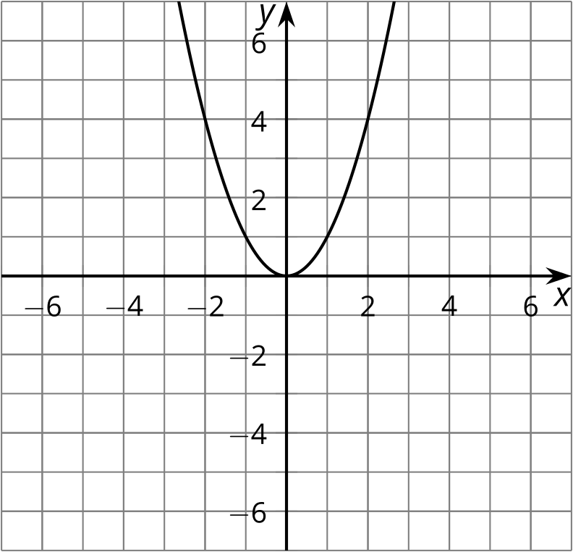

1. b.
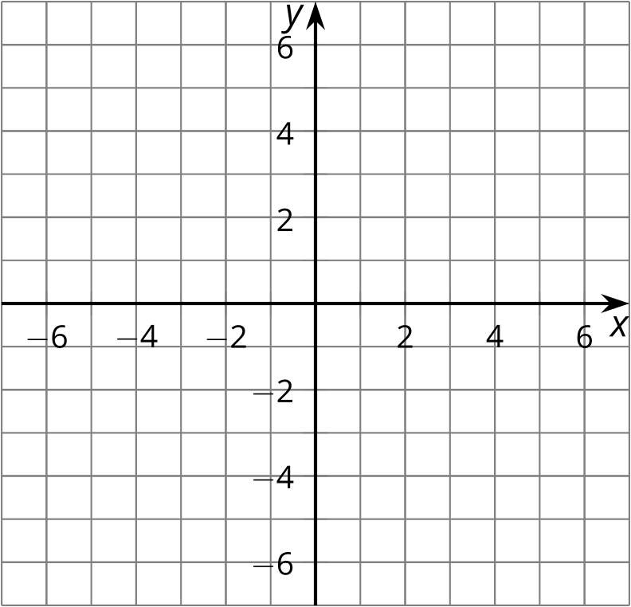

2. a.
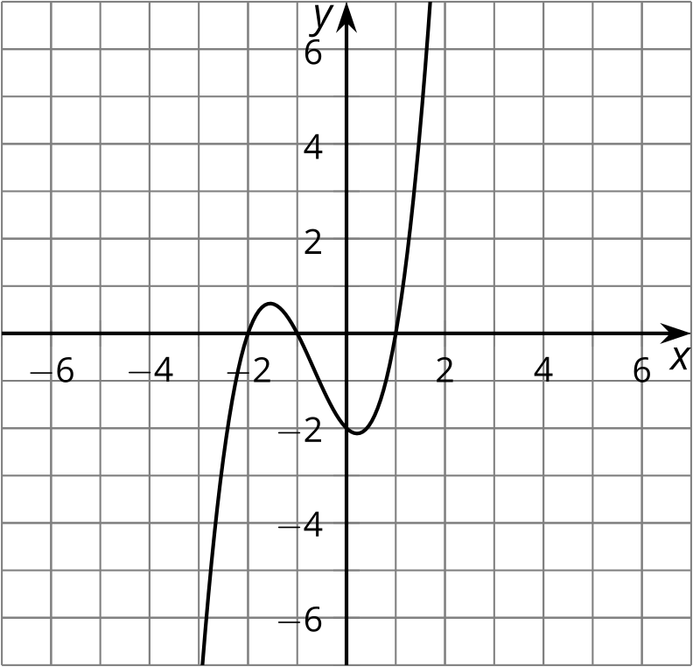

2. b.

3. a.
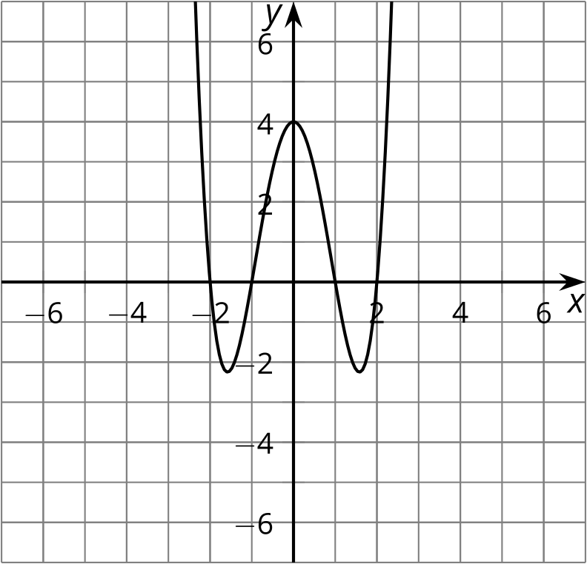

3. b.

4. a.
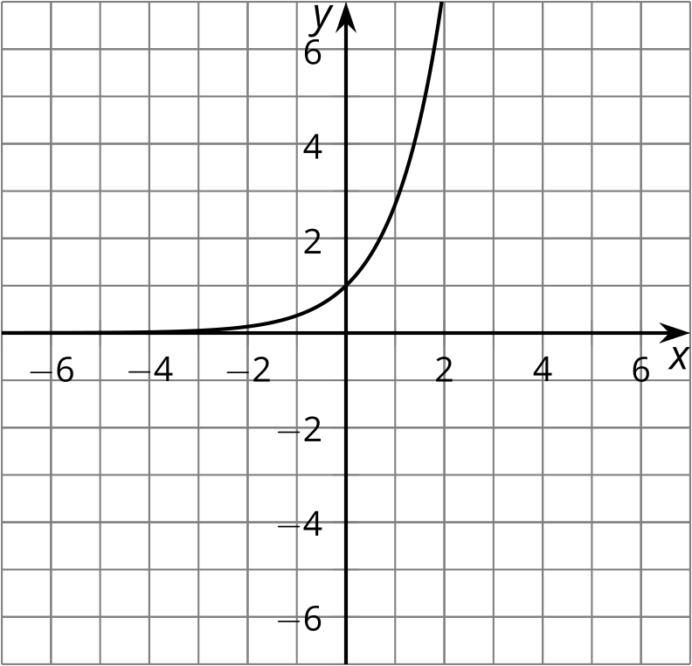

4. b.

5. a.
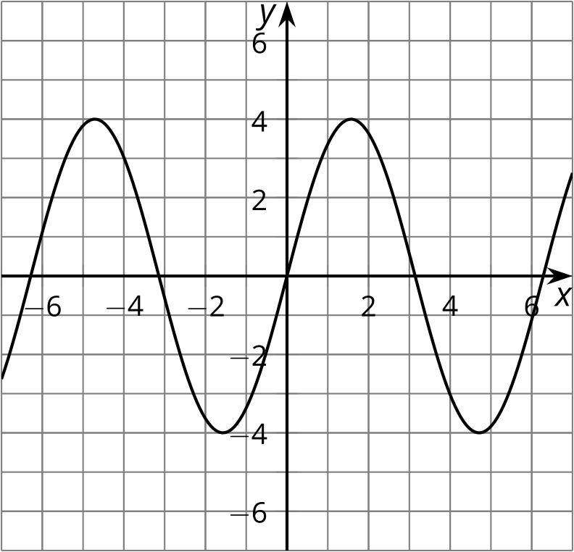

5. b.

6. a.

6. b.

Images for Activity Synthesis
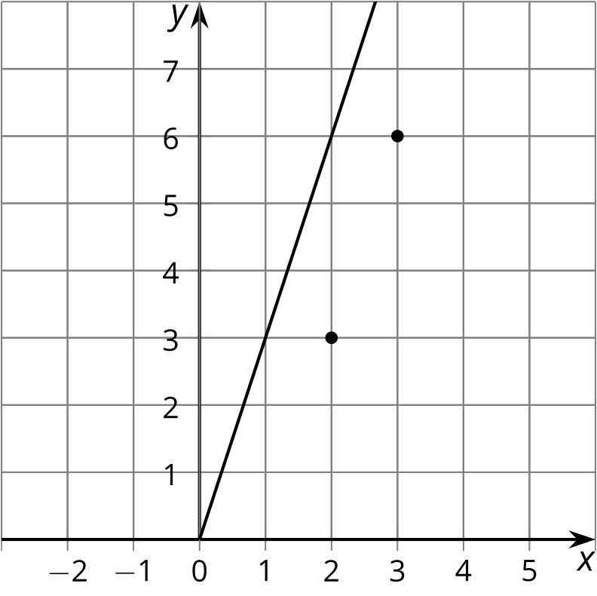
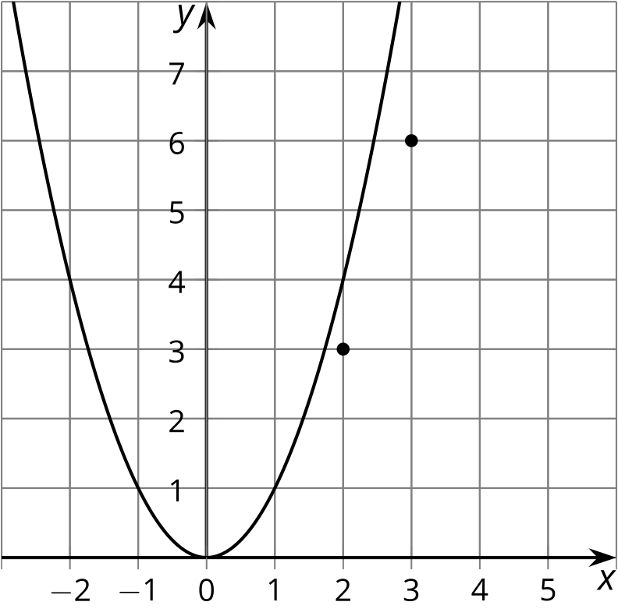
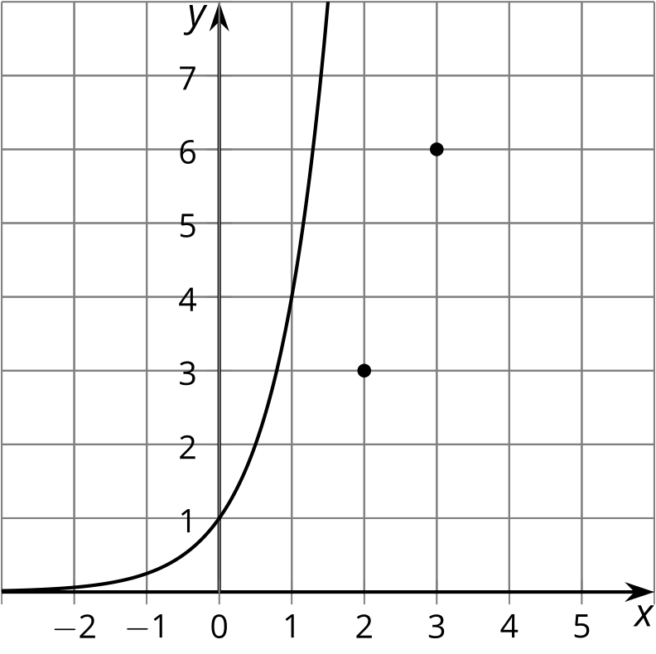
© CC BY 2019 by Illustrative Mathematics®

