Unit 2 Lesson 10: Multiplicity

1 Notice and Wonder: Duplicate Factors (Warm up)

Student Task Statement
What do you notice? What do you wonder?

$y={\left(x−3\right)}^{2}$
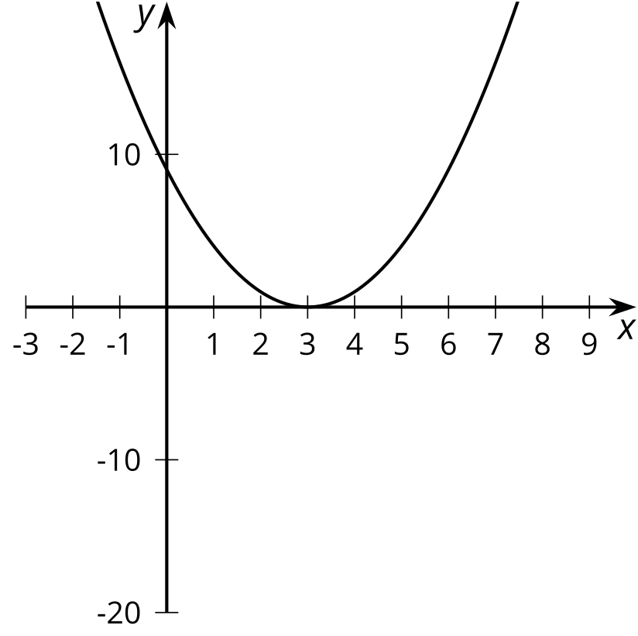

$y=\left(x+1\right){\left(x−3\right)}^{2}$
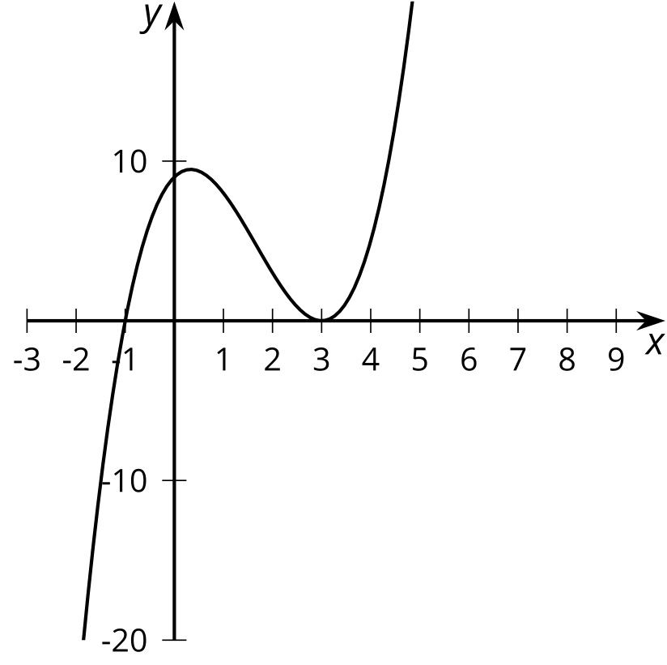

$y={\left(x−3\right)}^{3}$
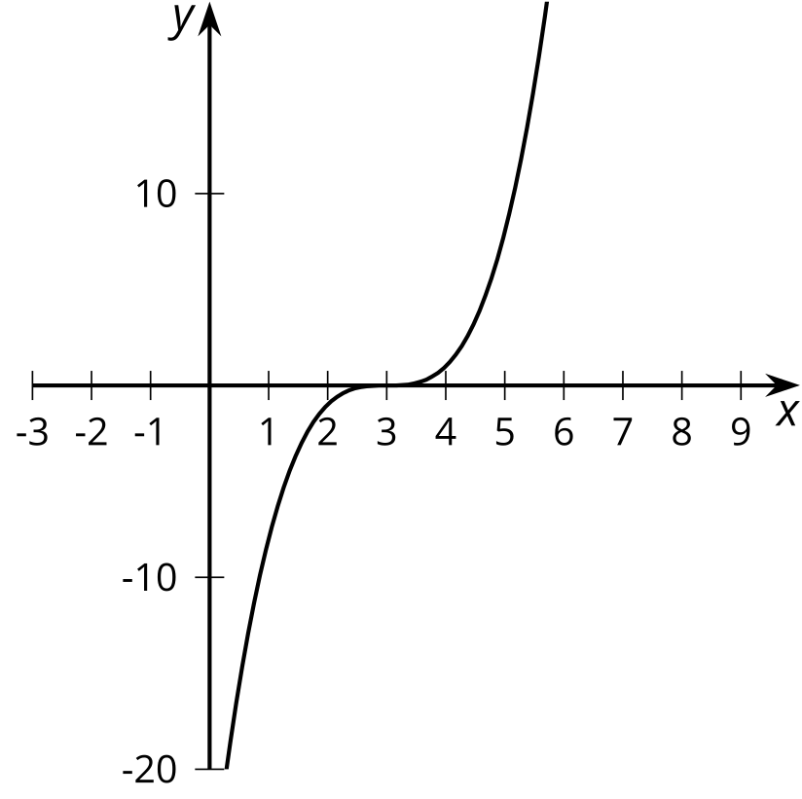

$y=\left(x−6\right){\left(x−3\right)}^{2}$
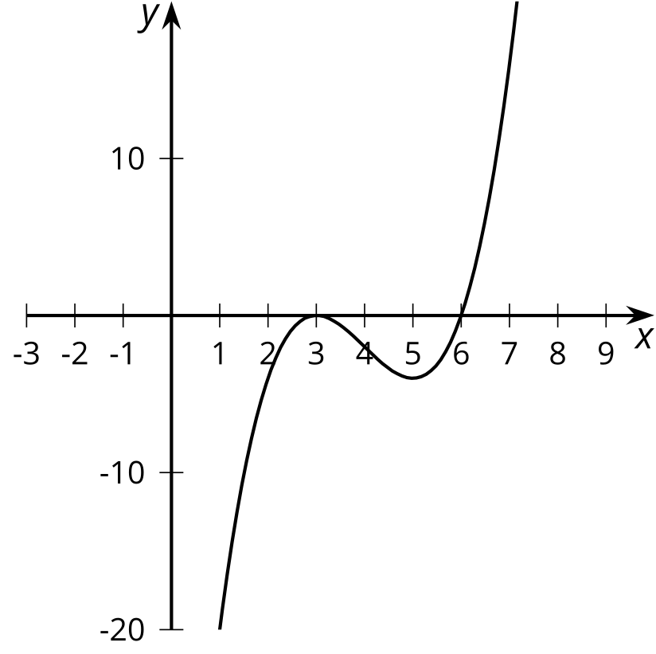

2 Sketching Polynomials

Student Task Statement
- For polynomials $A$–$F$:
  - Write the degree, all zeros, and complete the sentence about the end behavior.
  - Sketch a possible graph.
  - Check your sketch using graphing technology.
  - Pause here for your teacher to check your work.
- Create your own polynomial for your partner to figure out.
  - Create a polynomial with degree greater than 2 and less than 8 and write the equation in the space given.
  - Trade papers with a partner, then fill out the information about their polynomial and complete a sketch.
  - Trade papers back. Check your partner’s sketch using graphing technology.

$A\left(x\right)=\left(x+2\right)\left(x−2\right)\left(x−8\right)$
Degree: Zeros:
End behavior: As $x$ gets larger and larger in the negative direction,

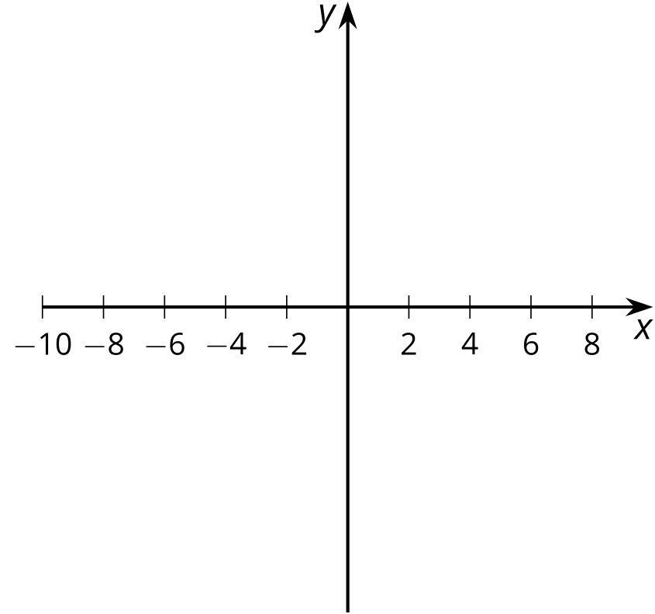
$B\left(x\right)=\text{-}\left(x+2\right){\left(x−2\right)}^{2}$
Degree: Zeros:
End behavior: As $x$ gets larger and larger in the negative direction,

$C\left(x\right)=\left(x+6\right){\left(x+2\right)}^{2}$
Degree: Zeros:
End behavior: As $x$ gets larger and larger in the negative direction,

$D\left(x\right)=\text{-}{\left(x+6\right)}^{2}\left(x+2\right)$
Degree: Zeros:
End behavior: As $x$ gets larger and larger in the negative direction,

​​​​​​
$E\left(x\right)=\left(x+4\right){\left(x−2\right)}^{3}$
Degree: Zeros:
End behavior: As $x$ gets larger and larger in the negative direction,

$F\left(x\right)=x^{3}\left(x+4\right){\left(x−3\right)}^{2}$
Degree: Zeros:
End behavior: As $x$ gets larger and larger in the negative direction,

Your polynomial:
Degree: Zeros:
End behavior: As $x$ gets larger and larger in the negative direction,

3 Using Knowledge of Zeros (Optional)

Student Task Statement
- Sketch a graph for a polynomial function $y=f\left(x\right)$ that has 3 different zeros and $f\left(x\right)≥0$ for all values of $x$.
- 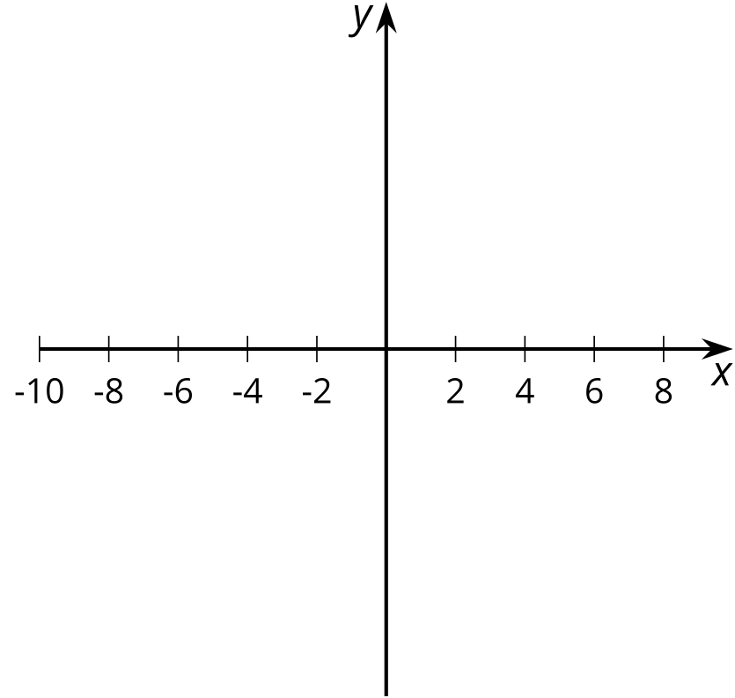
- What is the smallest degree the polynomial could have?
- What is a possible equation for the polynomial? Use graphing technology to see if your equation matches your sketch.
© CC BY 2019 by Illustrative Mathematics®

