Lesson 6: Writing Equations for Exponential Functions
- Let’s decide what information we need to write an equation for an exponential function.

6.1: All Equivalent?
- Discuss with a partner why the following expressions are equivalent.
  - ${64}^{\frac{1}{3}}$
  - ${\left(8^{2}\right)}^{\frac{1}{3}}$
  - ${\left(2^{3}\right)}^{\frac{2}{3}}$
  - ${\left(8^{\frac{1}{3}}\right)}^{2}$
  - $8^{\frac{2}{3}}$
- What is another expression equivalent to these?

6.2: Info Gap: Two Points
Your teacher will give you either a problem card or a data card. Do not show or read your card to your partner.
If your teacher gives you the data card:
- Silently read the information on your card.
- Ask your partner “What specific information do you need?” and wait for your partner to ask for information. Only give information that is on your card. (Do not figure out anything for your partner!)
- Before telling your partner the information, ask “Why do you need to know (that piece of information)?”
- Read the problem card, and solve the problem independently.
- Share the data card, and discuss your reasoning.
If your teacher gives you the problem card:
- Silently read your card and think about what information you need to answer the question.
- Ask your partner for the specific information that you need.
- Explain to your partner how you are using the information to solve the problem.
- When you have enough information, share the problem card with your partner, and solve the problem independently.
- Read the data card, and discuss your reasoning.
Pause here so your teacher can review your work. Ask your teacher for a new set of cards and repeat the activity, trading roles with your partner.

Are you ready for more?
Here is a graph representing a function of the form $h\left(x\right)=ab^{x}$.
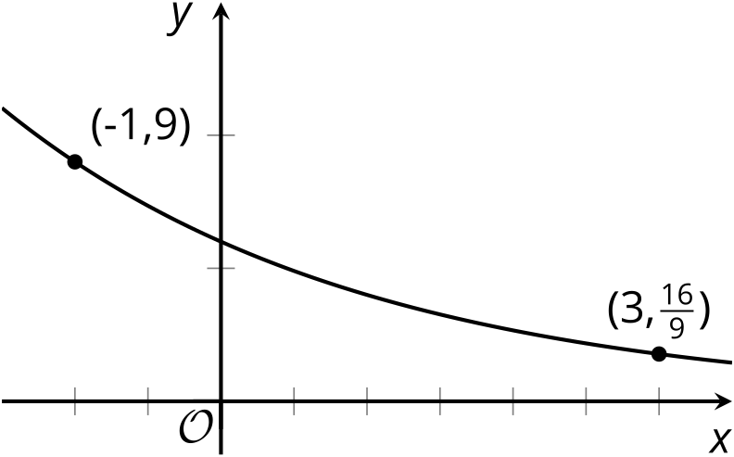
Find the values of $a$ and $b$. Show your reasoning.

6.3: Bacteria Growth Expressions
A bacteria population starts at 1000 and doubles every 10 hours.
- Explain why the expressions $1000⋅{\left(2^{\frac{1}{10}}\right)}^{h}$ and $1000⋅2^{\frac{h}{10}}$ both represent the bacteria population after $h$ hours.
- By what factor does the bacteria population grow each hour? Explain how you know.

Lesson 6 Summary
Equations are helpful for communicating how quantities are changing. We can write equations from descriptions or from graphs.
Sometimes, the information on how a quantity is changing is given in a graph instead of in words. We can find an equation for an exponential function using two points on its graph, just as we’ve done in the past with linear functions. Let’s say we want to find a function $f$ of the form $f\left(x\right)=a⋅b^{x}$ whose graph contains $\left(0,64\right)$ and $\left(0.5,38.4\right)$.
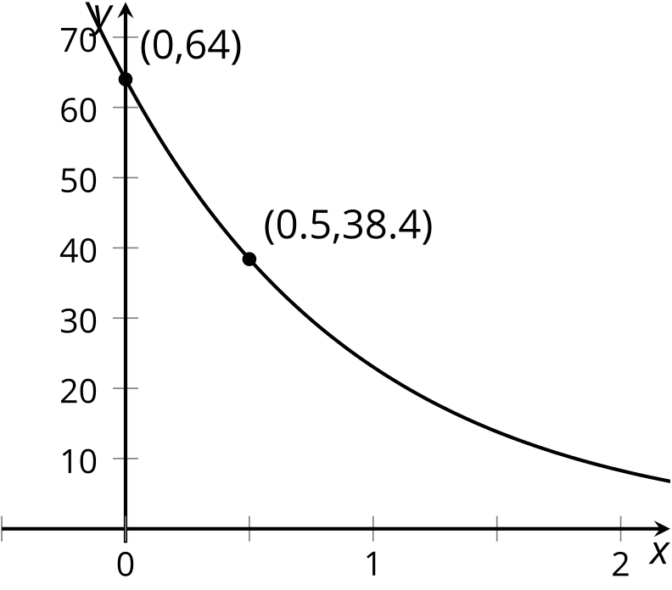
Since the point $\left(0,64\right)$ is on the graph of $f$, we know the value of the function at 0 is 64. This means that $f\left(0\right)=a⋅b^{0}=a$, so the value of $a$ is 64.
Using the second given point, $\left(0.5,38.4\right)$, we know $f\left(0.5\right)=38.4$. This means that $64⋅b^{0.5}=38.4$. Solving this equation we have:
$\begin{matrix}64⋅b^{0.5} & =38.4 \\ b^{0.5} & =\frac{38.4}{64} \\ b^{0.5} & =0.6\end{matrix}$
To determine the exact value of $b$, let’s use the properties of exponents. Since $b$ is positive, we can show that $b=0.36$ because
$\begin{matrix}b^{0.5} & =0.6 \\ {\left(b^{0.5}\right)}^{2} & ={\left(0.6\right)}^{2} \\ b & =0.36\end{matrix}$
We can now write an equation defining $f$: $f\left(x\right)=64⋅{\left(0.36\right)}^{x}$.
© CC BY 2019 by Illustrative Mathematics®

