Lesson 12 Practice Problems
- Match the directed line segment with the image of Polygon $P$ being transformed to Polygon $Q$ by translation by that directed line segment.

- Translation 1
- 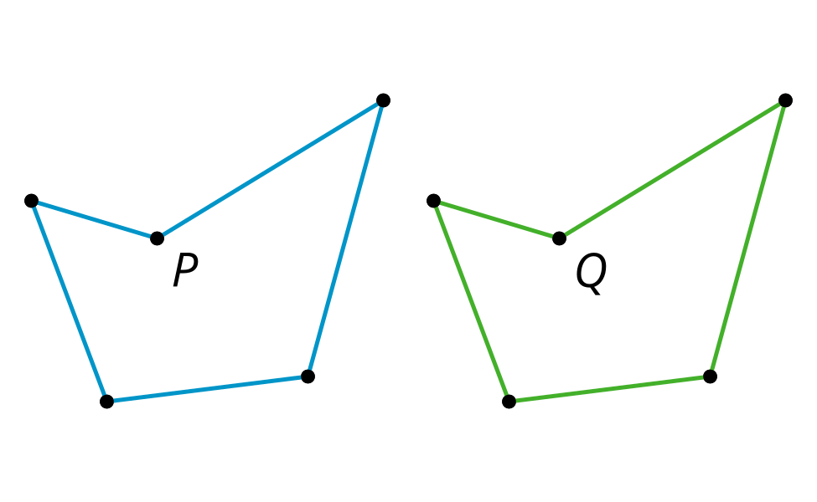

- Translation 2
- 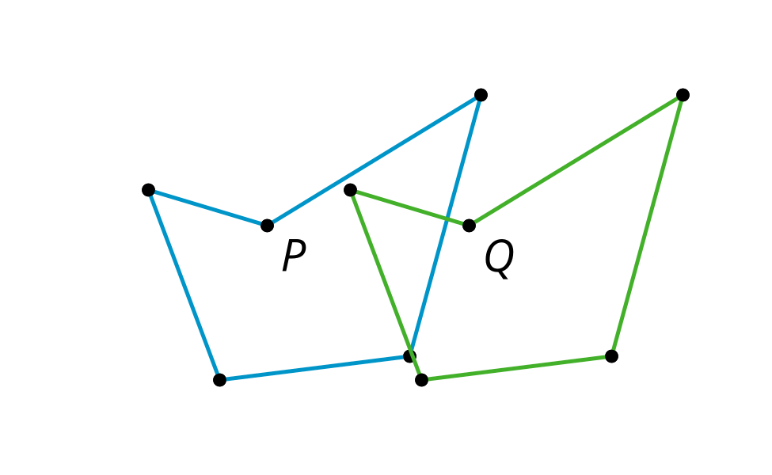

- Translation 3
- 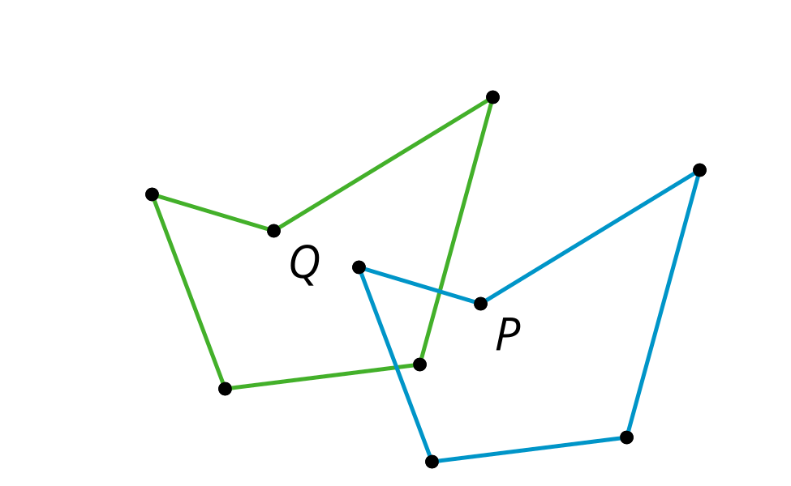

- Translation 4
- 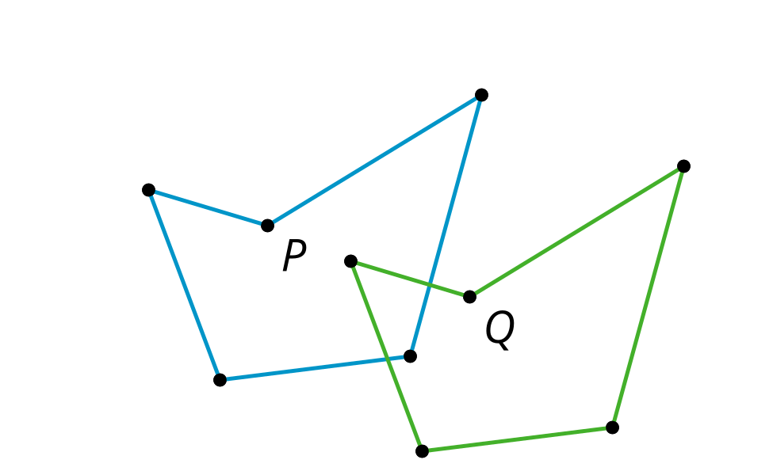
  - Translation 1
  - Translation 2
  - Translation 3
  - Translation 4
- Draw the image of quadrilateral $ABCD$ when translated by the directed line segment $v$. Label the image of $A$ as $A^{′}$, the image of $B$ as $B^{′}$, the image of $C$ as $C^{′}$ and the image of $D$ as $D^{′}$.
- 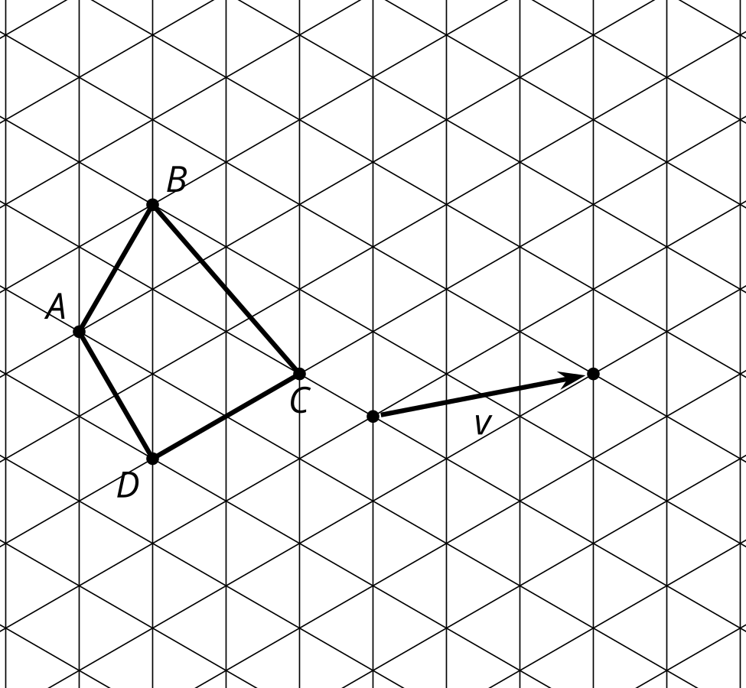
- Which statement is true about a translation?
  - A translation takes a line to a parallel line or itself.
  - A translation takes a line to a perpendicular line.
  - A translation requires a center of translation.
  - A translation requires a line of translation.
- Select all the points that stay in the same location after being reflected across line $ℓ$.
- 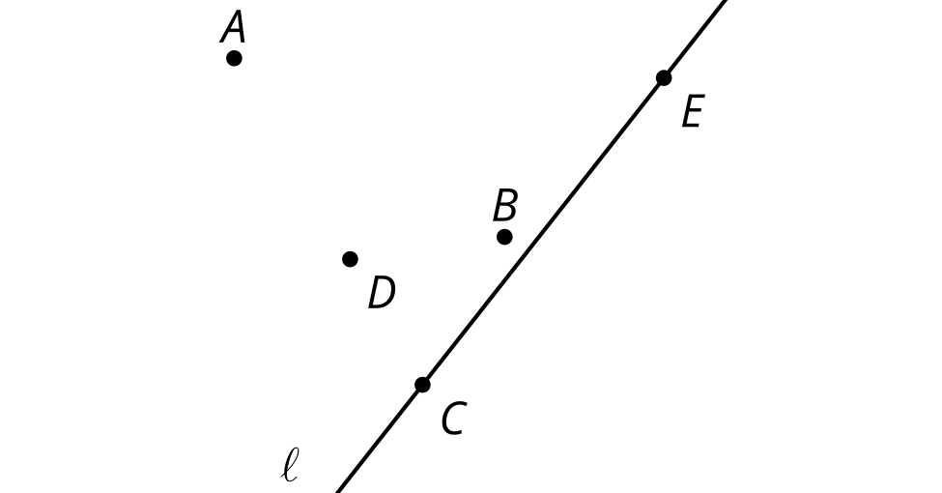
  - A
  - B
  - C
  - D
  - E
- (From Unit 1, Lesson 11.)
- Lines $ℓ$ and $m$ are perpendicular. A point $Q$ has this property: rotating $Q$ 180 degrees using center $P$ has the same effect as reflecting $Q$ over line $m$.

- $m⊥ℓ$
- 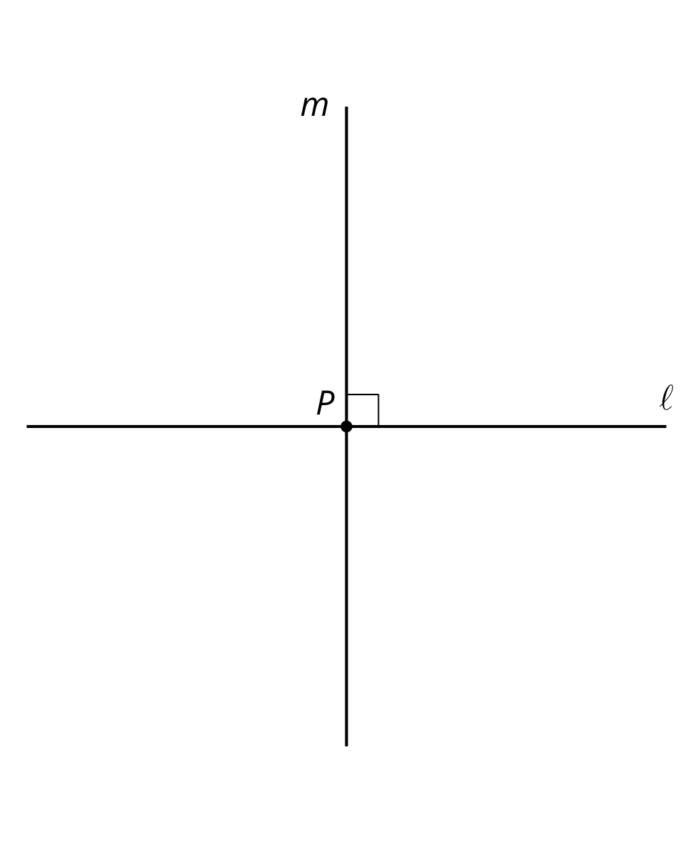
  - Give two possible locations of $Q$.
  - Do all points in the plane have this property?
- (From Unit 1, Lesson 11.)
- There is a sequence of rigid transformations that takes $A$ to $A^{′}$, $B$ to $B^{′}$, and $C$ to $C^{′}$. The same sequence takes $D$ to $D^{′}$. Draw and label $D^{′}$:
- 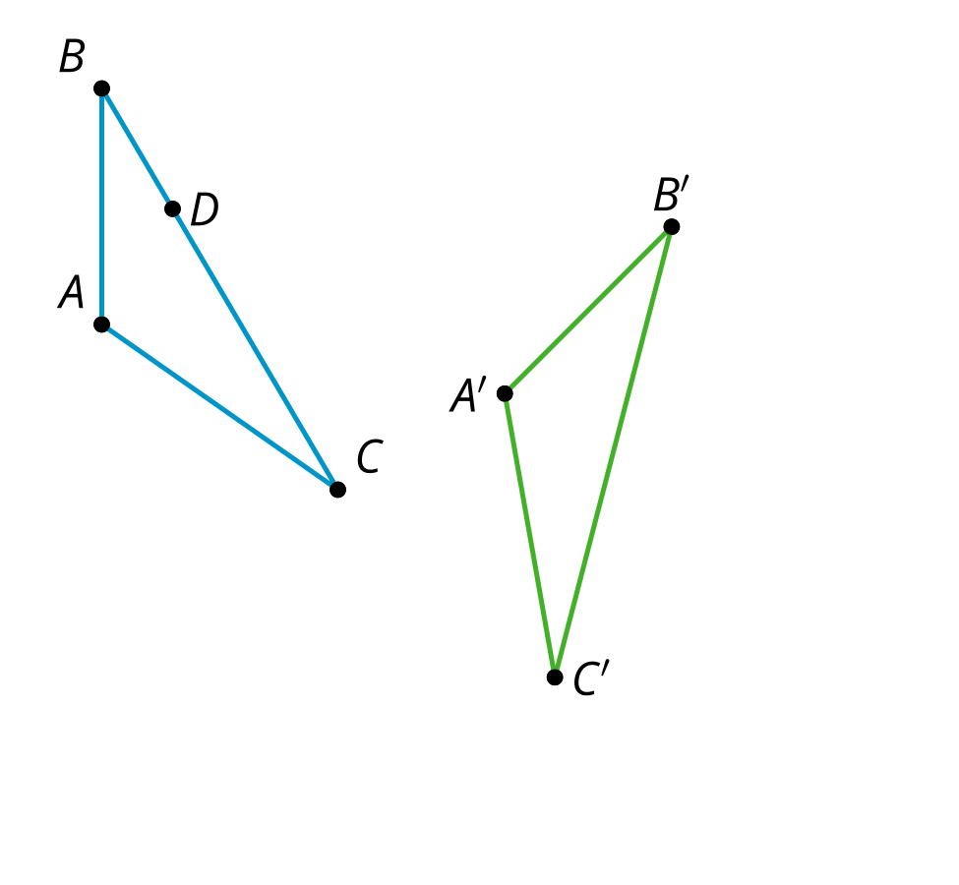
- (From Unit 1, Lesson 10.)
- Two distinct lines, $ℓ$ and $m$, are each perpendicular to the same line $n$.
  - What is the measure of the angle where line $ℓ$ meets line $n$?
  - What is the measure of the angle where line $m$ meets line $n$?
- (From Unit 1, Lesson 6.)
© CC BY 2019 by Illustrative Mathematics®

