Lesson 5: Changes Over Rational Intervals
- Let’s look at how an exponential function changes when the input changes by a fractional amount.

5.1: Changes Over Intervals
Consider the exponential function $h\left(x\right)=4^{x}$. For each question, be prepared to share your reasoning with the class.
- By what factor does $h$ increase when the exponent $x$ increases by 1?
- By what factor does $h$ increase when the exponent $x$ increases by 2?
- By what factor does $h$ increase when the exponent $x$ increases by 0.5?

5.2: Machine Depreciation
After purchase, the value of a machine depreciates exponentially. The table shows its value as a function of years since purchase. If a spreadsheet tool is available, consider using it to help you reason about the following questions.
years since purchase | value in dollars
0 | 16,000
0.5
1 | 13,600
1.5
2 | 11,560
3 | 9,826
- The value of the machine in dollars is a function $f$ of time $t$, the number of years since the machine was purchased. Find an equation defining $f$ and be prepared to explain your reasoning.
- Find the value of the machine when $t$ is 0.5 and 1.5. Record the values in the table.
- Observe the values in the table. By what factor did the value of the machine change:
  - every one year, say from 1 year to 2 years, or from 0.5 years to 1.5 years?
  - every half a year, say from 0 to 0.5 year, or from 1.5 years to 2 years?
- Suppose we know $f\left(q\right)$, the value of the machine $q$ years since purchase. Explain how we could use $f\left(q\right)$ to find $f\left(q+0.5\right)$, the value of the machine half a year after that point.

Are you ready for more?
A bank account is growing exponentially. At the beginning of 2010, the balance, in dollars, was 1,200. At the beginning of 2015, the balance was 1,350. What would the bank account balance be at the beginning of 2018? Give an approximate answer as well as an exact expression.

5.3: Fever Medicine
The graph shows the amount of medicine in a child’s body $h$ hours after taking the medicine. The amount of medicine decays exponentially.
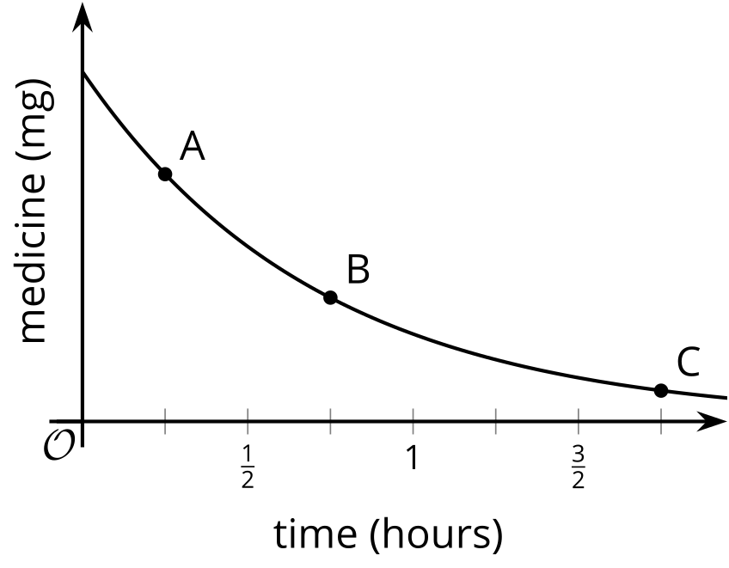
- After $\frac{1}{4}$ hour there are about 7 mg of medicine left. After $\frac{3}{4}$ hour there are about 3.5 mg of medicine left. About how many mg of medicine are left after 1$\frac{3}{4}$ hours? Explain how you know.
- How does the decay rate from $\frac{1}{4}$ hour to $\frac{1}{2}$ hour compare to the decay rate from $\frac{1}{2}$ hour to $\frac{3}{4}$ hour? Explain how you know.

Lesson 5 Summary
Earlier we learned that, for an exponential function, every time the input increases by a certain amount the output changes by a certain factor.
For example, the population of a country, in millions, can be modeled by the exponential function $f\left(c\right)=5⋅{16}^{c}$, where $c$ is time in centuries since 1900. By this model, the growth factor for any one century after the initial measurement is 16.
What about the growth factor for any one decade (one tenth of a century)? Let’s start by finding the growth factors between 1910 and 1920 ($c$ between 0.1 and 0.2) and between 1960 and 1970 ($c$ between 0.6 and 0.7). To do that we can calculate the quotients of the function at those input values.
- from 1910 to 1920: $\frac{f\left(0.2\right)}{f\left(0.1\right)}=\frac{5⋅{16}^{\left(0.2\right)}}{5⋅{16}^{\left(0.1\right)}}$, which equals ${16}^{\left(0.1\right)}$ (or $\sqrt[10]{16}$)
- from 1960 to 1970: $\frac{f\left(0.7\right)}{f\left(0.6\right)}=\frac{5⋅{16}^{\left(0.7\right)}}{5⋅{16}^{\left(0.6\right)}}$, which equals ${16}^{\left(0.1\right)}$ (or $\sqrt[10]{16}$)
Now we can generalize about the growth factor for any one decade using the population $x$ centuries after 1900, $f\left(x\right)$, and the population one decade (one tenth of a century) after that point, $f\left(x+0.1\right)$.
- from $x$ to $\left(x+0.1\right)$: $\frac{f\left(x+0.1\right)}{f\left(x\right)}=\frac{5⋅{16}^{\left(x+0.1\right)}}{5⋅{16}^{x}}$, which also equals ${16}^{\left(0.1\right)}$ (or $\sqrt[10]{16}$)
This is consistent with what we know about how exponential functions change over whole-number intervals: they always increase or decrease by equal factors over equal intervals. This is true even when the intervals are fractional.
© CC BY 2019 by Illustrative Mathematics®

