Unit 7 Lesson 3: Powers of Powers of 10

1 Big Cube (Warm up)

Student Task Statement
What is the volume of a giant cube that measures 10,000 km on each side?

2 Raising Powers of 10 to Another Power

Student Task Statement

  - Complete the table to explore patterns in the exponents when raising a power of 10 to a power. You may skip a single box in the table, but if you do, be prepared to explain why you skipped it.
- expression | - expanded | - single power of 10
- ${\left({10}^{3}\right)}^{2}$ | - $\left(10⋅10⋅10\right)\left(10⋅10⋅10\right)$ | - ${10}^{6}$
- ${\left({10}^{2}\right)}^{5}$ | - $\left(10⋅10\right)\left(10⋅10\right)\left(10⋅10\right)\left(10⋅10\right)\left(10⋅10\right)$
 | - $\left(10⋅10⋅10\right)\left(10⋅10⋅10\right)\left(10⋅10⋅10\right)\left(10⋅10⋅10\right)$
  - ${\left({10}^{4}\right)}^{2}$
  - ${\left({10}^{8}\right)}^{11}$
  - If you chose to skip one entry in the table, which entry did you skip? Why?
- Use the patterns you found in the table to rewrite ${\left({10}^{m}\right)}^{n}$ as an equivalent expression with a single exponent, like 103.
- If you took the amount of oil consumed in 2 months in 2013 worldwide, you could make a cube of oil that measures ${10}^{3}$ meters on each side. How many cubic meters of oil is this? Do you think this would be enough to fill a pond, a lake, or an ocean?

Activity Synthesis
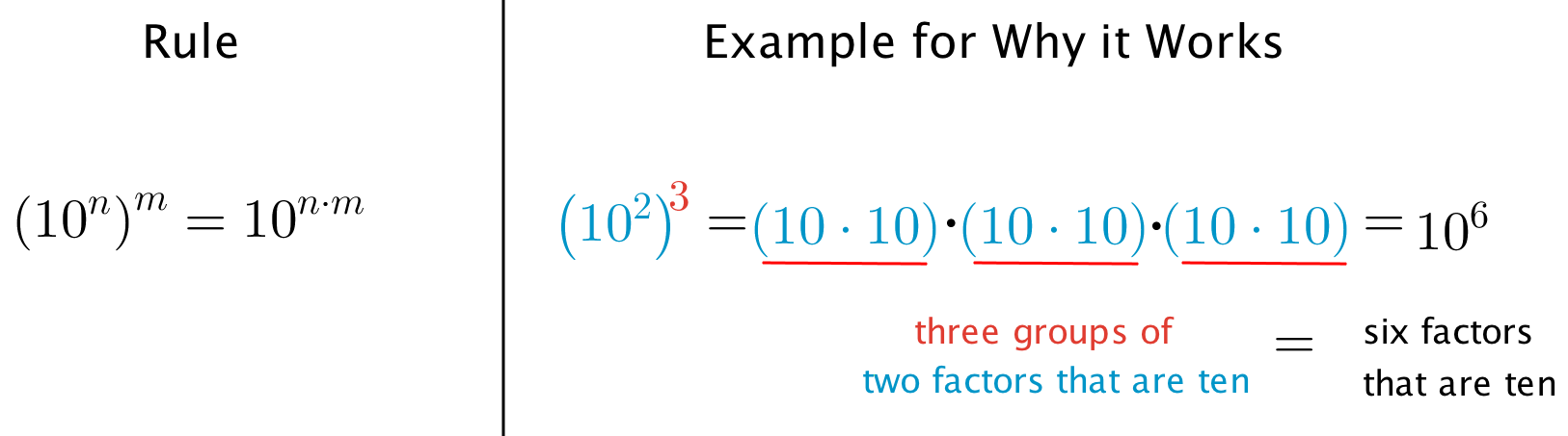

3 How Do the Rules Work?

Student Task Statement
Andre and Elena want to write ${10}^{2}⋅{10}^{2}⋅{10}^{2}$ with a single exponent.
- Andre says, “When you multiply powers with the same base, it just means you add the exponents, so ${10}^{2}⋅{10}^{2}⋅{10}^{2}={10}^{2+2+2}={10}^{6}$.”
- Elena says, “${10}^{2}$ is multiplied by itself 3 times, so ${10}^{2}⋅{10}^{2}⋅{10}^{2}={\left({10}^{2}\right)}^{3}={10}^{2+3}={10}^{5}$.”
Do you agree with either of them? Explain your reasoning.
© CC BY Open Up Resources. Adaptations CC BY IM.

