Unit 2 Lesson 12: Polynomial Division (Part 1)

1 Notice and Wonder: A Different Use for Diagrams (Warm up)

Student Task Statement
What do you notice? What do you wonder?
A. $\left(x−3\right)\left(x+5\right)=x^{2}+2x−15$
 | $x$ | 5
$x$ | $x^{2}$ | $5x$
-3 | $\text{-}3x$ | -15
B. $\left(x−1\right)\left(x^{2}+3x−4\right)=x^{3}+2x^{2}−7x+4$
 | $x^{2}$ | $3x$ | -4
$x$ | $x^{3}$ | $3x^{2}$ | $\text{-}4x$
-1 | $\text{-}x^{2}$ | $\text{-}3x$ | +4
C. $\left(x−2\right)\left(?\right)=\left(x^{3}−x^{2}−4x+4\right)$
$x$ | $x^{3}$
-2

2 Factoring with Diagrams

Student Task Statement
Priya wants to sketch a graph of the polynomial $f$ defined by $f\left(x\right)=x^{3}+5x^{2}+2x−8$. She knows $f\left(1\right)=0$, so she suspects that $\left(x−1\right)$ could be a factor of $x^{3}+5x^{2}+2x−8$ and writes $\left(x^{3}+5x^{2}+2x−8\right)=\left(x−1\right)\left(?x^{2}+?x+?\right)$ and draws a diagram.
$x$ | $x^{3}$
-1
- Finish Priya’s diagram.
- Write $f\left(x\right)$ as the product of $\left(x−1\right)$ and another factor.
- Write $f\left(x\right)$ as the product of three linear factors.
- Make a sketch of $y=f\left(x\right)$.
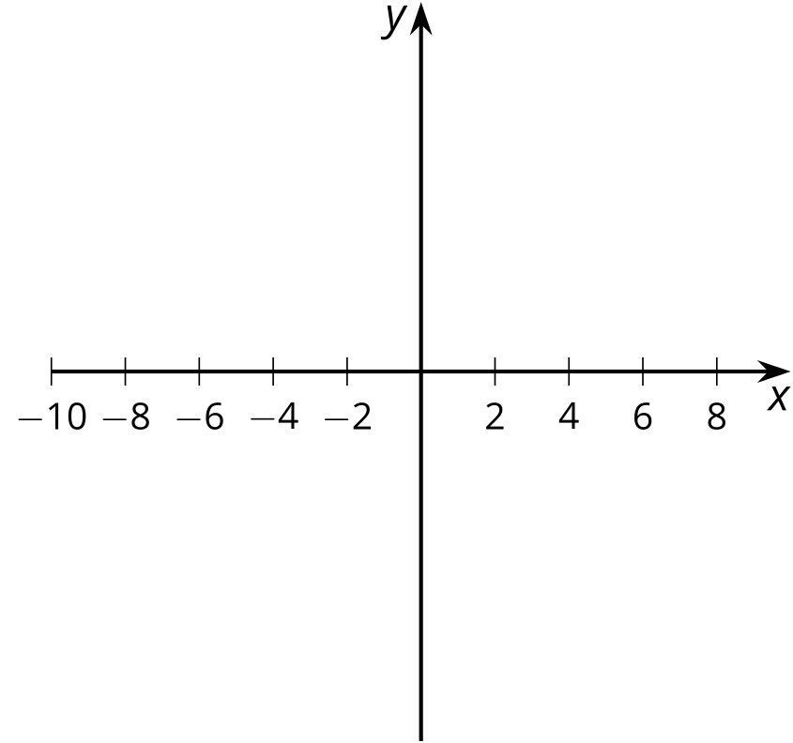

3 More Factoring with Diagrams

Student Task Statement
Here are some polynomial functions with known factors. Rewrite each polynomial as a product of linear factors. Note: you may not need to use all the columns in each diagram. For some problems, you may need to make another diagram.
- $A\left(x\right)=x^{3}−7x^{2}−16x+112$, $\left(x−7\right)$
 | - $x^{2}$
- $x$ | - $x^{3}$ | - 0
- -7 | - $\text{-}7x^{2}$
- $B\left(x\right)=2x^{3}−x^{2}−27x+36$, $\left(x−\frac{3}{2}\right)$
 | - $2x^{2}$
- $x$ | - $2x^{3}$ | - $2x^{2}$
- $\text{-}\frac{3}{2}$ | - $\text{-}3x^{2}$
- $C\left(x\right)=x^{3}−3x^{2}−13x+15$, $\left(x+3\right)$
- $x$
- 3
- $D\left(x\right)=x^{4}−13x^{2}+36$, $\left(x−2\right)$, $\left(x+2\right)$
- (Hint: $x^{4}−13x^{2}+36=x^{4}+0x^{3}−13x^{2}+0x+36$)
- $F\left(x\right)=4x^{4}−15x^{3}−48x^{2}+109x+30$, $\left(x−5\right)$, $\left(x−2\right)$, $\left(x+3\right)$
© CC BY 2019 by Illustrative Mathematics®

