Lesson 15 Practice Problems
- For each figure, identify any lines of symmetry the figure has.
- 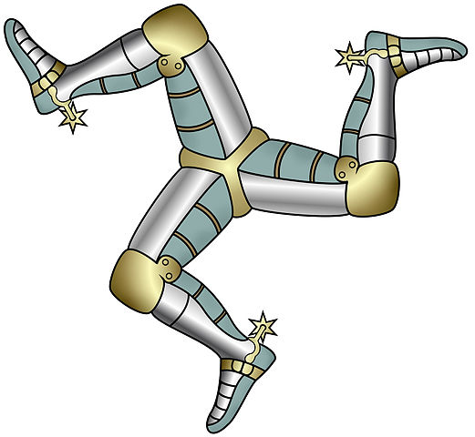

- In quadrilateral $BADC$, $AB=AD$ and $BC=DC$. The line $AC$ is a line of symmetry for this quadrilateral.
- 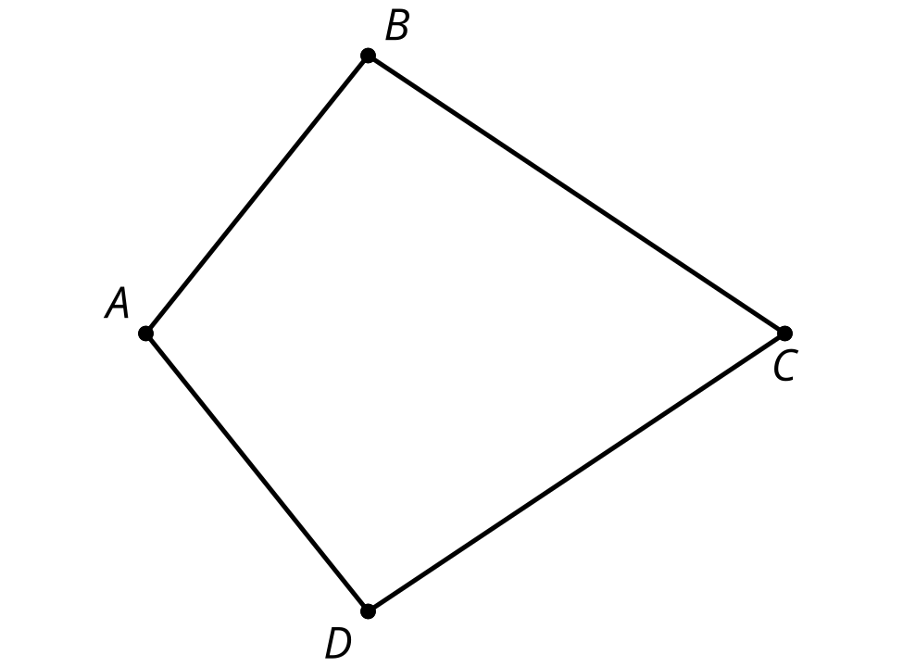
  - Based on the line of symmetry, explain why the diagonals $AC$ and $BD$ are perpendicular.
  - Based on the line of symmetry, explain why angles $ABC$ and $ADC$ have the same measure.
- Three line segments form the letter Z. Rotate the letter Z counterclockwise around the midpoint of segment $BC$ by 180 degrees. Describe the result.
- 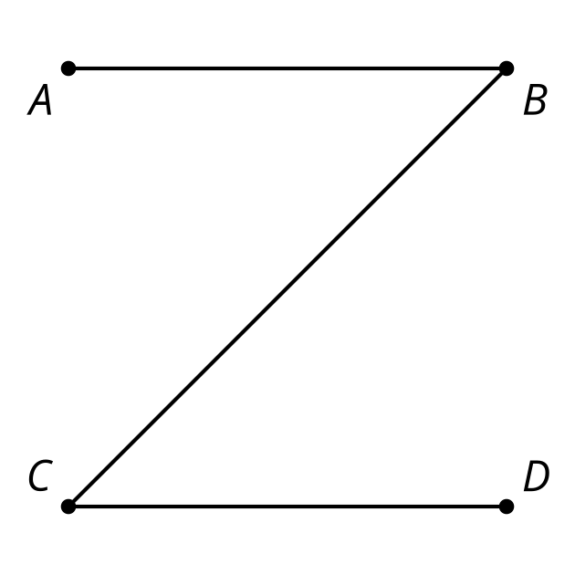
- (From Unit 1, Lesson 14.)
- There is a square, $ABCS$, inscribed in a circle with center $D$. What is the smallest angle we can rotate around $D$ so that the image of $A$ is $B$?
  - ${45}^{∘}$
  - ${60}^{∘}$
  - ${90}^{∘}$
  - ${180}^{∘}$
- (From Unit 1, Lesson 14.)
- Points $A$, $B$, $C$, and $D$ are vertices of a square. Point $E$ is inside the square. Explain how to tell whether point $E$ is closer to $A$, $B$, $C$, or $D$.
- (From Unit 1, Lesson 9.)
- Lines $ℓ$ and $m$ are perpendicular.
- Sometimes reflecting a point over $m$ has the same effect as rotating the point 180 degrees using center $P$. Select all labeled points which have the same image for both transformations.

- $m⊥ℓ$
- 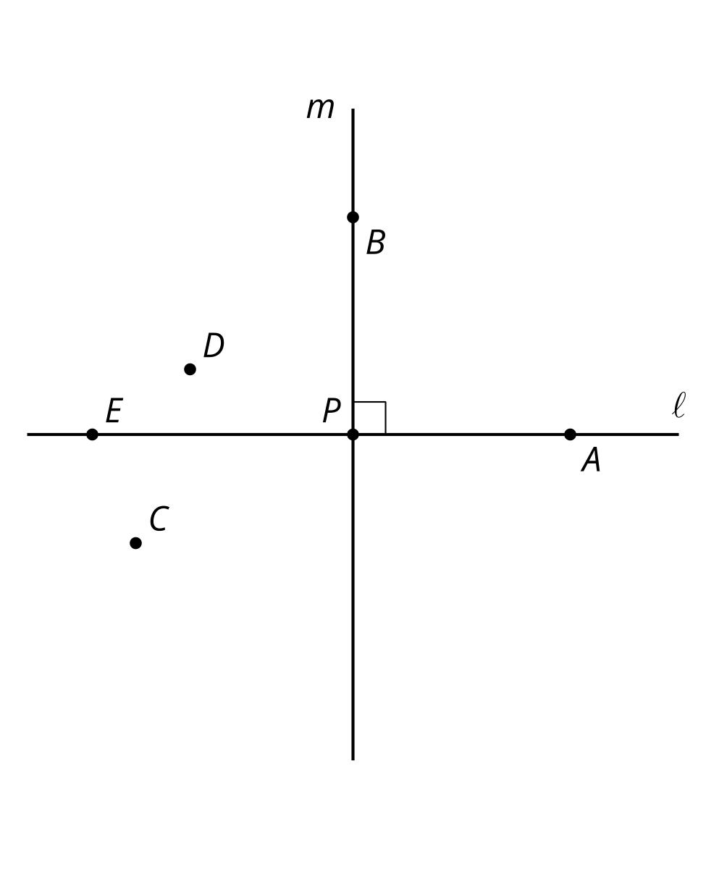
  - A
  - B
  - C
  - D
  - E
- (From Unit 1, Lesson 11.)
- Here is triangle $POG$. Match the description of the rotation with the image of $POG$ under that rotation.
- 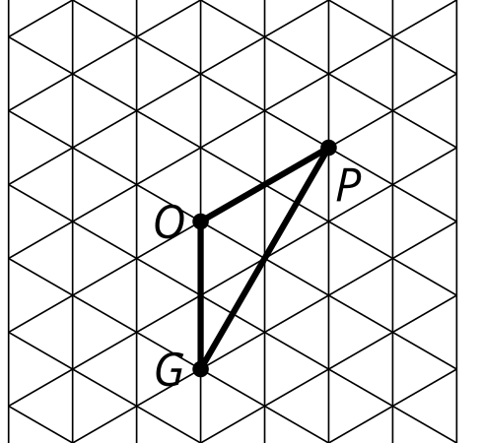
  - Rotate 60 degrees clockwise around $O$.
  - Rotate 120 degrees clockwise around $O$.
  - Rotate 60 degrees counterclockwise around $O$.
  - Rotate 60 degrees clockwise around $P$.
  - 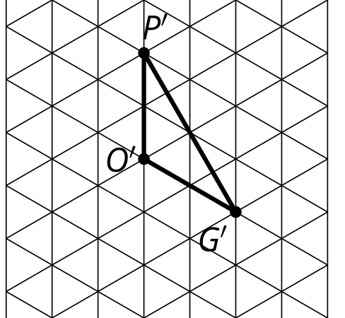
  - 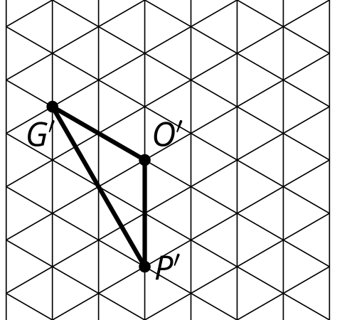
  - 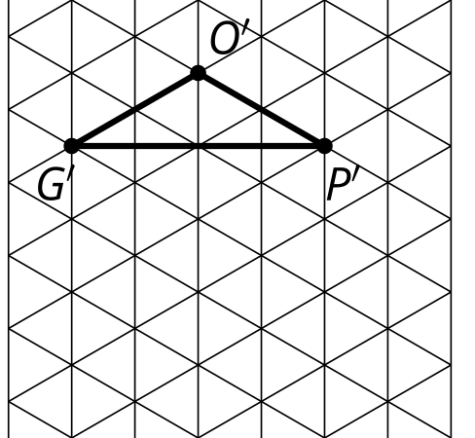
  - 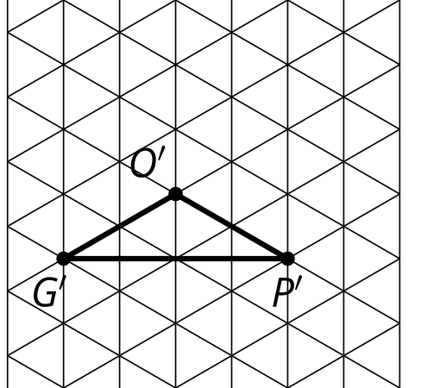
- (From Unit 1, Lesson 13.)
© CC BY 2019 by Illustrative Mathematics®

