Unit 5 Lesson 11: Making a Model for Data

1 What Function Could It Be? (Warm up)

Student Task Statement
What do you notice? What do you wonder?
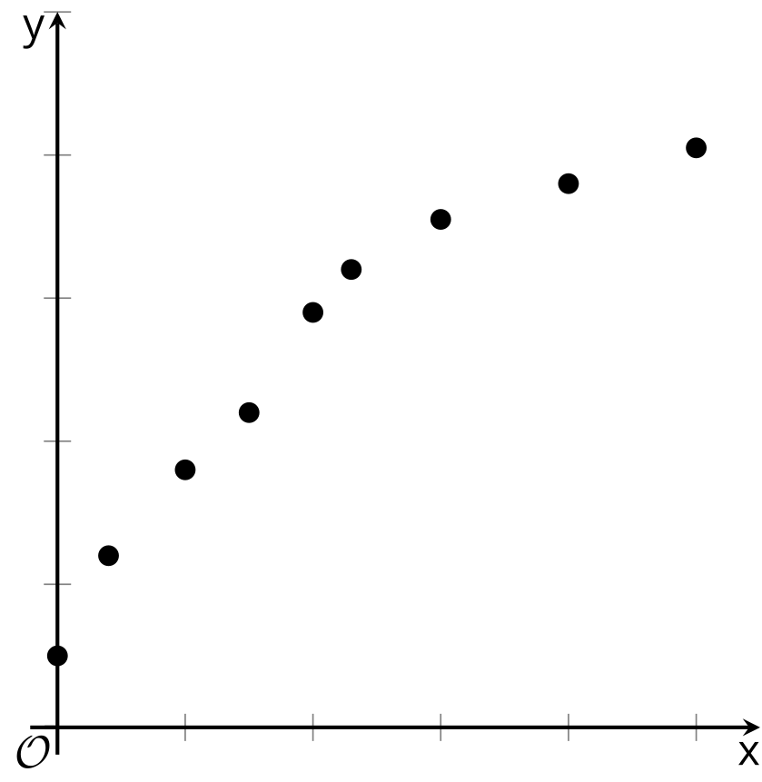

2 Heating Up

Student Task Statement
Here is a graph of data showing the temperature of a bottle of water after it has been removed from the refrigerator.
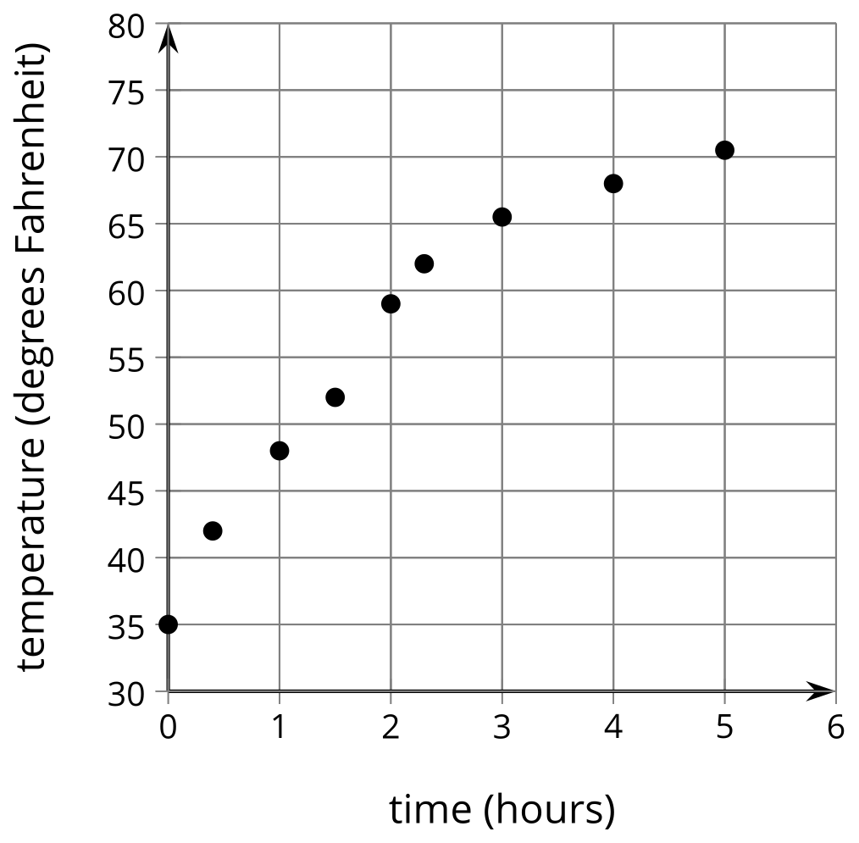
For the function types assigned by your teacher:
- Apply a sequence of transformations to your function so that it matches the data as well as possible.
- How well does your model fit the data? Make adjustments as needed.

Images for Activity Synthesis
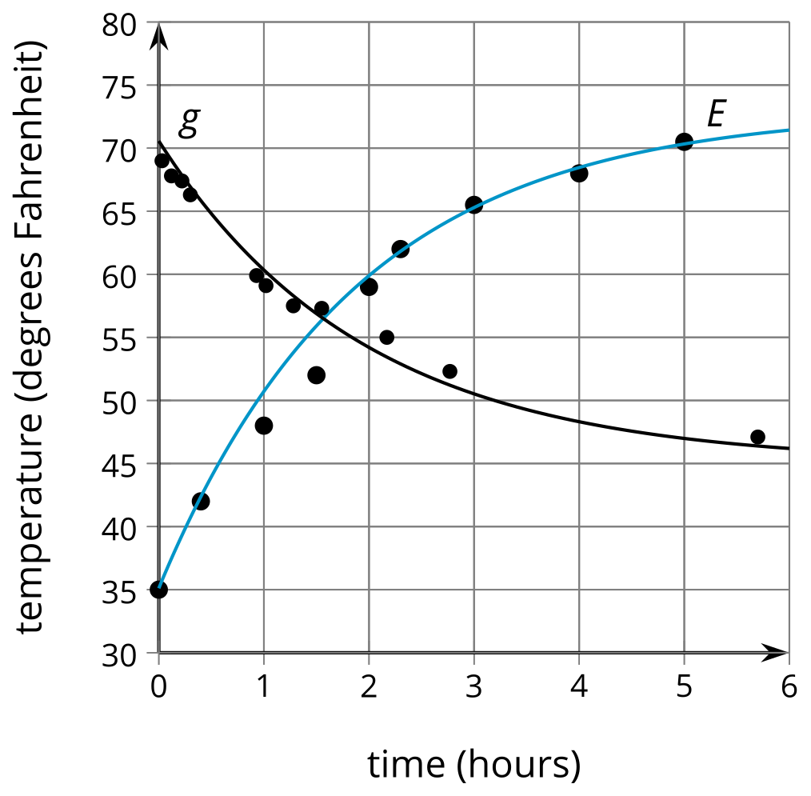
© CC BY 2019 by Illustrative Mathematics®

