Lesson 2: Mixtures
Let's explore how recipes and ratios are related.

2.1: Flower Pattern
This flower is made up of yellow hexagons, red trapezoids, and green triangles.
- Write sentences to describe the ratios of the shapes that make up this pattern.
- How many of each shape would be in two copies of this flower pattern?

2.2: Powdered Drink Mix
Here are diagrams representing three mixtures of powdered drink mix and water:
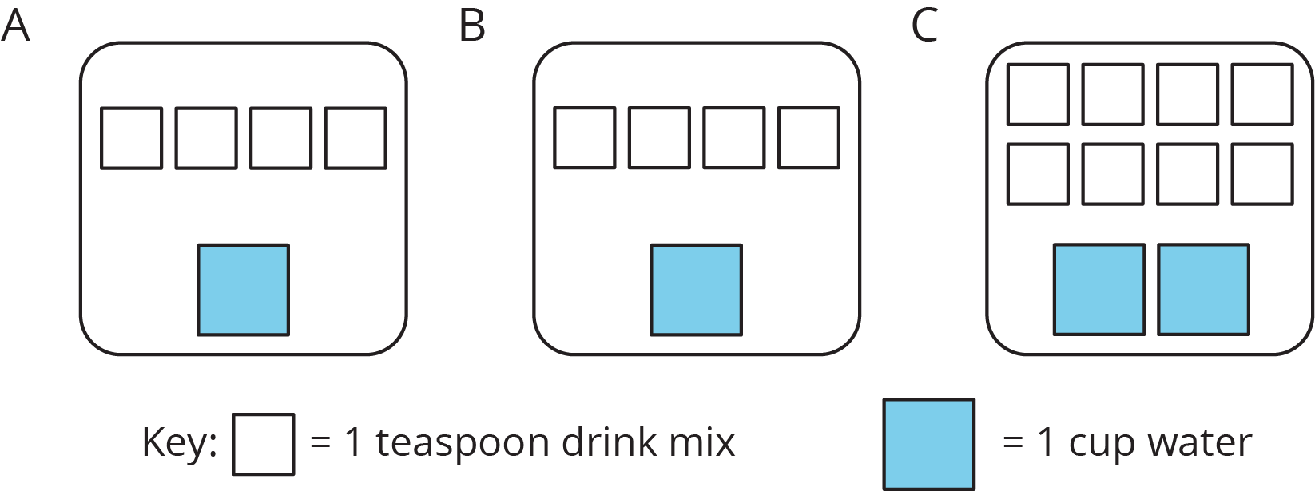
- How would the taste of Mixture A compare to the taste of Mixture B?
- Use the diagrams to complete each statement:
  - Mixture B uses ______ cups of water and ______ teaspoons of drink mix. The ratio of cups of water to teaspoons of drink mix in Mixture B is ________.
  - Mixture C uses ______ cups of water and ______ teaspoons of drink mix. The ratio of cups of water to teaspoons of drink mix in Mixture C is ________.
- How would the taste of Mixture B compare to the taste of Mixture C?

Are you ready for more?
Sports drinks use sodium (better known as salt) to help people replenish electrolytes. Here are the nutrition labels of two sports drinks.
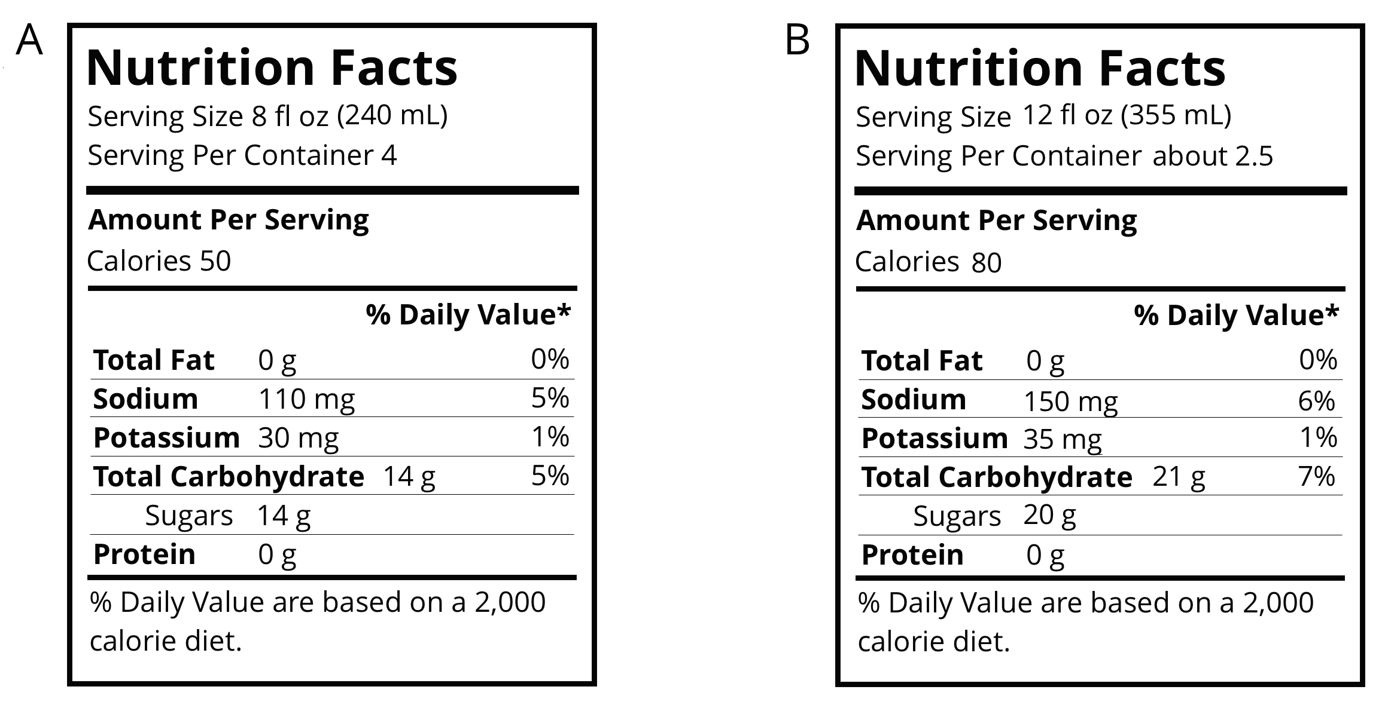
- Which of these drinks is saltier? Explain how you know.
- If you wanted to make sure a sports drink was less salty than both of the ones given, what ratio of sodium to water would you use?

2.3: Batches of Cookies
A recipe for one batch of cookies calls for 5 cups of flour and 2 teaspoons of vanilla.
- Draw a diagram that shows the amount of flour and vanilla needed for two batches of cookies.
- How many batches can you make with 15 cups of flour and 6 teaspoons of vanilla? Show the additional batches by adding more ingredients to your diagram.
- How much flour and vanilla would you need for 5 batches of cookies?
- Whether the ratio of cups of flour to teaspoons of vanilla is $5:2$, $10:4$, or $15:6$, the recipes would make cookies that taste the same. We call these equivalent ratios.
  - Find another ratio of cups of flour to teaspoons of vanilla that is equivalent to these ratios.
  - How many batches can you make using this new ratio of ingredients?

Lesson 2 Summary
When mixing colors, doubling or tripling the amount of each color will create the same shade of the mixed color. In fact, you can always multiply the amount of each color by the same number to create a different amount of the same mixed color.
For example, a batch of dark orange paint uses 4 ml of red paint and 2 ml of yellow paint.
- To make two batches of dark orange paint, we can mix 8 ml of red paint with 4 ml of yellow paint.
- To make three batches of dark orange paint, we can mix 12 ml of red paint with 6 ml of yellow paint.
Here is a diagram that represents 1, 2, and 3 batches of this recipe.
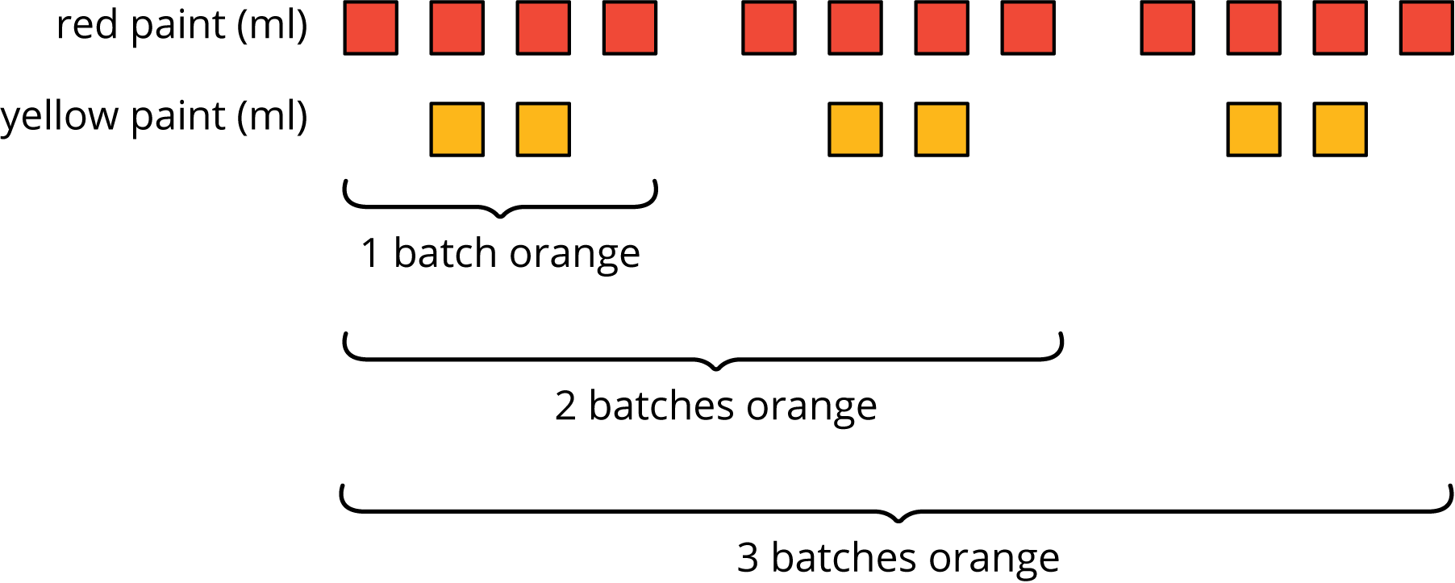
We say that the ratios $4:2$, $8:4$, and $12:6$ are equivalent because they describe the same color mixture in different numbers of batches, and they make the same shade of orange.
© CC BY Open Up Resources. Adaptations CC BY IM.

