Unit 7 Lesson 4 Cumulative Practice Problems
- $M$ is a point on line segment $KL$. $NM$ is a line segment. Select all the equations that represent the relationship between the measures of the angles in the figure.
- 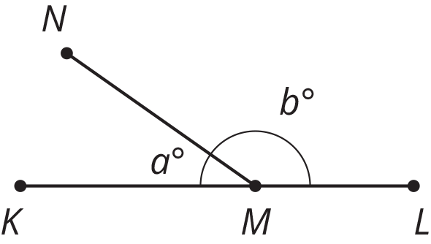
  - $a=b$
  - $a+b=90$
  - $b=90−a$
  - $a+b=180$
  - $180−a=b$
  - $180=b−a$
- Which equation represents the relationship between the angles in the figure?
- 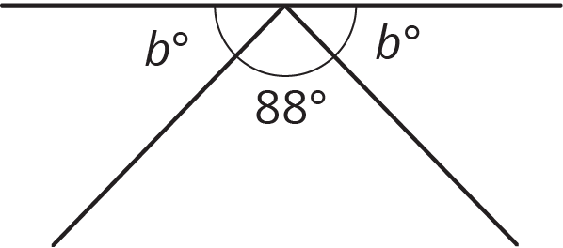
  - $88+b=90$
  - $88+b=180$
  - $2b+88=90$
  - $2b+88=180$
- Segments $AB$, $EF$, and $CD$ intersect at point $C$, and angle $ACD$ is a right angle. Find the value of $g$.
- 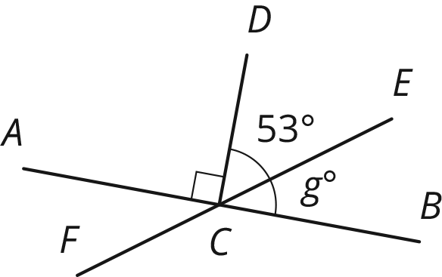
- Select all the expressions that are the result of decreasing $x$ by 80%.
  - $\frac{20}{100}x$
  - $x−\frac{80}{100}x$
  - $\frac{100−20}{100}x$
  - $0.80x$
  - $(1−0.8)x$
- (From Unit 6, Lesson 12.)
- Andre is solving the equation $4(x+\frac{3}{2})=7$. He says, “I can subtract $\frac{3}{2}$ from each side to get $4x=\frac{11}{2}$ and then divide by 4 to get $x=\frac{11}{8}$.” Kiran says, “I think you made a mistake.”
  - How can Kiran know for sure that Andre’s solution is incorrect?
  - Describe Andre’s error and explain how to correct his work.
- (From Unit 6, Lesson 8.)
- Solve each equation.
- $\frac{1}{7}a+\frac{3}{4}=\frac{9}{8}$
- $\frac{2}{3}+\frac{1}{5}b=\frac{5}{6}$
- $\frac{3}{2}=\frac{4}{3}c+\frac{2}{3}$
- $0.3d+7.9=9.1$
- $11.03=8.78+0.02e$
- (From Unit 6, Lesson 7.)
- A train travels at a constant speed for a long distance. Write the two constants of proportionality for the relationship between distance traveled and elapsed time. Explain what each of them means.
- time elapsed (hr) | - distance (mi)
- 1.2 | - 54
- 3 | - 135
- 4 | - 180
- (From Unit 2, Lesson 5.)
© CC BY Open Up Resources. Adaptations CC BY IM.

