Lesson 9 Practice Problems
- Technology required. Ramps in a parking garage need to be both steep and safe. The maximum safe incline for a ramp is 8.5 degrees. Is this ramp safe? If not, provide dimensions that would make the ramp safe.
- 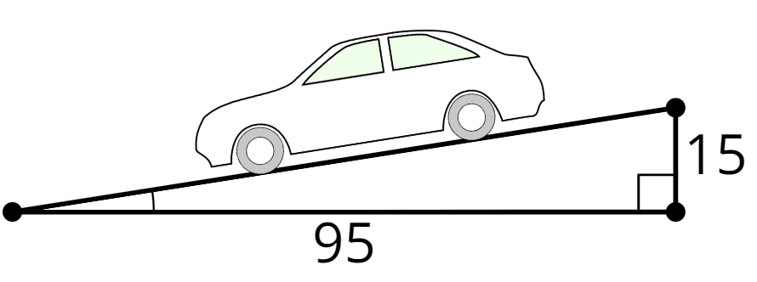
- Technology required. $ABCD$ is a rectangle. Find the length of $AC$ and the measures of $α$ and $θ$.
- 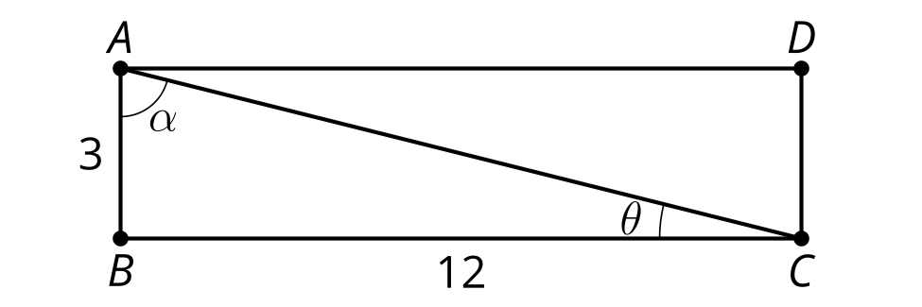
- Technology required. Find the missing measurements.
- 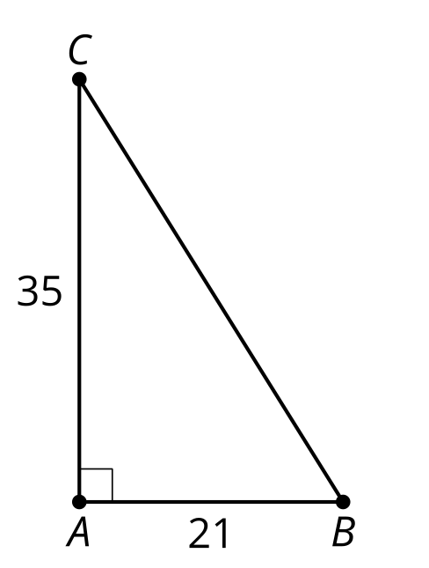
- Select all the true equations:
- 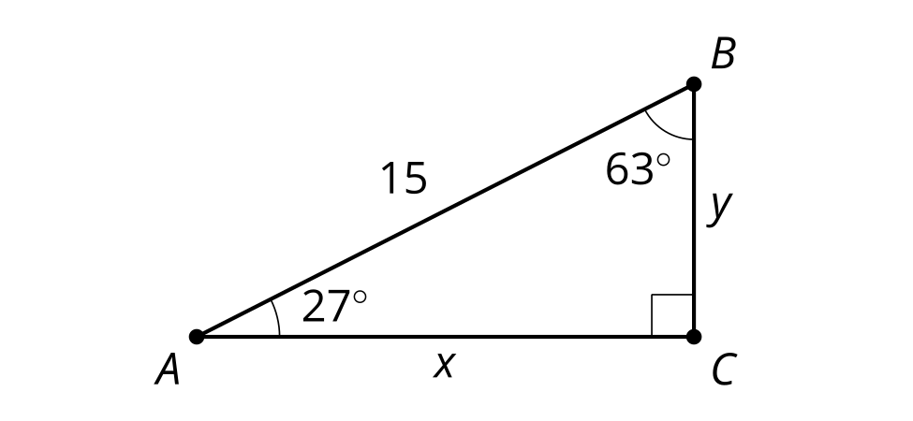
  - $sin\left(27\right)=\frac{x}{15}$
  - $cos\left(63\right)=\frac{y}{15}$
  - $tan\left(27\right)=\frac{y}{x}$
  - $sin\left(63\right)=\frac{x}{15}$
  - $tan\left(63\right)=\frac{y}{x}$
- (From Unit 4, Lesson 8.)
- What value of $θ$ makes this equation true? $sin\left(30\right)=cos\left(θ\right)$
  - -30
  - 30
  - 60
  - 180
- (From Unit 4, Lesson 8.)
- A rope with a length of 3.5 meters is tied from a stake in the ground to the top of a tent. It forms a 17 degree angle with the ground. How tall is the tent?
  - $3.5tan\left(17\right)$
  - $3.5cos\left(17\right)$
  - $3.5sin\left(17\right)$
  - $\frac{sin\left(17\right)}{3.5}$
- (From Unit 4, Lesson 7.)
- Technology required. What is the value of $x$?
- 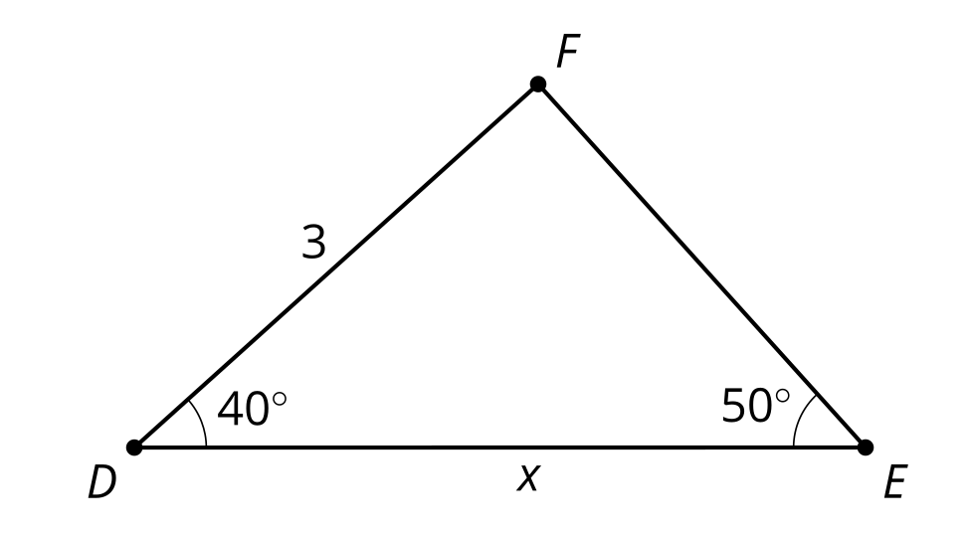
- (From Unit 4, Lesson 6.)
- Find the missing side in each triangle using any method. Check your answers using a different method.
- 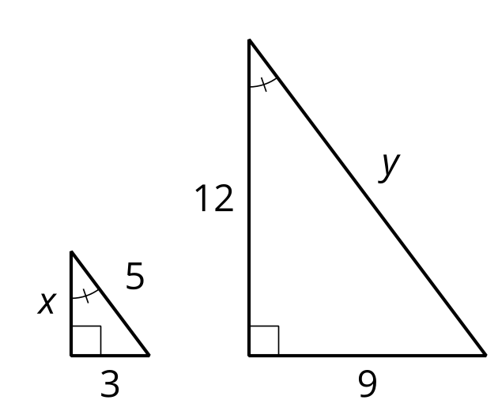
- (From Unit 4, Lesson 1.)
- The triangles are congruent. Write a sequence of rigid motions that takes triangle $XYZ$ onto triangle $BCA$.
- 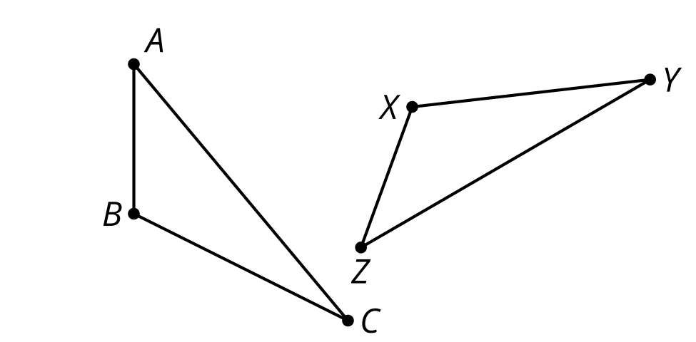
- (From Unit 2, Lesson 3.)
© CC BY 2019 by Illustrative Mathematics®

