Lesson 1: What Attributes Do You See?
- Let’s sort shapes into groups.

Warm-up: Which One Doesn’t Belong: Who’s in the Group?
Which one doesn’t belong?
A
B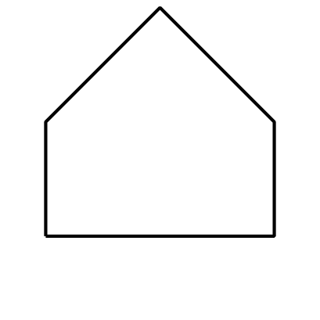
C
D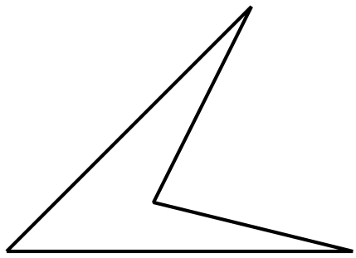

1.1: Card Sort: Shapes
Your teacher will give you a set of cards that show shapes.
- Work with your partner to sort the cards into categories. Be prepared to explain your categories.
- Take turns sorting the cards into two new categories. Don’t tell your partner how you sorted them. Your partner will then guess how you sorted your shapes.
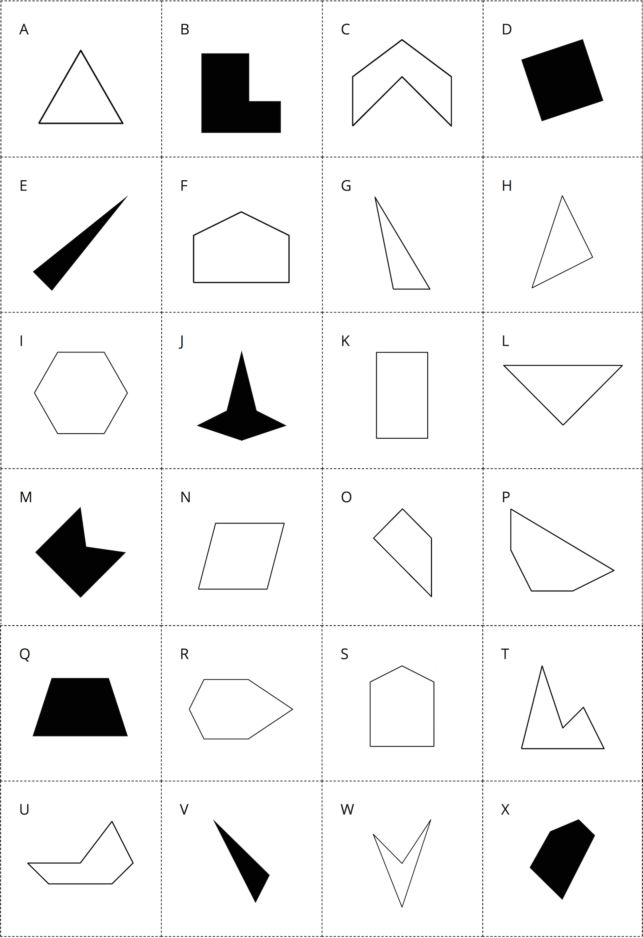
© CC BY 2021 Illustrative Mathematics®

