Unit 8 Lesson 6: A Proof of the Pythagorean Theorem

1 Notice and Wonder: A Square and Four Triangles (Warm up)

Student Task Statement
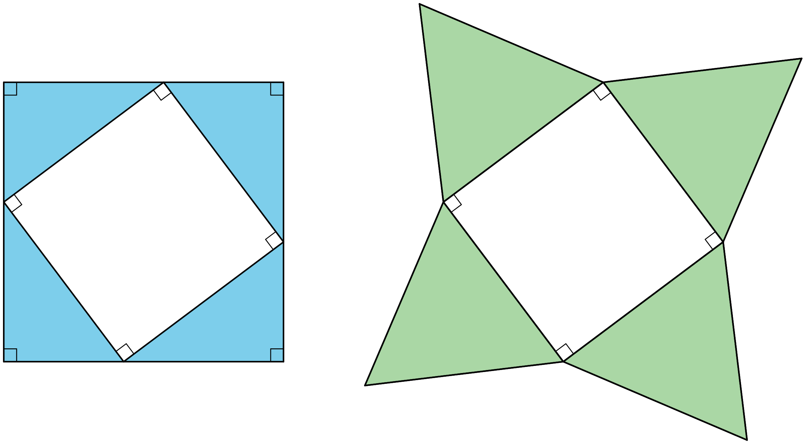
What do you notice? What do you wonder?

2 Adding Up Areas

Student Task Statement
Both figures shown here are squares with a side length of $a+b$. Notice that the first figure is divided into two squares and two rectangles. The second figure is divided into a square and four right triangles with legs of lengths $a$ and $b$. Let’s call the hypotenuse of these triangles $c$.
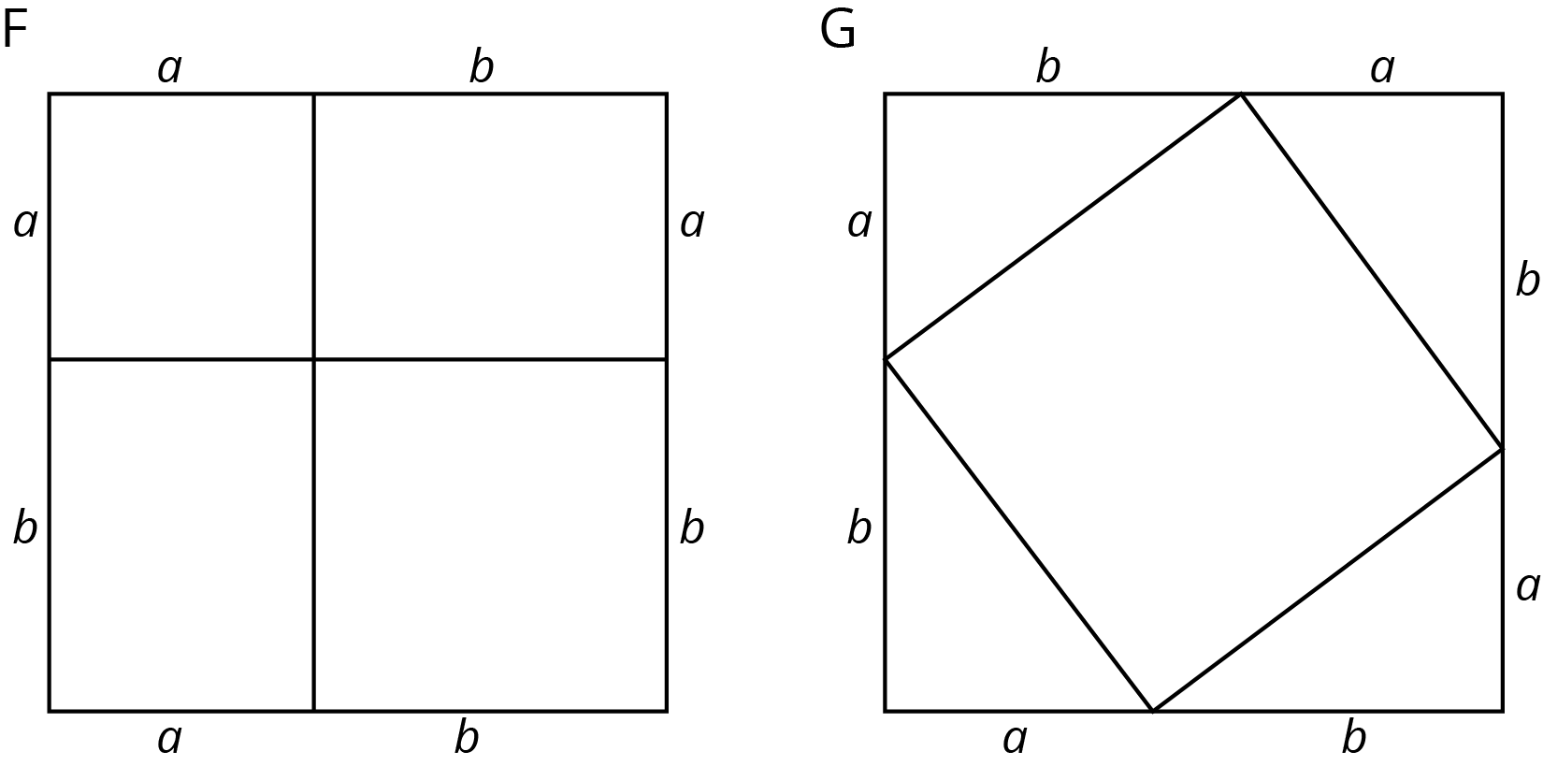
- What is the total area of each figure?
- Find the area of each of the 9 smaller regions shown the figures and label them.
- Add up the area of the four regions in Figure F and set this expression equal to the sum of the areas of the five regions in Figure G. If you rewrite this equation using as few terms as possible, what do you have?

Activity Synthesis
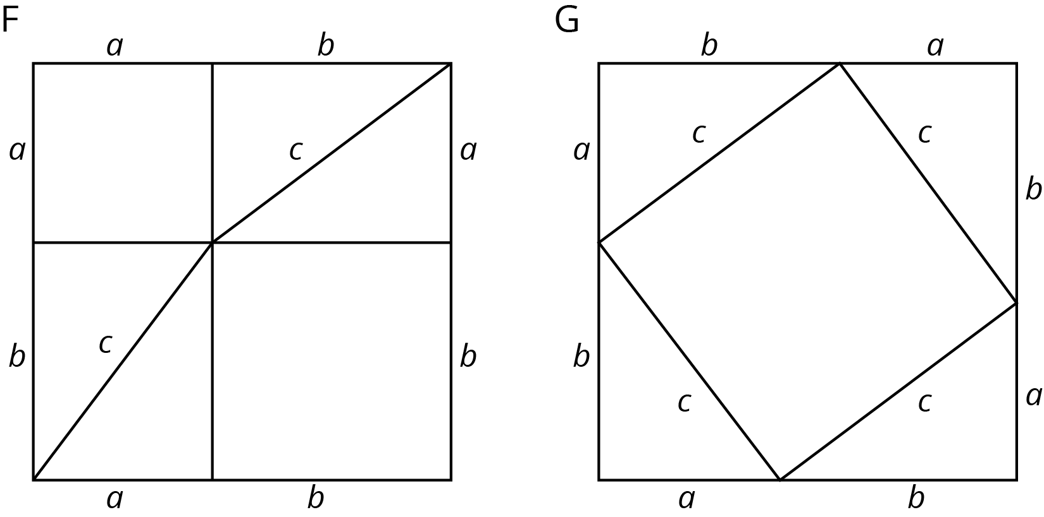

3 Find the Missing Side Lengths

Student Task Statement
- Find $c$.
- 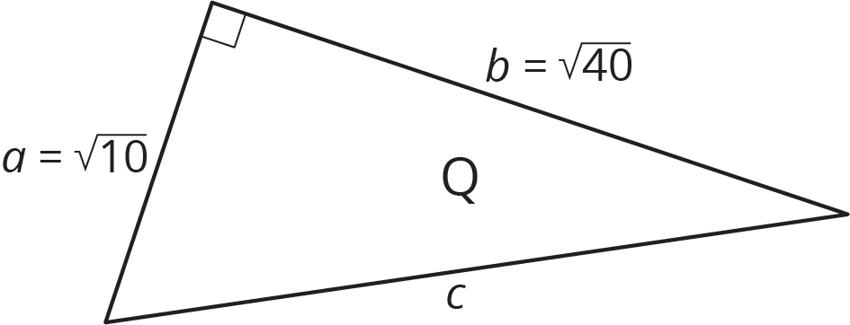

- Find $b$.
- 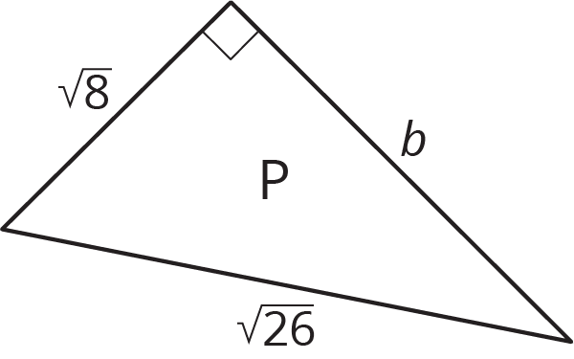
- A right triangle has sides of length 2.4 cm and 6.5 cm. What is the length of the hypotenuse?
- A right triangle has a side of length $\frac{1}{4}$ and a hypotenuse of length $\frac{1}{3}$. What is the length of the other side?
- Find the value of $x$ in the figure.
- 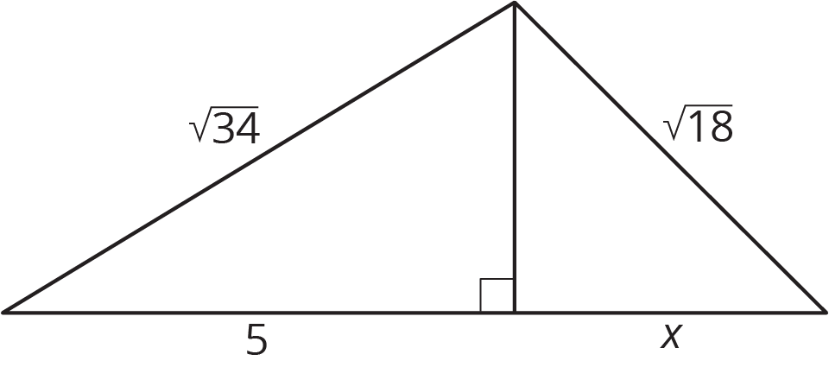

4 A Transformational Proof (Optional)

Student Task Statement
Your teacher will give your group a sheet with 4 figures and a set of 5 cut out shapes labeled D, E, F, G, and H.
- Arrange the 5 cut out shapes to fit inside Figure 1. Check to see that the pieces also fit in the two smaller squares in Figure 4.
- Explain how you can transform the pieces arranged in Figure 1 to make an exact copy of Figure 2.
- Explain how you can transform the pieces arranged in Figure 2 to make an exact copy of Figure 3.
- Check to see that Figure 3 is congruent to the large square in Figure 4.
- If the right triangle in Figure 4 has legs $a$ and $b$ and hypotenuse $c$, what have you just demonstrated to be true?
© CC BY Open Up Resources. Adaptations CC BY IM.

