Lesson 10 Practice Problems
- Here are 4 triangles that have each been transformed by a different transformation. Which transformation is not a rigid transformation?
  - 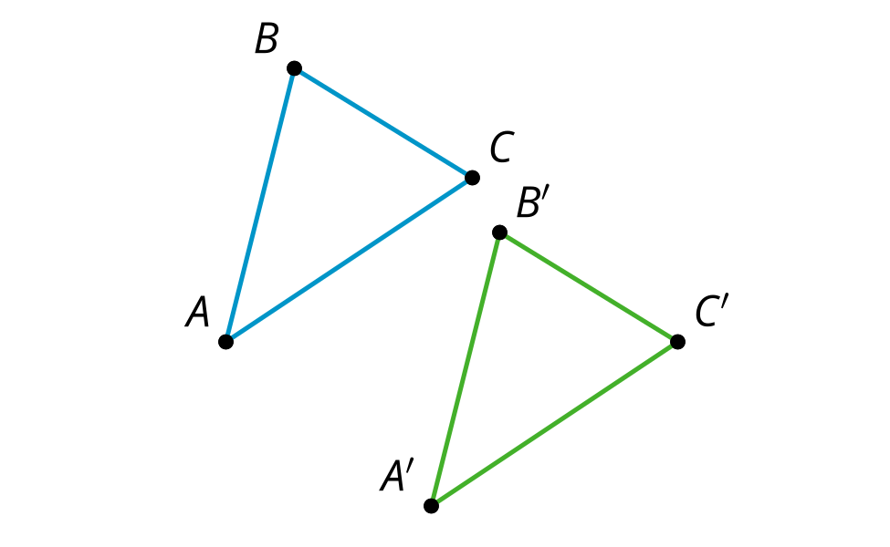
  - 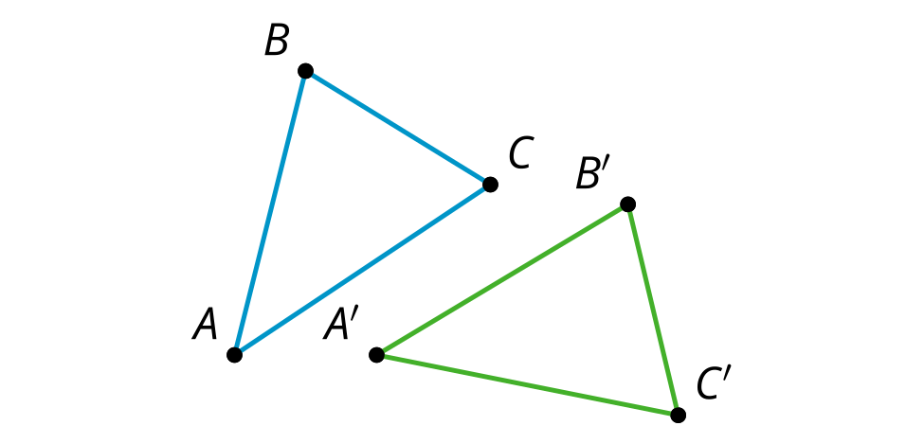
  - 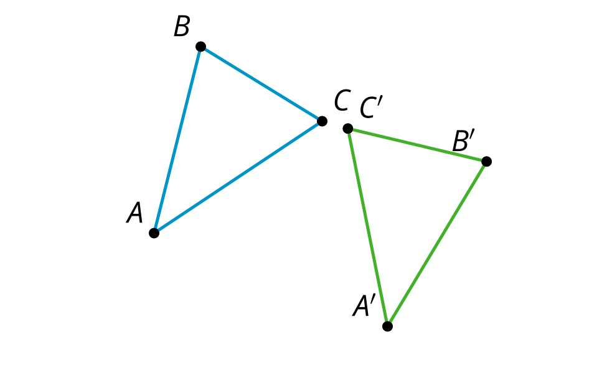
  - 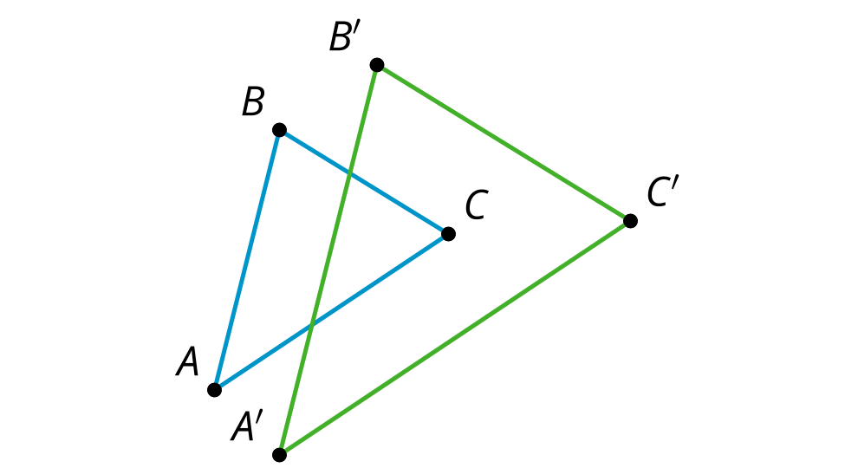
- What is the definition of congruence?
  - If two figures have the same shape, then they are congruent.
  - If two figures have the same area, then they are congruent.
  - If there is a sequence of transformations taking one figure to another, then they are congruent.
  - If there is a sequence of rotations, reflections, and translations that take one figure to the other, then they are congruent.
- There is a sequence of rigid transformations that takes $A$ to $A^{′}$, $B$ to $B^{′}$, and $C$ to $C^{′}$. The same sequence takes $D$ to $D^{′}$. Draw and label $D^{′}$:
- 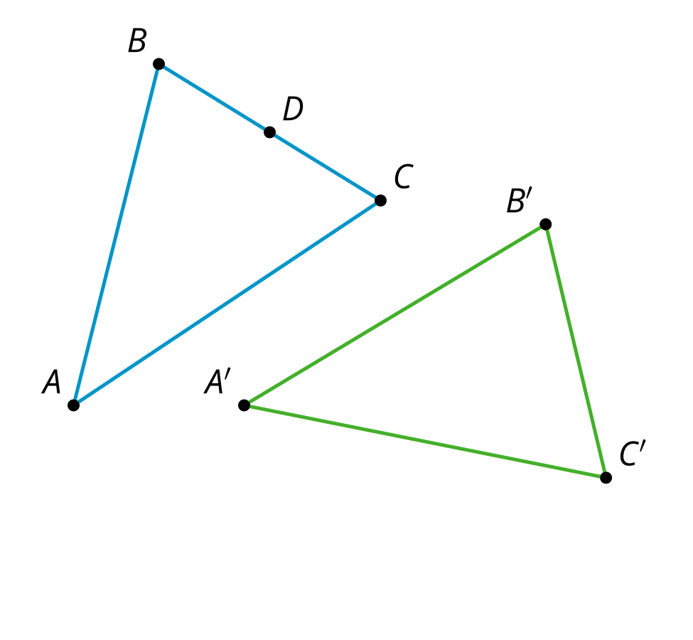
- Three schools are located at points $A$, $B$, and $C$. The school district wants to locate its new stadium at a location that will be roughly the same distance from all 3 schools. Where should they build the stadium? Explain or show your reasoning.
- 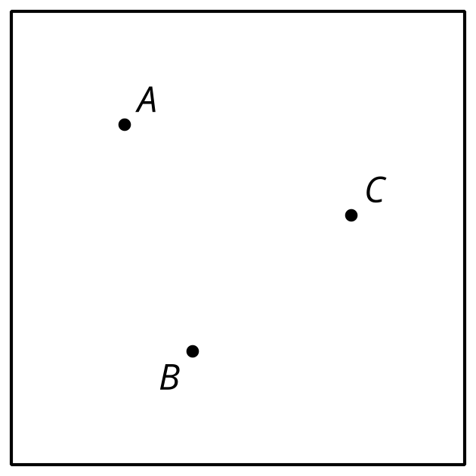
- (From Unit 1, Lesson 9.)
- To construct a line passing through point $C$ that is parallel to the line $AB$, Han constructed the perpendicular bisector of $AB$ and then drew line $CD$.
- 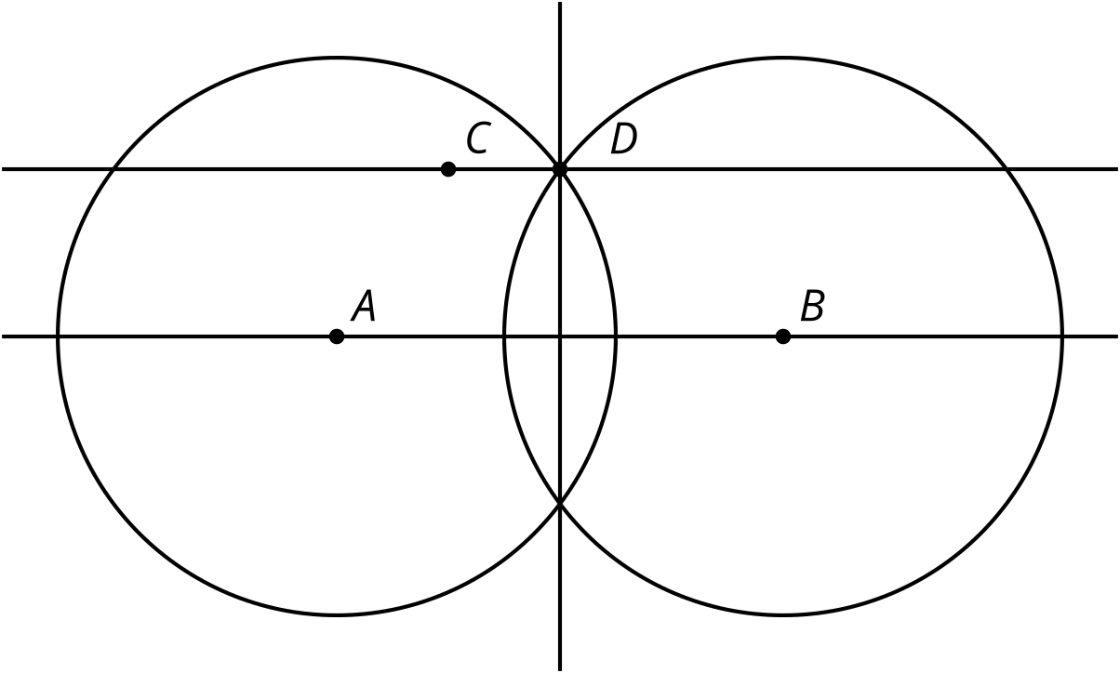
- Is $CD$ guaranteed to be parallel to $AB$? Explain how you know.
- (From Unit 1, Lesson 6.)
- This diagram is a straightedge and compass construction of a line perpendicular to line $AB$ passing through point $C$. Select all the statements that must be true.
- 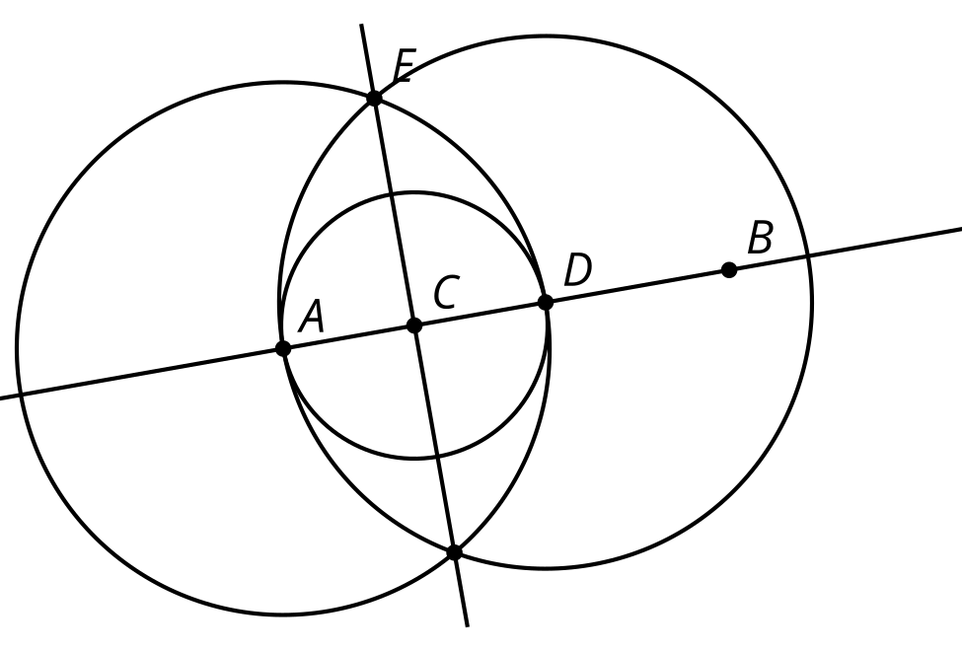
  - $AD=BD$
  - $EC=AD$
  - $AC=DC$
  - $EA=ED$
  - $ED=DB$
  - $CB=AD$
- (From Unit 1, Lesson 5.)
© CC BY 2019 by Illustrative Mathematics®

