Lesson 3: Understanding Rational Inputs
- Let’s look at exponential functions where the input values are not whole numbers.

3.1: Keeping Equations True
- Select all solutions to $x⋅x=5$. Be prepared to explain your reasoning.
  - $\frac{1}{25}$
  - $\sqrt{5}$
  - $\frac{5}{2}$
  - $5^{\frac{1}{2}}$
  - $\frac{\sqrt{5}}{2}$
  - $\sqrt{25}$
- Select all solutions to $p⋅p⋅p=10$. Be prepared to explain your reasoning.
  - ${10}^{\frac{1}{3}}$
  - $\sqrt{10}$
  - $\frac{10}{3}$
  - $\frac{\sqrt{10}}{3}$
  - $\sqrt[3]{10}$
  - $\frac{1}{3}\sqrt{10}$

3.2: Florida in the 1800’s
In 1840, the population of Florida was about 54,500. Between 1840 and 1860, the population grew exponentially, increasing by about 60% each decade.
- Find the population of Florida in 1850 and in 1860 according to this model.
- The population is a function $f$ of the number of decades $d$ after 1840. Write an equation for $f$.

  - Explain what $f\left(0.5\right)$ means in this situation.
  - Graph your function using graphing technology and estimate the value of $f\left(0.5\right)$.
  - Explain why we can find the value of $f\left(0.5\right)$ by multiplying 54,500 by $\sqrt{1.6}$. Find that value.
- Based on the model, what was the population of Florida in 1858? Show your reasoning.

Are you ready for more?
Andre said, “The population of Florida increased by the same percentage between 1842 and 1852 and between 1847 and 1857.” Do you agree with his statement? Explain or show your reasoning.

3.3: Disappearing Medicine
The amount of a medicine in the bloodstream of a patient decreases roughly exponentially. Here is a graph representing $f$, an exponential function that models the medicine in the body of a patient, $t$ hours after an injection is given.
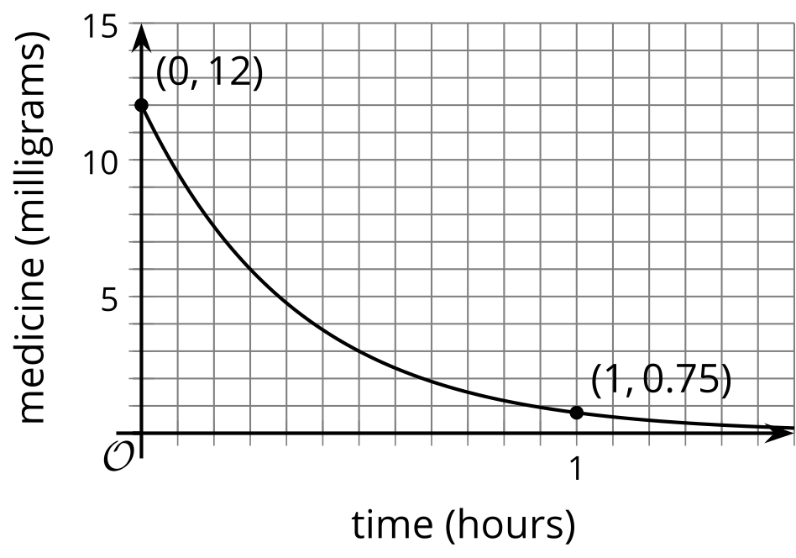
- Use the graph to estimate $f\left(\frac{1}{3}\right)$ and explain what it tells us in this situation.
- After one hour, 0.75 mg of medicine remains in the bloodstream. Find an equation that defines $f$.

Are you ready for more?
By what percentage does the amount of medicine in the body decay every 10 minutes? Explain or show your reasoning.

Lesson 3 Summary
Some exponential functions can have inputs that are any numbers on the number line, not just integers.
Suppose the area of a pond covered by algae $A$, in square meters, is modeled by $A=200⋅{\left(\frac{1}{2}\right)}^{w}$ where $w$ is the number of weeks since a treatment was applied to the pond. How could we use this equation to determine the area covered after 1 day?
Well, since $w=1$ is one week and each week has 7 days, $w=\frac{1}{7}$ is 1 day. So after 1 day, the algae covers $200{\left(\frac{1}{2}\right)}^{\frac{1}{7}}$ square meters, or about 181 square meters. Using a calculator, we know that the expression ${\left(\frac{1}{2}\right)}^{\frac{1}{7}}$, which is equivalent to $\sqrt[7]{\frac{1}{2}}$, is about about 0.906. This means that after 1 day, only 91% of the algae from the previous day remains.
This information can also be seen on a graph representing the area. The point at $\left(1,100\right)$ marks the area covered by the algae after 1 week. Point $P$ marks the covered area after $\frac{1}{7}$ of a week or one day.
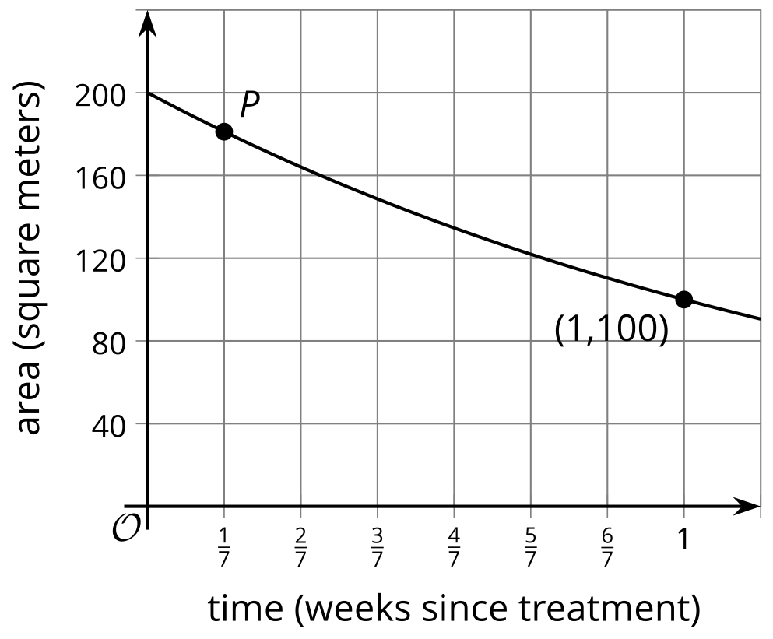
The graph can be used to estimate the vertical coordinate of $P$ and shows that it is close to 180.
© CC BY 2019 by Illustrative Mathematics®

