Lesson 16 Practice Problems
- Each student in a class recorded how many books they read during the summer. Here is a box plot that summarizes their data.
- 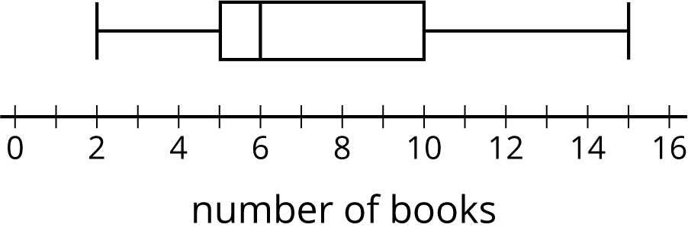
  - What is the greatest number of books read by a student in this group?
  - What is the median number of books read by the students?
  - What is the interquartile range (IQR)?
- Use this five-number summary to draw a box plot. All values are in seconds.
  - Minimum: 40
  - First quartile (Q1): 45
  - Median: 48
  - Third quartile (Q3): 50
  - Maximum: 60
- The data shows the number of hours per week that each of 13 seventh-grade students spent doing homework. Create a box plot to summarize the data.
- 3 | - 10 | - 12 | - 4 | - 7 | - 9 | - 5 | - 5
- 11 | - 11 | - 5 | - 12 | - 11

- The box plot displays the data on the response times of 100 mice to seeing a flash of light. How many mice are represented by the rectangle between 0.5 and 1 second?
- 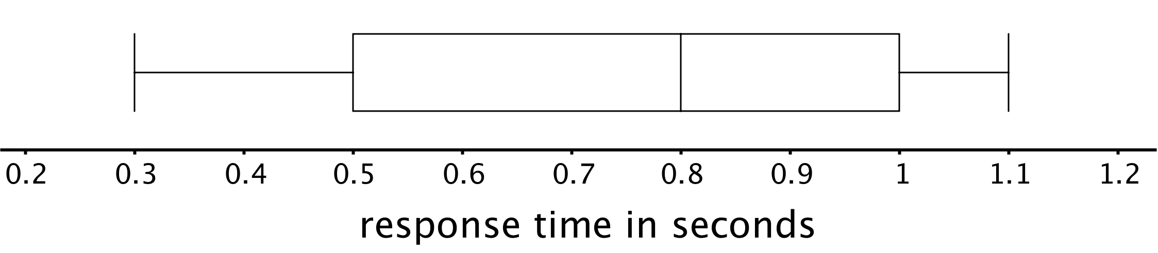
- Here is a dot plot that represents a data set. Explain why the mean of the data set is greater than its median.
- 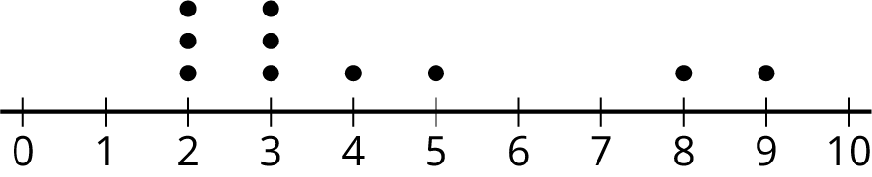

- (From Unit 8, Lesson 14.)
- Jada earns money from babysitting, walking her neighbor’s dogs, and running errands for her aunt. Every four weeks, she combines her earnings and divides them into three equal parts—one for spending, one for saving, and one for donating to a charity. Jada donated $26.00 of her earnings from the past four weeks to charity.
- How much could she have earned from each job? Make two lists of how much she could have earned from the three jobs during the past four weeks.
- (From Unit 8, Lesson 9.)
© CC BY Open Up Resources. Adaptations CC BY IM.

