Lesson 9 Practice Problems
- Which construction can be used to determine whether point $C$ is closer to point $A$ or point $B$?
  - Construct triangle $ABC$.
  - Construct a line perpendicular to segment $AB$ through point $C$.
  - Construct the bisector of angle $ACB$.
  - Construct the perpendicular bisector of segment $AB$.
- The diagram is a straightedge and compass construction. Lines $ℓ$, $m$, and $n$ are the perpendicular bisectors of the sides of triangle $ABC$. Select all the true statements.
- 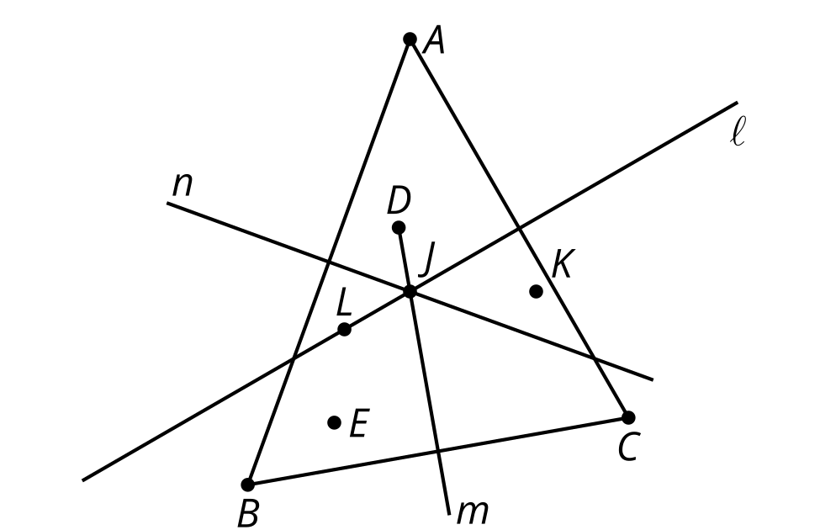
  - Point $E$ is closer to point $A$ than it is to point $C$.
  - Point $L$ is closer to point $B$ than it is to point $A$.
  - Point $D$ is closer to point $B$ than it is to point $C$.
  - Point $J$ is closer to point $A$ than it is to point $B$ or point $C$.
  - Point $K$ is closer to point $C$ than it is to point $A$ or point $B$.
  - Point $L$ is closer to point $C$ than it is to point $A$ or point $B$.
- Decompose the figure into regions that are closest to each vertex. Explain or show your reasoning.
- 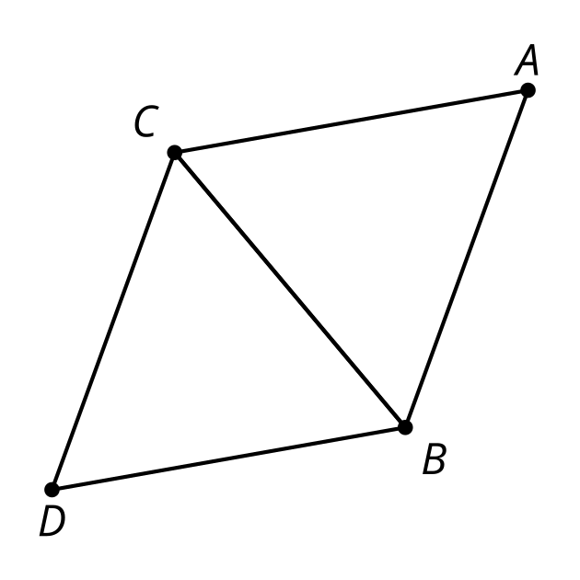
- Which construction could be used to construct an isosceles triangle $ABC$ given line segment $AB$?
  - Mark a third point $C$ not on segment $AB$. Draw segments $AC$ and $BC$.
  - Label a point $C$ on segment $AB$ and construct a line perpendicular to $AB$ through point $C$. Draw segments $AC$ and $BC$.
  - Construct the perpendicular bisector of segment $AB$. Mark the intersection of this line and $AB$ and label it $C$. Draw segments $AC$ and $BC$.
  - Construct the perpendicular bisector of segment $AB$. Mark any point $C$ on the perpendicular bisector except where it intersects $AB$. Draw segments $AC$ and $BC$.
- Select all true statements about regular polygons.
  - All angles are right angles.
  - All angles are congruent.
  - All side lengths are equal.
  - There are exactly 4 sides.
  - There are at least 3 sides.
- (From Unit 1, Lesson 7.)
- This diagram shows the beginning of a straightedge and compass construction of a rectangle.
- The construction followed these steps:
- 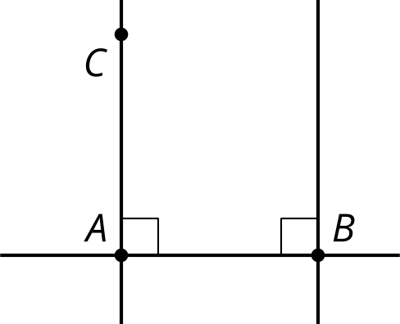
  - Start with two marked points $A$ and $B$
  - Use a straightedge to construct line $AB$
  - Use a previous construction to construct a line perpendicular to $AB$ passing through $A$
  - Use a previous construction to construct a line perpendicular to $AB$ passing through $B$
  - Mark a point $C$ on the line perpendicular to $AB$ passing through $A$
- Explain the steps needed to complete this construction.
- (From Unit 1, Lesson 7.)
- This diagram is a straightedge and compass construction. Is it important that the circle with center $B$ passes through $D$ and that the circle with center $D$ passes through $B$? Show or explain your reasoning.
- 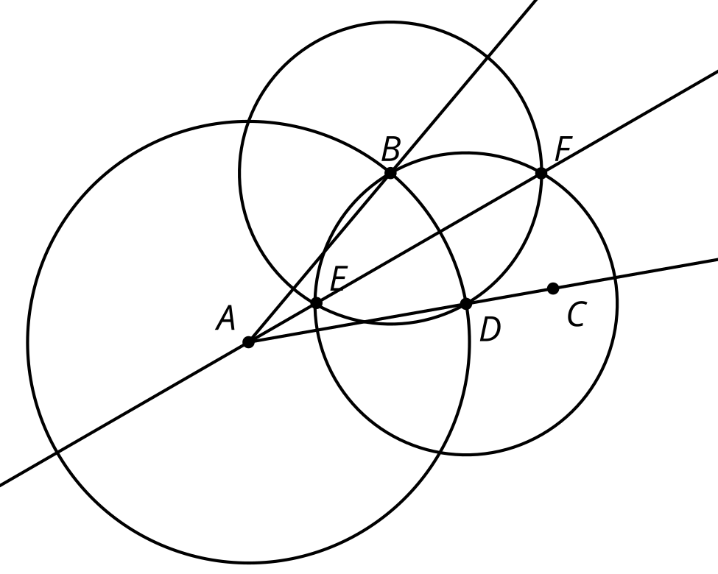
- (From Unit 1, Lesson 5.)
© CC BY 2019 by Illustrative Mathematics®

