Lesson 3: Fracciones no unitarias

Standards Alignments
Addressing | 3.NF.A.1

Teacher-facing Learning Goals
- Understand a fraction $\frac{a}{b}$ as the quantity formed by $a$ parts of size $\frac{1}{b}$.

Student-facing Learning Goals
- Aprendamos sobre fracciones no unitarias.

Lesson Purpose
The purpose of this lesson is for students to understand non-unit fractions.
Previously, students learned how to write unit fractions, using numbers of the form $\frac{1}{b}$. They also partitioned rectangles and used unit fractions to describe one of the parts. In this lesson, students use diagrams with multiple equal parts shaded to make sense of how non-unit fractions are made of unit fractions.
Students learn that a unit fraction is a fraction in which the numerator is 1 because it describes one of the equal-sized parts. They work with fractions that are equal to a whole number and fractions greater than a whole number to see that all non-unit fractions are built from unit fractions in the same way. Students also notice that if all the parts are shaded, then the non-unit fraction is equivalent to a whole number. The terms numerator and denominator are not used until the next section.

Access for:

Students with Disabilities
- Representation (Activity 2)

English Learners
- MLR8 (Activity 2)

Instructional Routines
Notice and Wonder (Warm-up)

Materials to Copy
- Fraction Match Part 1 (groups of 2): Activity 2
- Fraction Match Part 2 (groups of 4): Activity 2

Lesson Timeline
Warm-up | 10 min
Activity 1 | 15 min
Activity 2 | 20 min
Lesson Synthesis | 10 min
Cool-down | 5 min

Teacher Reflection Question
How did students leverage their knowledge of unit fractions from previous lessons to make sense of non-unit fractions for the first time?

Cool-down
(to be completed at the end of the lesson) 5min
La fracción sombreada

Standards Alignments
Addressing | 3.NF.A.1

Student-facing Task Statement
El rectángulo representa 1 unidad. ¿Qué fracción está sombreada? Explica tu razonamiento.
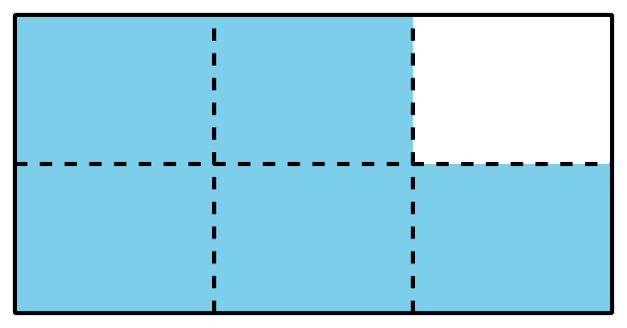

Student Responses
$\frac{5}{6}$. Sample response: The rectangle is split into 6 equal parts and 5 of the one-sixth parts are shaded.

