Lesson 14 Practice Problems
- Clare is using little wooden cubes with edge length $\frac{1}{2}$ inch to build a larger cube that has edge length 4 inches. How many little cubes does she need? Explain your reasoning.
- The triangle has an area of $7\frac{7}{8}$ cm² and a base of $5\frac{1}{4}$ cm.
- What is the length of $h$? Explain your reasoning.
- 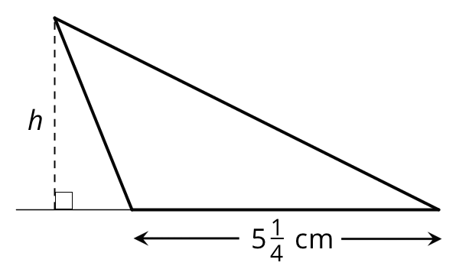

  - Which expression can be used to find how many cubes with edge length of $\frac{1}{3}$ unit fit in a prism that is 5 units by 5 units by 8 units? Explain or show your reasoning.
    - $\left(5⋅\frac{1}{3}\right)⋅\left(5⋅\frac{1}{3}\right)⋅\left(8⋅\frac{1}{3}\right)$
    - $5⋅5⋅8$
    - $\left(5⋅3\right)⋅\left(5⋅3\right)⋅\left(8⋅3\right)$
    - $\left(5⋅5⋅8\right)⋅\left(\frac{1}{3}\right)$
  - Mai says that we can also find the answer by multiplying the edge lengths of the prism and then multiplying the result by 27. Do you agree with her? Explain your reasoning.
- A builder is building a fence with $6\frac{1}{4}$-inch-wide wooden boards, arranged side-by-side with no gaps or overlaps. How many boards are needed to build a fence that is 150 inches long? Show your reasoning.
- (From Unit 4, Lesson 12.)
- Find the value of each expression. Show your reasoning and check your answer.
  - $2\frac{1}{7}÷\frac{2}{7}$
  - $\frac{17}{20}÷\frac{1}{4}$
- (From Unit 4, Lesson 12.)
- Consider the problem: A bucket contains $11\frac{2}{3}$ gallons of water and is $\frac{5}{6}$ full. How many gallons of water would be in a full bucket?
- Write a multiplication and a division equation to represent the situation. Then, find the answer and show your reasoning.

- (From Unit 4, Lesson 11.)
- There are 80 kids in a gym. 75% are wearing socks. How many are not wearing socks? If you get stuck, consider using a tape diagram.
- (From Unit 3, Lesson 12.)

  - Lin wants to save $75 for a trip to the city. If she has saved $37.50 so far, what percentage of her goal has she saved? What percentage remains?
  - Noah wants to save $60 so that he can purchase a concert ticket. If he has saved $45 so far, what percentage of his goal has he saved? What percentage remains?
- (From Unit 3, Lesson 11.)
© CC BY Open Up Resources. Adaptations CC BY IM.

