Lesson 10 Practice Problems
- Here are 2 circles. The smaller circle has radius $r$, circumference $c$, and diameter $d$. The larger circle has radius $R$, circumference $C$, and diameter $D$. The larger circle is a dilation of the smaller circle by a factor of $k$.
- 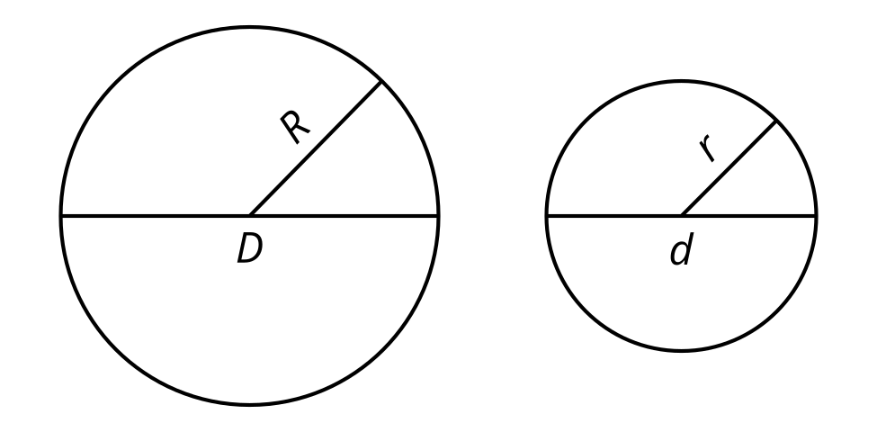
- Using the circles, write 3 pairs of equivalent ratios. Find the value of each set of ratios you wrote.
- Tyler is confident that all circles are similar, but he cannot explain why this is true. Help Tyler explain why all circles are similar.
- Circle B is a dilation of circle A.

- circle A
- 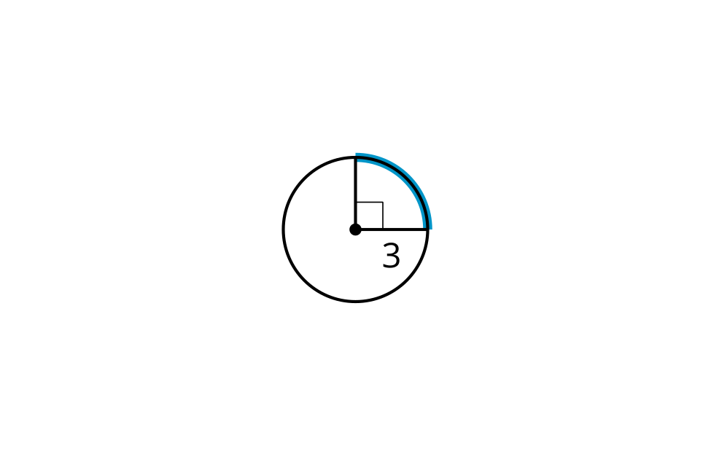

- circle B
- 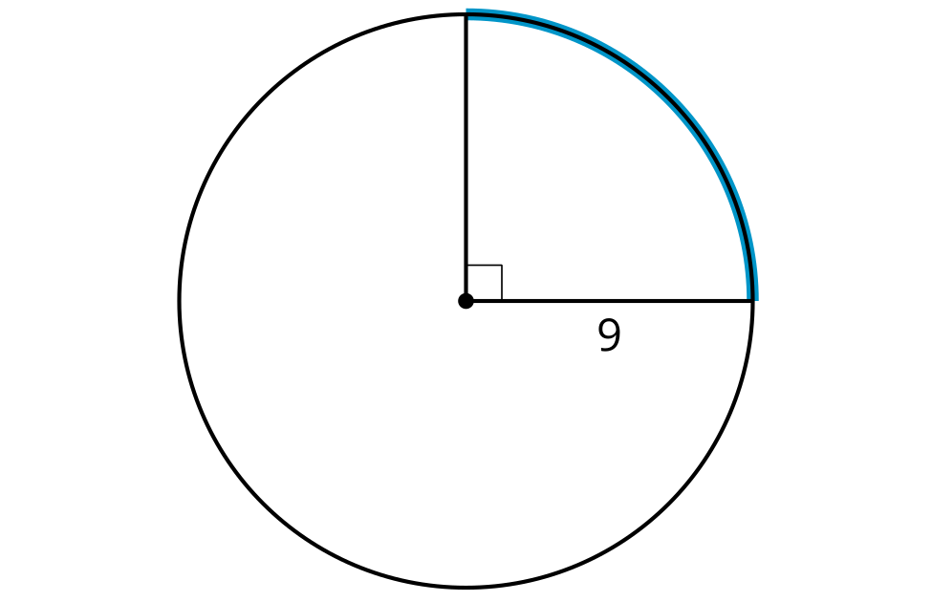
  - What is the scale factor of dilation?
  - What is the length of the highlighted arc in circle A?
  - What is the length of the highlighted arc in circle B?
  - What is the ratio of the arc lengths?
  - How does the ratio of arc length compare to the scale factor?
- Kiran cuts out a square piece of paper with side length 6 inches. Mai cuts out a paper sector of a circle with radius 6 inches, and calculates the arc length to be $4π$ inches. Whose paper is larger? Explain or show your reasoning.
- (From Unit 7, Lesson 9.)
- A circle has radius 3 centimeters. Suppose an arc on the circle has length $4π$ centimeters. What is the measure of the central angle whose radii define the arc?
- (From Unit 7, Lesson 9.)
- A circle with a shaded sector is shown.
  - What is the area of the shaded sector?
  - What is the length of the arc that outlines this sector?
- 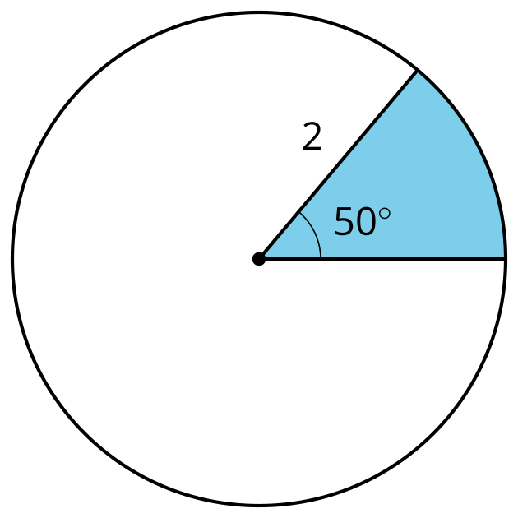
- (From Unit 7, Lesson 8.)
- The towns of Washington, Franklin, and Springfield are connected by straight roads. The towns wish to build an airport to be shared by all of them.
- 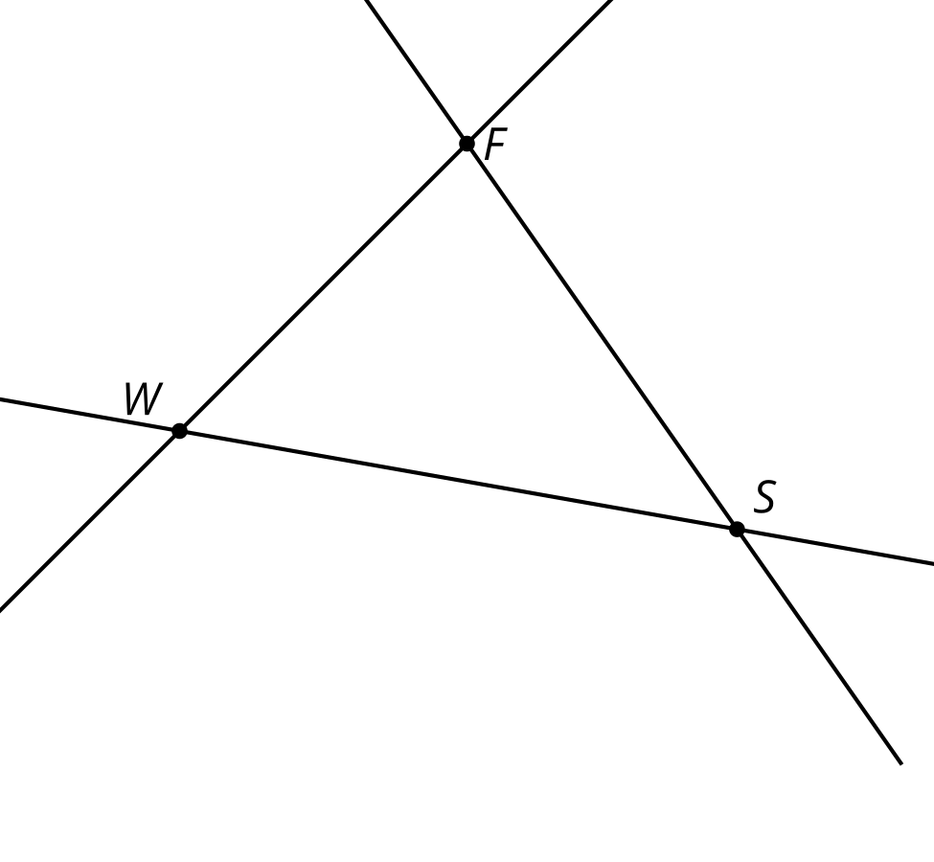
  - Where should they build the airport if they want it to be the same distance from each town’s center? Describe how to find the precise location.
  - Where should they build the airport if they want it to be the same distance from each of the roads connecting the towns? Describe how to find the precise location.
- (From Unit 7, Lesson 7.)
- Chords $AC$ and $DB$ intersect at point $E$. Select all pairs of angles that must be congruent.
- 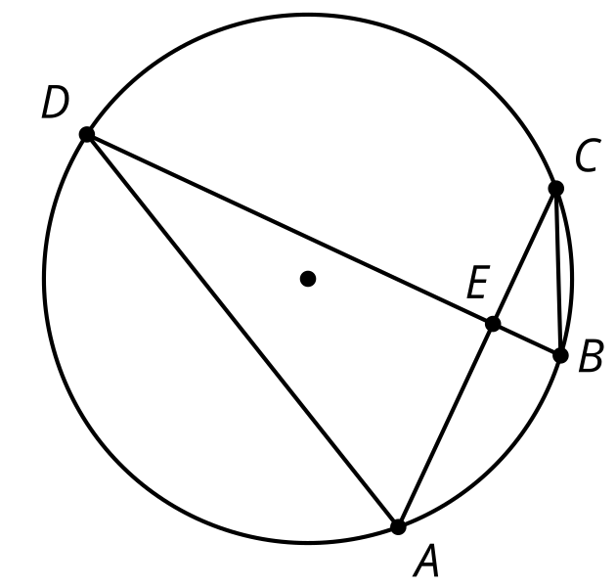
  - angle A D B and angle A C B
  - angle A D B and angle C A D
  - angle D E A and angle C E B
  - angle C A D and angle C B D
  - angle B C A and angle C B D
- (From Unit 7, Lesson 2.)
© CC BY 2019 by Illustrative Mathematics®

