Unit 5 Lesson 6: Scaling Solids

1 Math Talk: Cube Volumes (Warm up)

Student Task Statement
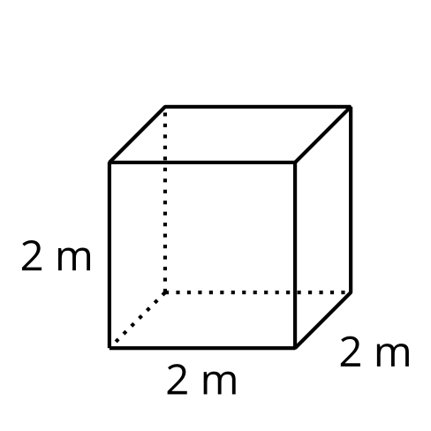
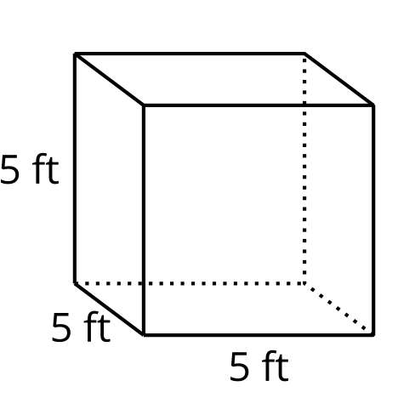
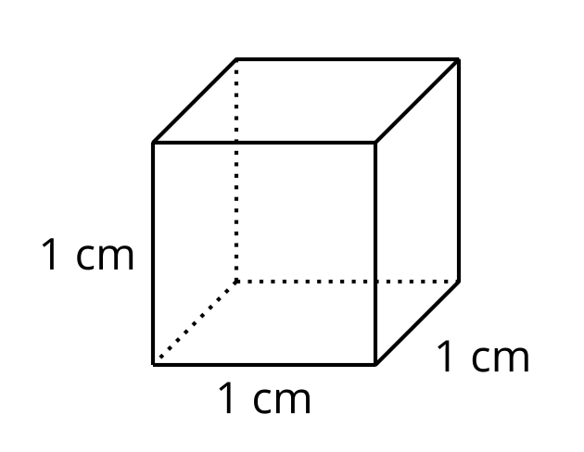
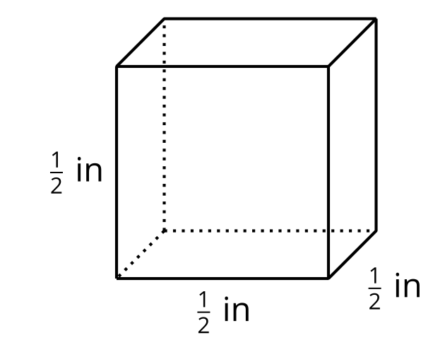
Find the volume of each cube mentally.

2 How Do Surface Area and Volume Change with Scaling?

Student Task Statement
- Use unit cubes to build cubes that result from dilating a unit cube by each scale factor shown in the table. Then, complete the table with the surface area and volume of each dilated cube.
- scale factor | - surface area in square units | - volume in cubic units
- 1
- 2
- 3
- 4
- Suppose a unit cube is dilated by some scale factor $k$.
  - Write an expression for the surface area of the dilated cube.
  - Write an expression for the volume of the dilated cube.
  - Compare and contrast the expression for surface area and the expression for volume.

3 Scaling All Solids

Student Task Statement
Clare says, “We know that if we dilate a cube by a factor of $k$, the cube’s volume is multiplied by $k^{3}$. It seems like that must apply to all solids, but I’m not sure how to prove it.”
Elena says, “Earlier in the unit, we showed that we can cover any two-dimensional shape with rectangles, so the property that area changes by $k^{2}$ when we dilate a figure by $k$ applies to all shapes, not just rectangles. Can we do something similar here?”
- Use Elena’s line of reasoning to argue that for any solid, if it’s dilated by a factor of $k$, the volume is multiplied by $k^{3}$.
- Suppose a triangular prism has surface area 84 square centimeters and volume 36 cubic centimeters. The prism is dilated by scale factor $k=4$. Calculate the surface area and volume of the dilated prism.

Images for Activity Synthesis
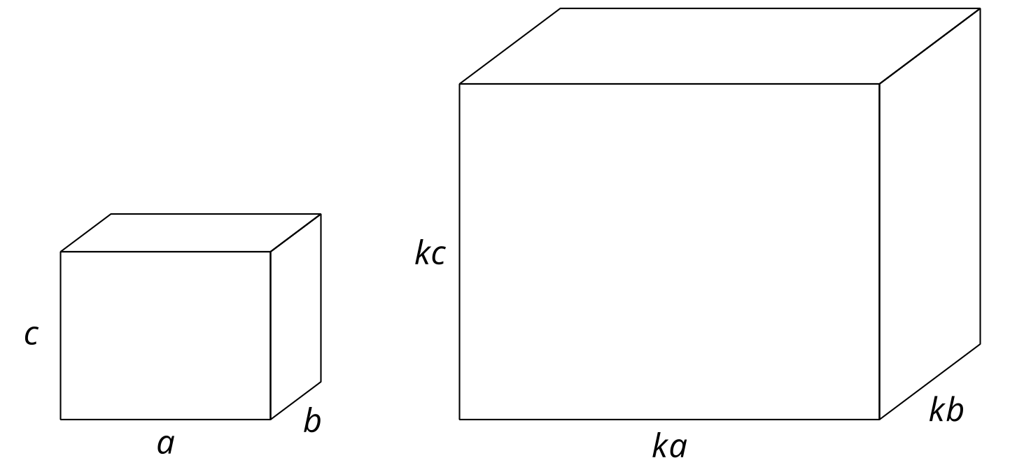
© CC BY 2019 by Illustrative Mathematics®

