Lesson 9 Practice Problems
- Jada cuts out a rectangular piece of paper that measures 5 inches by 4 inches. Han cuts out a paper sector of a circle with radius 5 inches, and calculates the arc length to be $2π$ inches. Whose paper is larger? Show your reasoning.
- A circle has radius 10 centimeters. Suppose an arc on the circle has length $8π$ centimeters. What is the measure of the central angle whose radii define the arc?
- A circle has radius 6 units. For each arc length, find the area of a sector of this circle which defines that arc length.
  - $4π$ units
  - $5π$ units
  - 10 units
  - $ℓ$ units
- Select all the sectors which have an area of $3π$ square units.
  - a sector with a radius of 6 units and a central angle of 30 degrees
  - a sector with a radius of 6 units and a central angle of 45 degrees
  - a sector with a radius of 3 units and a central angle of 60 degrees
  - a sector with a radius of 3 units and a central angle of 120 degrees
  - a sector with a radius of 3 units and a central angle of 180 degrees
- (From Unit 7, Lesson 8.)
- A circle has radius 4 units and a central angle measuring 45 degrees. What is the length of the arc defined by the central angle?
- (From Unit 7, Lesson 8.)
- Clare and Diego are discussing inscribing circles in quadrilaterals.
- Diego thinks that you can inscribe a circle in any quadrilateral since you can inscribe a circle in any triangle. Clare thinks it is not always possible because she does not think the angle bisectors are guaranteed to intersect at a single point. She claims she can draw a quadrilateral for which an inscribed circle can’t be drawn.
- Do you agree with either of them? Explain or show your reasoning.
- (From Unit 7, Lesson 7.)
- Triangle $ABC$ is shown together with the angle bisectors of each of its angles. Draw a point $D$ that is equidistant from sides $AC$ and $AB$, but which is closest to side $BC$.
- 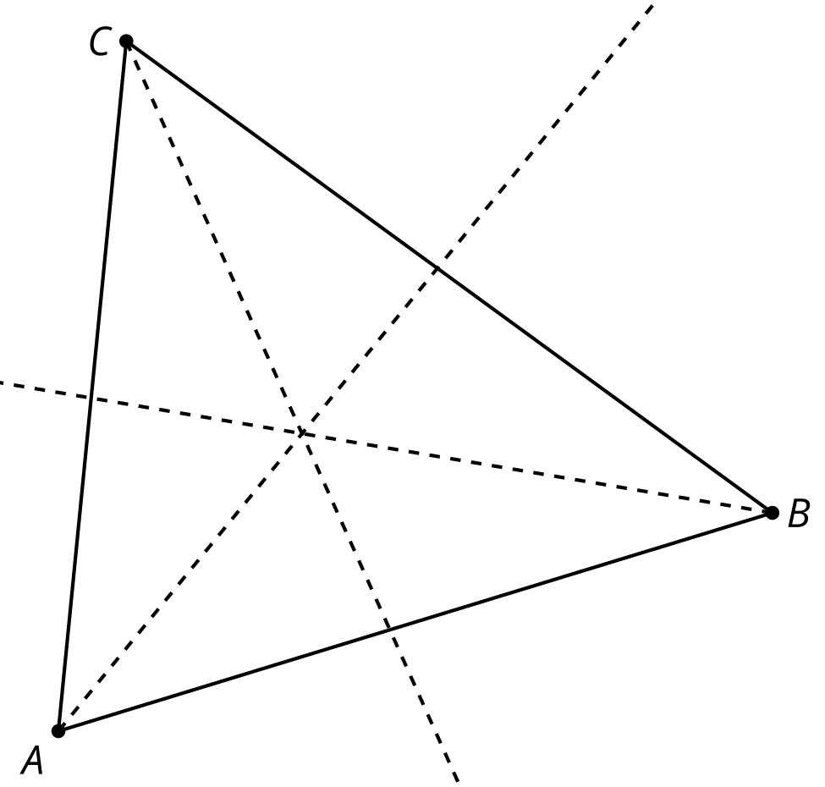
- (From Unit 7, Lesson 6.)
- Priya and Mai are trying to prove that if 2 chords are congruent, they are equidistant from the center of the circle. Priya draws this picture.
- 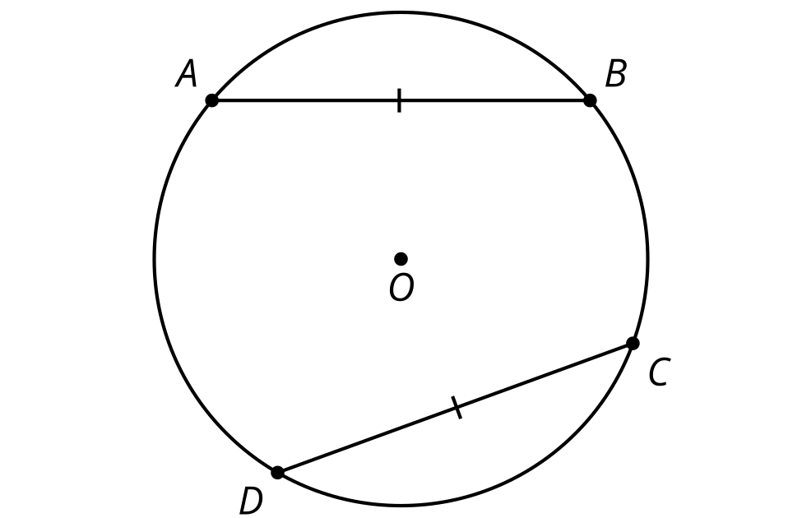
- Mai adds the perpendicular segment from the center of the circle to each chord.
- 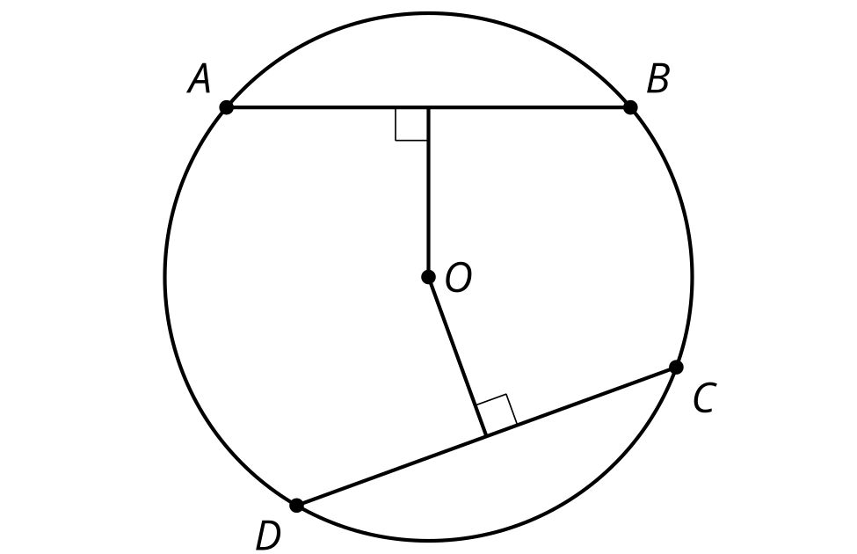
- Priya says, “I think we should try to use triangles because that is how we proved things congruent before.” Mai says, “I think you’re right, but how? Should we draw in some radii?”
- Help them complete the proof.
- (From Unit 7, Lesson 1.)
© CC BY 2019 by Illustrative Mathematics®

