Lesson 9: Which Variable to Solve for? (Part 2)
- Let’s solve an equation for one of the variables.

9.1: Faces, Vertices, and Edges
In an earlier lesson, you saw the equation $V+F−2=E$, which relates the number of vertices, faces, and edges in a Platonic solid.
- Write an equation that makes it easier to find the number of vertices in each of the Platonic solids described:
- 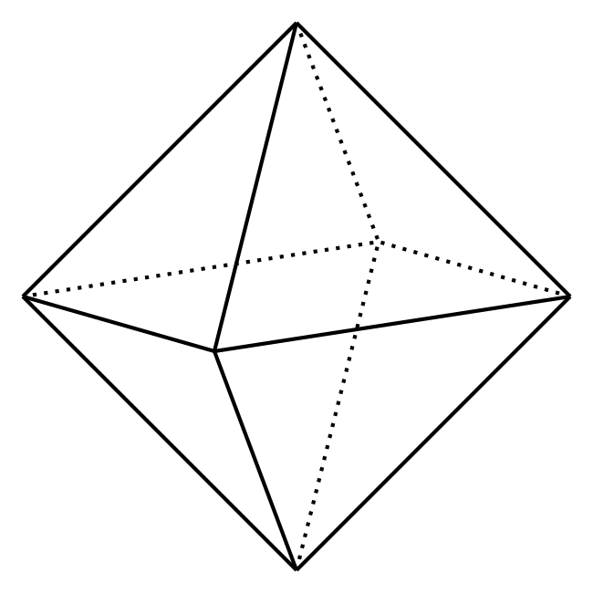
  - An octahedron (shown here), which has 8 faces.
  - An icosahedron, which has 30 edges.
- A Buckminsterfullerene (also called a “Buckyball”) is a polyhedron with 60 vertices. It is not a Platonic solid, but the numbers of faces, edges, and vertices are related the same way as those in a Platonic solid.
- Write an equation that makes it easier to find the number of faces a Buckyball has if we know how many edges it has.

9.2: Cargo Shipping
An automobile manufacturer is preparing a shipment of cars and trucks on a cargo ship that can carry 21,600 tons.
The cars weigh 3.6 tons each and the trucks weigh 7.5 tons each.
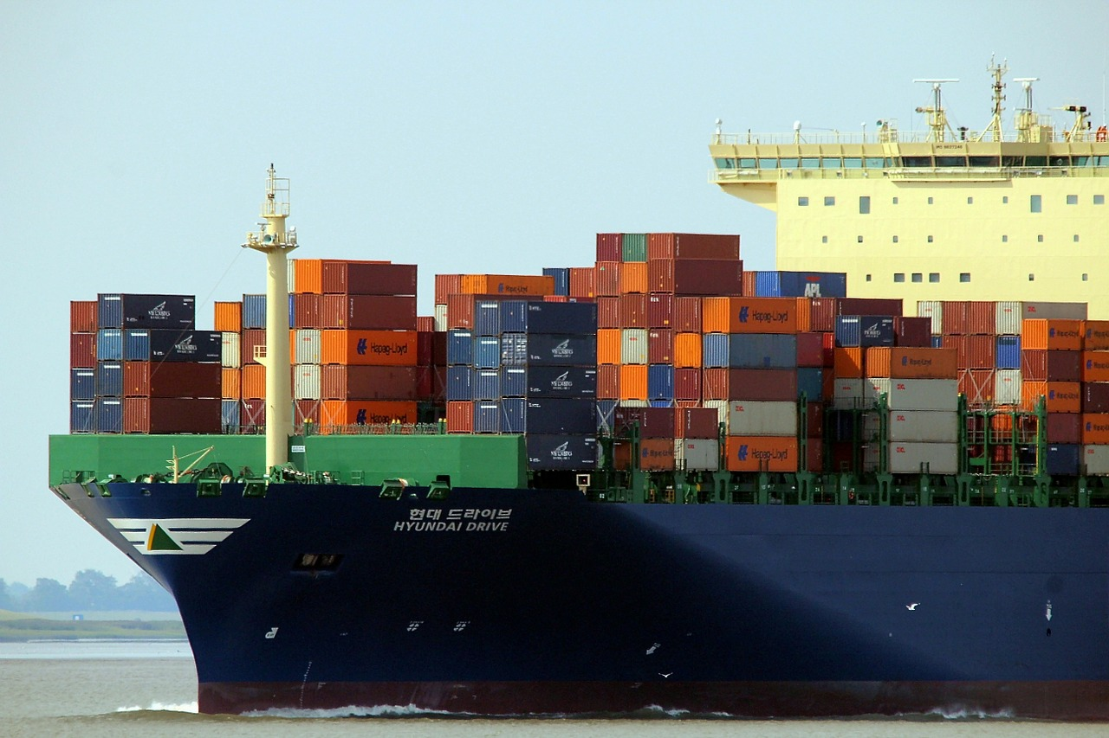
- Write an equation that represents the weight constraint of a shipment. Let $c$ be the number of cars and $t$ be the number of trucks.
- For one shipment, trucks are loaded first and cars are loaded afterwards. (Even though trucks are bulkier than cars, a shipment can consist of all trucks as long as it is within the weight limit.)
- Find the number of cars that can be shipped if the cargo already has:
  - 480 trucks
  - 1,500 trucks
  - 2,736 trucks
  - $t$ trucks
- For a different shipment, cars are loaded first, and then trucks are loaded afterwards.
  - Write an equation you could enter into a calculator or a spreadsheet tool to find the number of trucks that can be shipped if the number of cars is known.
  - Use your equation and a calculator or a computer to find the number of trucks that can be shipped if the cargo already has 1,000 cars. What if the cargo already has 4,250 cars?

Are you ready for more?
For yet another shipment, the manufacturer is also shipping motorcycles, which weigh 0.3 ton each.
- Write an equation that you could enter into a calculator or a spreadsheet tool to find the number of motorcycles that can be shipped, $m$, if the number of cars and trucks are known.
- Use your equation to find the number of motorcycles that can be shipped if the cargo already contains 1,200 trucks and 3,000 cars.

9.3: Streets and Staffing
The Department of Streets of a city has a budget of $1,962,800 for resurfacing roads and hiring additional workers this year.
The cost of resurfacing a mile of 2-lane road is estimated at $84,000. The average starting salary of a worker in the department is $36,000 a year.
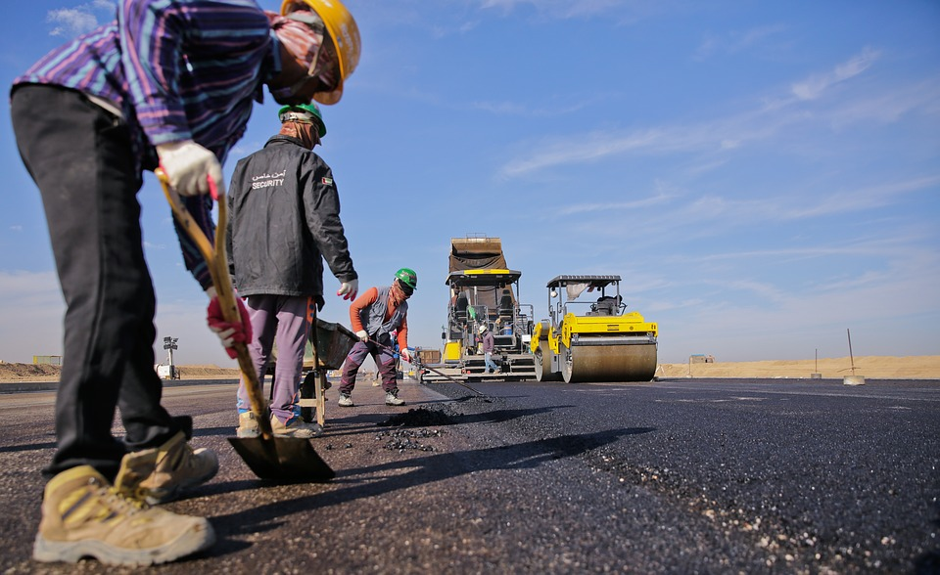
- Write an equation that represents the relationship between the miles of 2-lane roads the department could resurface, $m$, and the number of new workers it could hire, $p$, if it spends the entire budget.
- Take the equation you wrote in the first question and:
  - Solve for $p$. Explain what the solution represents in this situation.
  - Solve for $m$. Explain what the solution represents in this situation.
- The city is planning to hire 6 new workers and to use its entire budget.
  - Which equation should be used to find out how many miles of 2-lane roads it could resurface? Explain your reasoning.
  - Find the number of miles of 2-lane roads the city could resurface if it hires 6 new workers.

Lesson 9 Summary
Solving for a variable is an efficient way to find out the values that meet the constraints in a situation. Here is an example.
An elevator has a capacity of 3,000 pounds and is being loaded with boxes of two sizes—small and large. A small box weighs 60 pounds and a large box weighs 150 pounds.
Let $x$ be the number of small boxes and $y$ the number of large boxes. To represent the combination of small and large boxes that fill the elevator to capacity, we can write:
$60x+150y=3,​000$
If there are 10 large boxes already, how many small boxes can we load onto the elevator so that it fills it to capacity? What if there are 16 large boxes?
In each case, we can substitute 10 or 16 for $y$ and perform acceptable moves to solve the equation. Or, we can first solve for $x$:
$\begin{matrix}60x+150y & =3,​000 & & \text{original equation} \\ 60x & =3,​000−150y & & \text{subtract }150y\text{ from each side} \\ x & =\frac{3,000−150y}{60} & & \text{divide each side by 60}\end{matrix}$
This equation allows us to easily find the number of small boxes that can be loaded, $x$, by substituting any number of large boxes for $y$.
Now suppose we first load the elevator with small boxes, say, 30 or 42, and want to know how many large boxes can be added for the elevator to reach its capacity.
We can substitute 30 or 42 for $x$ in the original equation and solve it. Or, we can first solve for $y$:
$\begin{matrix}60x+150y & =3,​000 & & \text{original equation} \\ 150y & =3,​000−60x & & \text{subtract }60x\text{ from each side} \\ y & =\frac{3,000−60x}{150} & & \text{divide each side by 150}\end{matrix}$
Now, for any value of $x$, we can quickly find $y$ by evaluating the expression on the right side of the equal sign.
Solving for a variable—before substituting any known values—can make it easier to test different values of one variable and see how they affect the other variable. It can save us the trouble of doing the same calculation over and over.
© CC BY 2019 by Illustrative Mathematics®

