Lesson 13 Practice Problems

  - Find the unknown side length of the rectangle if its area is 11 m². Show your reasoning.
  - 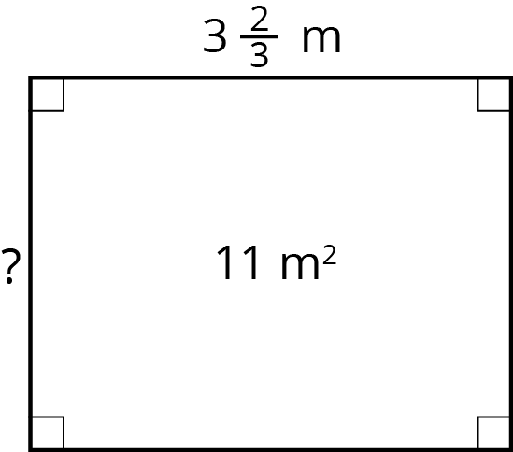
  - Check your answer by multiplying it by the given side length ($3\frac{2}{3}$). Is the resulting product 11? If not, revise your previous work.
- A worker is tiling the floor of a rectangular room that is 12 feet by 15 feet. The tiles are square with side lengths $1\frac{1}{3}$ feet. How many tiles are needed to cover the entire floor? Show your reasoning.

- A television screen has length $16\frac{1}{2}$ inches, width $w$ inches, and area 462 square inches. Select all the equations that represent the relationship of the side lengths and area of the television.
  - $w⋅462=16\frac{1}{2}$
  - $16\frac{1}{2}⋅w=462$
  - $462÷16\frac{1}{2}=w$
  - $462÷w=16\frac{1}{2}$
  - $16\frac{1}{2}⋅462=w$
- The area of a rectangle is $17\frac{1}{2}$ in² and its shorter side is $3\frac{1}{2}$ in. Draw a diagram that shows this information. What is the length of the longer side?
- A bookshelf is 42 inches long.
  - How many books of length $1\frac{1}{2}$ inches will fit on the bookshelf? Explain your reasoning.
  - A bookcase has 5 of these bookshelves. How many feet of shelf space is there? Explain your reasoning.
- (From Unit 4, Lesson 12.)
- Find the value of $\frac{5}{32}÷\frac{25}{4}$. Show your reasoning.
- (From Unit 4, Lesson 11.)
- How many groups of $1\frac{2}{3}$ are in each of these quantities?
  - $1\frac{5}{6}$
  - $4\frac{1}{3}$
  - $\frac{5}{6}$
- (From Unit 4, Lesson 6.)
- It takes $1\frac{1}{4}$ minutes to fill a 3-gallon bucket of water with a hose. At this rate, how long does it take to fill a 50-gallon tub? If you get stuck, consider using a table.
- (From Unit 2, Lesson 14.)
© CC BY Open Up Resources. Adaptations CC BY IM.

