Lesson 9: Working with Signed Numbers
- Let’s work with signed numbers.

9.1: Sorting Expressions
Sort these into two groups, so that the expressions in each group all have the same value.
- $3−5$
- $5+3$
- $4⋅2$
- $\text{-}\frac{1}{3}⋅6$
- $5−\text{-}3$
- $\text{-}4⋅\text{-}2$
- $3+\text{-}5$
- $\frac{1}{3}⋅\text{-}6$

9.2: Expanded Form
For each expression given in factored form, write two equivalent expressions in expanded form. If you get stuck, draw a diagram to represent the product. Some blank diagrams are provided—draw additional diagrams as needed.
- $\left(30+3\right)\left(30−2\right)$
- $\left(20−1\right)\left(20−1\right)$
- $\left(100+5\right)\left(100−m\right)$
- $\left(40−a\right)\left(40+b\right)$
- $y\left(11−y\right)$
- $\text{-}7\left(3a−1\right)$
- $\frac{1}{4}\left(\text{-}8a+12a\right)$
- $\text{-}x\left(3x−5\right)$

9.3: Factoring and Expanding
In each row, write the equivalent expression. If you get stuck, use a diagram to organize your work. The first row is provided as an example. Diagrams are provided for the first three rows.
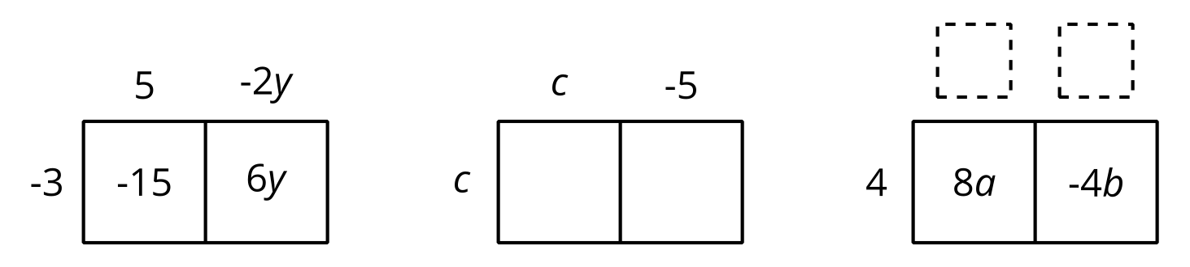
factored | expanded
$\text{-}3\left(5−2y\right)$ | $\text{-}15+6y$
$c\left(c−5\right)$
 | $8a−4b$
$\text{-}3\left(2w−7z\right)$
$\text{-}\left(3y−2x\right)$
 | $12x−14x^{2}$
$n\left(3−10\right)$
 | $5y−7y$
$\text{-}5x\left(y−2z\right)$
 | $wt−tv−5tz$
$\text{-}a\left(2b−4c+a\right)$
© CC BY 2019 by Illustrative Mathematics®

