Lesson 25: Using Linear Relations to Solve Problems
Let’s write equations for real-world situations and think about their solutions.

25.1: Buying Fruit
For each relationship described, write an equation to represent the relationship.
- Grapes cost $2.39 per pound. Bananas cost $0.59 per pound. You have $15 to spend on $g$ pounds of grapes and $b$ pounds of bananas.
- A savings account has $50 in it at the start of the year and $20 is deposited each week. After $x$ weeks, there are $y$ dollars in the account.

25.2: Five Savings Accounts
Each line represents one person’s weekly savings account balance from the start of the year.
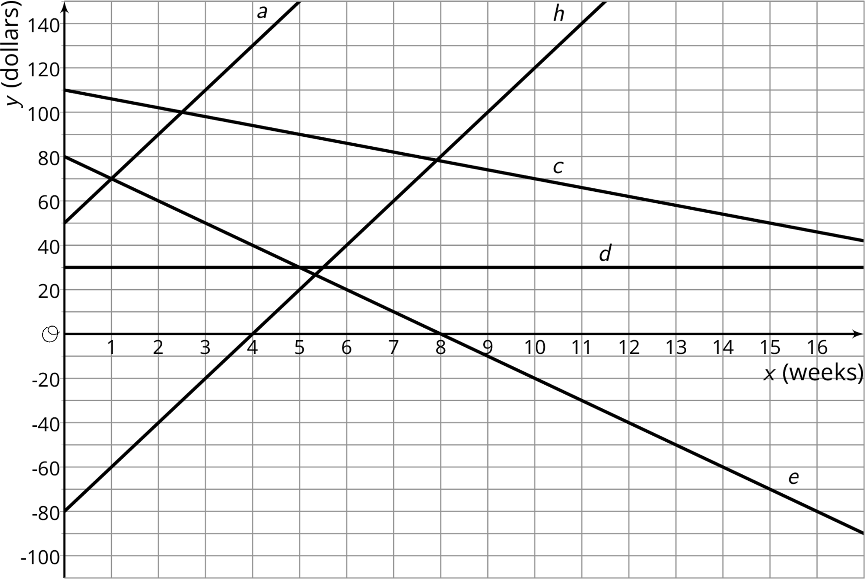
- Choose one line and write a description of what happens to that person's account over the first 17 weeks of the year. Do not tell your group which line you chose.
- Share your story with your group and see if anyone can guess your line.
- Write an equation for each line on the graph. What do the slope, $m$, and vertical intercept, $b$, in each equation mean in the situation?
- For which equation is $\left(1,70\right)$ a solution? Interpret this solution in terms of your story.
- Predict the balance in each account after 20 weeks.

25.3: Fabulous Fish
The Fabulous Fish Market orders tilapia, which costs $3 per pound, and salmon, which costs $5 per pound. The market budgets $210 to spend on this order each day.
- What are five different combinations of salmon and tilapia that the market can order?
- Define variables and write an equation representing the relationship between the amount of each fish bought and how much the market spends.
- Sketch a graph of the relationship. Label your axes.
- 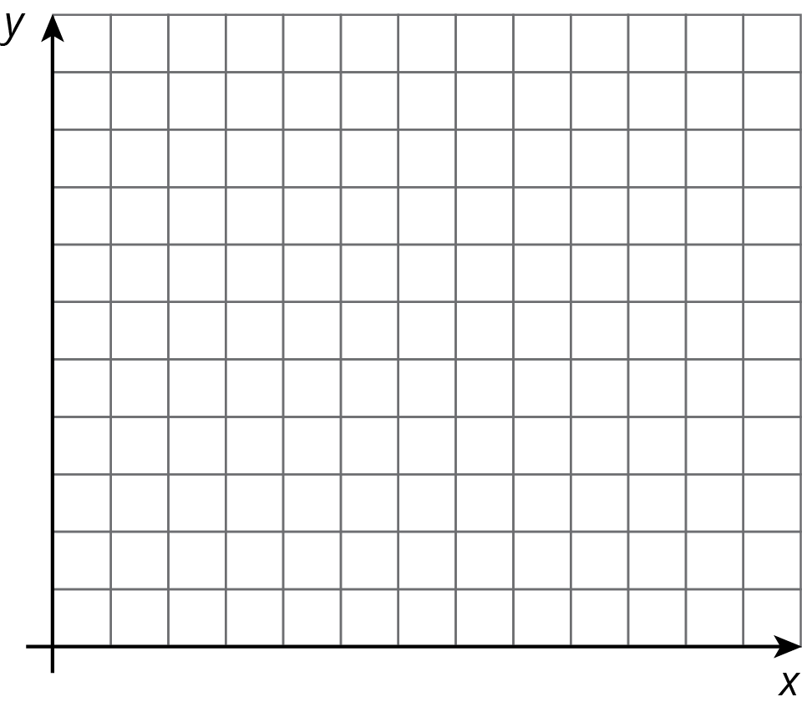
- On your graph, plot and label the combinations A—F.
 | - A | - B | - C | - D | - E | - F
- pounds of tilapia | - 5 | - 19 | - 27 | - 25 | - 65 | - 55
- pounds of salmon | - 36 | - 30.6 | - 25 | - 27 | - 6 | - 4
- Which of these combinations can the market order? Explain or show your reasoning.
- List two ways you can tell if a pair of numbers is a solution to an equation.
© CC BY Open Up Resources. Adaptations CC BY IM.

