Lesson 2 Practice Problems
- The second H-shaped polygon is a scaled copy of the first.
- 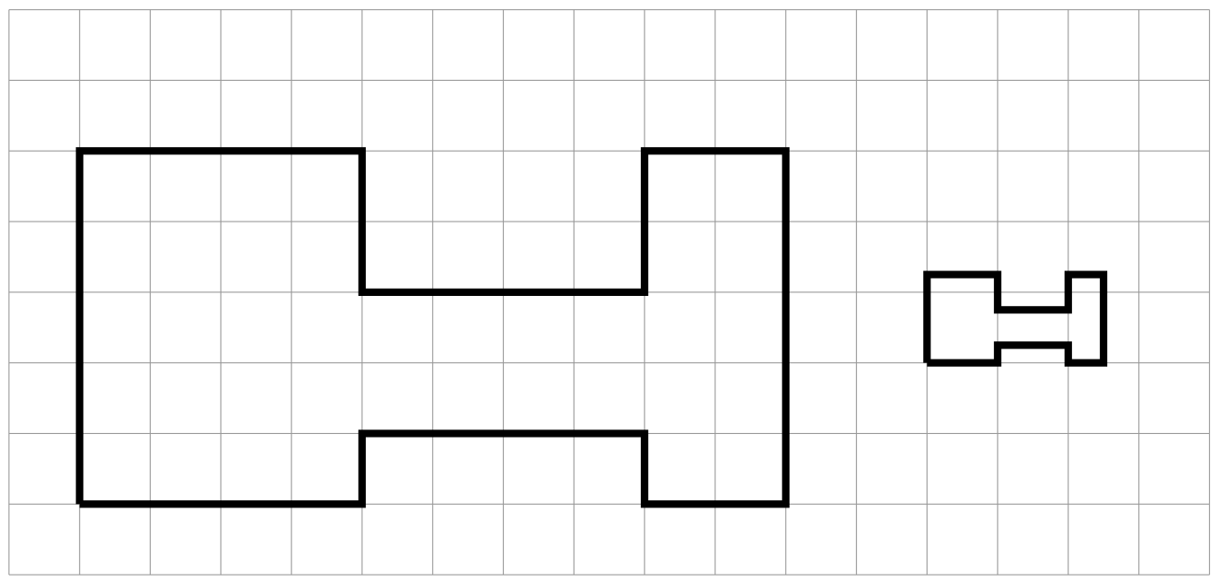
  - Show one pair of corresponding points and two pairs of corresponding sides in the original polygon and its copy. Consider using colored pencils to highlight corresponding parts or labeling some of the vertices.
  - What scale factor takes the original polygon to its smaller copy? Explain or show your reasoning.
- Figure B is a scaled copy of Figure A. Select all of the statements that must be true:
  - Figure B is larger than Figure A.
  - Figure B has the same number of edges as Figure A.
  - Figure B has the same perimeter as Figure A.
  - Figure B has the same number of angles as Figure A.
  - Figure B has angles with the same measures as Figure A.
- Quadrilateral A has side lengths 6, 9, 9, and 12. Quadrilateral B is a scaled copy of Quadrilateral A, with its shortest side of length 2. What is the perimeter of Quadrilateral B?
- Here are 3 polygons.
- 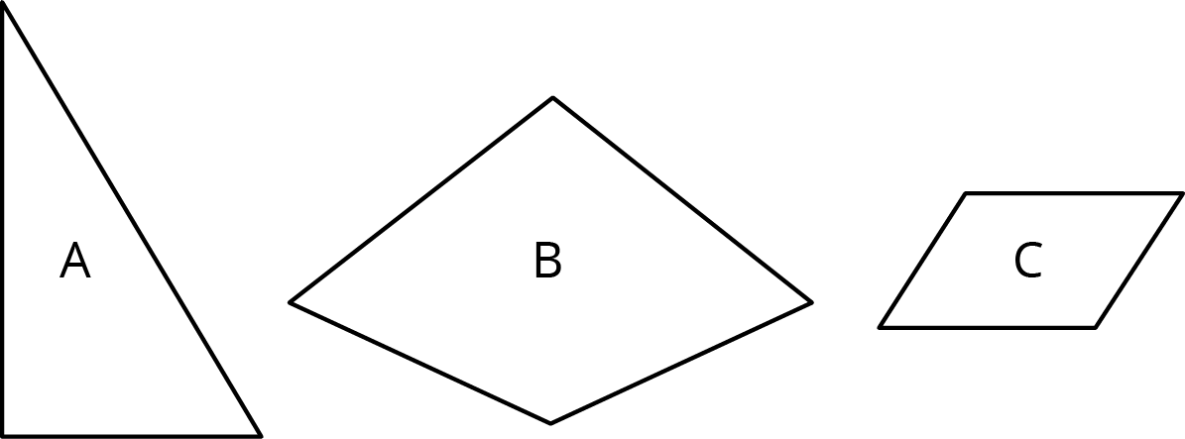
- Draw a scaled copy of Polygon A using a scale factor of 2.
- Draw a scaled copy of Polygon B using a scale factor of $\frac{1}{2}$.
- Draw a scaled copy of Polygon C using a scale factor of $\frac{3}{2}$.
© CC BY Open Up Resources. Adaptations CC BY IM.

