Unit 5 Lesson 14: Using Operations on Decimals to Solve Problems

1 Close Estimates (Warm up)

Student Task Statement
For each expression, choose the best estimate of its value.
- $76.2÷15$
  - 0.5
  - 5
  - 50
- $56.34÷48$
  - 1
  - 10
  - 100
- $124.3÷20$
  - 6
  - 60
  - 600

2 Applying Division with Decimals (Optional)

Student Task Statement
Your teacher will assign to you either Problem A or Problem B. Work together as a group to answer the questions. Be prepared to create a visual display to show your reasoning with the class.
Problem A:
A piece of rope is 5.75 meters in length.
- If it is cut into 20 equal pieces, how long will each piece be?
- If it is cut into 0.05-meter pieces, how many pieces will there be?
Problem B:
A tortoise travels 0.945 miles in 3.5 hours.
- If it moves at a constant speed, how many miles per hour is it traveling?
- At this rate, how long will it take the tortoise to travel 4.86 miles?
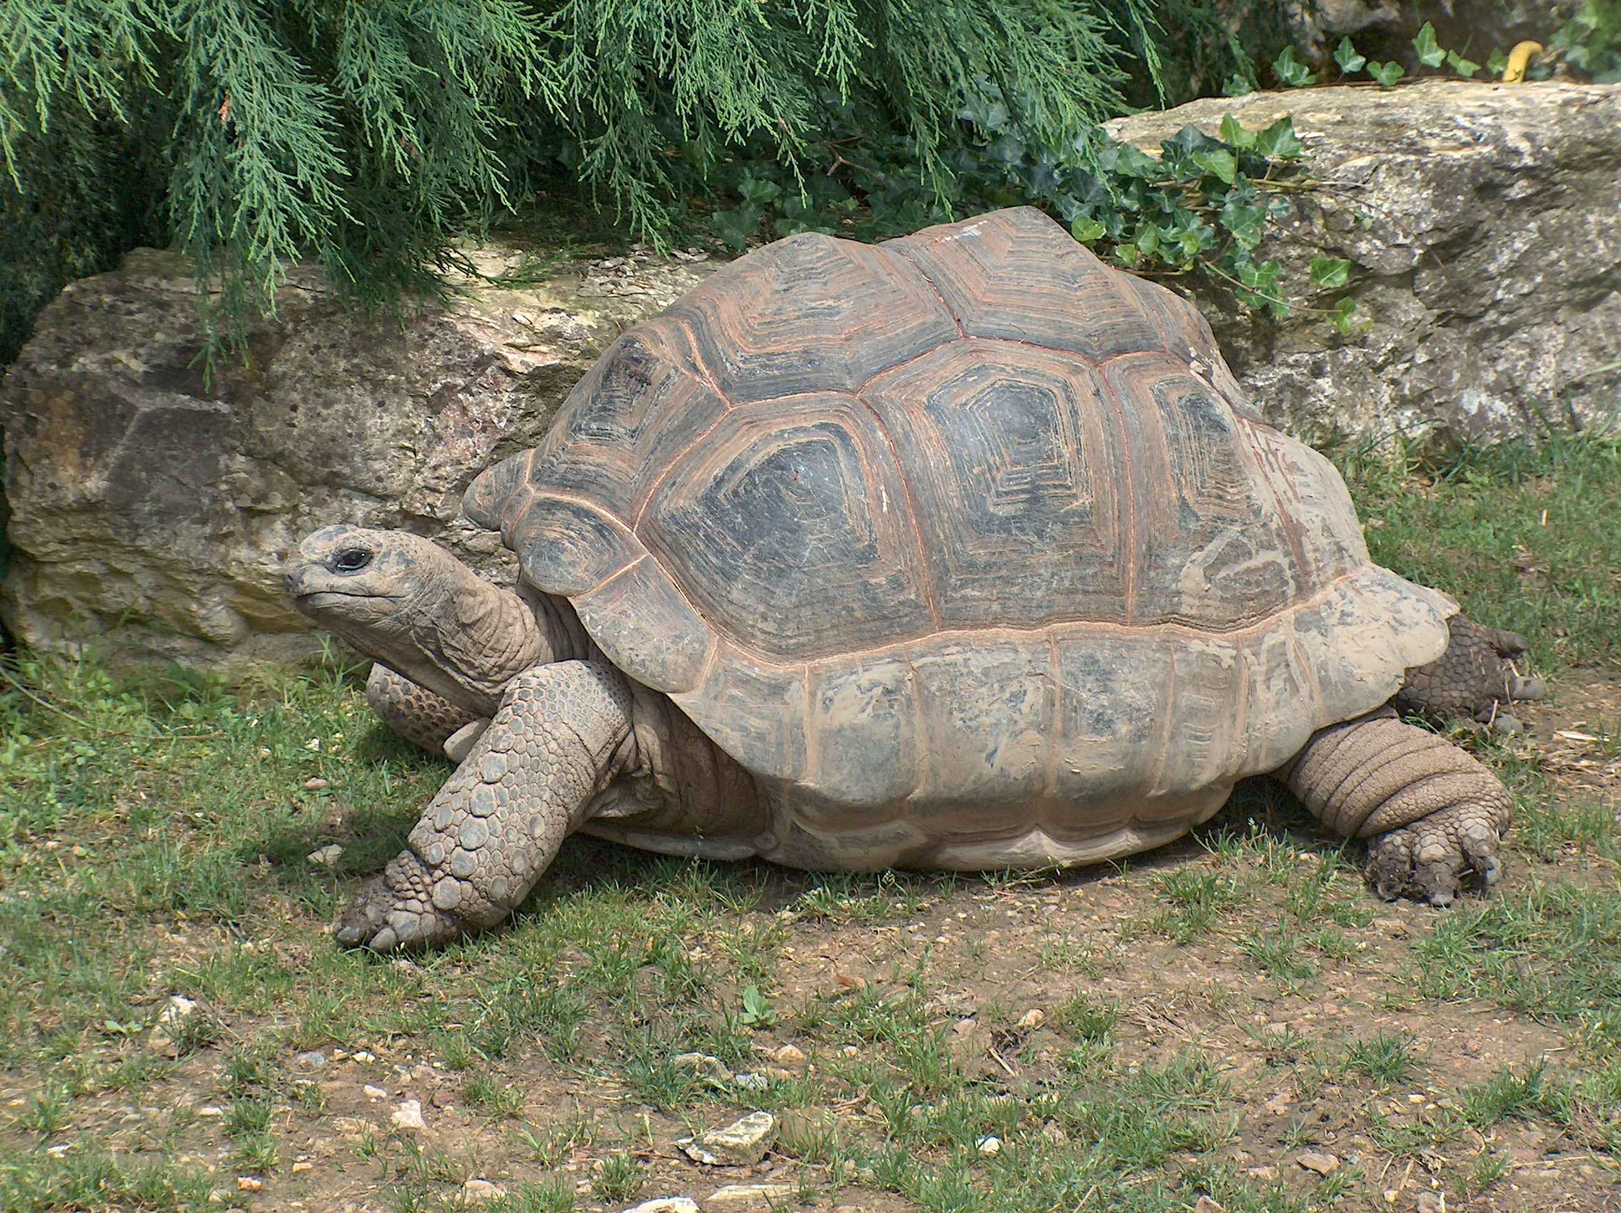

3 Distance between Hurdles

Images for Launch
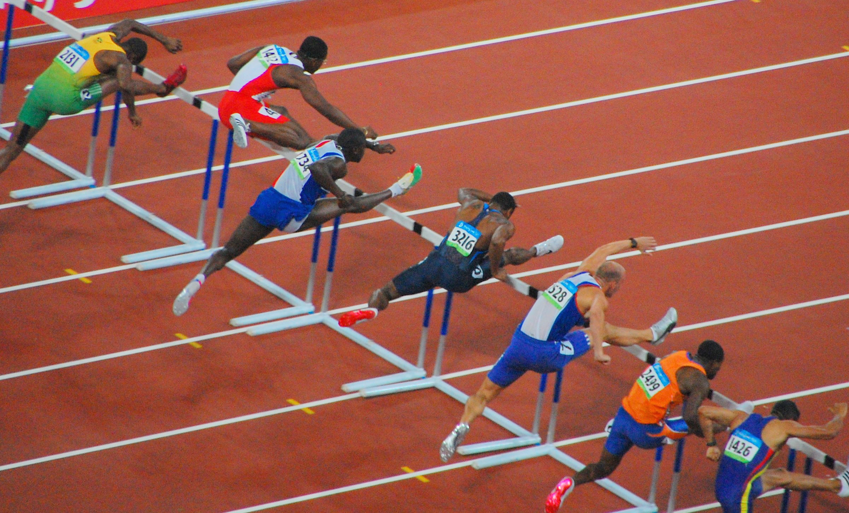

Student Task Statement
There are 10 equally-spaced hurdles on a race track. The first hurdle is 13.72 meters from the start line. The final hurdle is 14.02 meters from the finish line. The race track is 110 meters long.
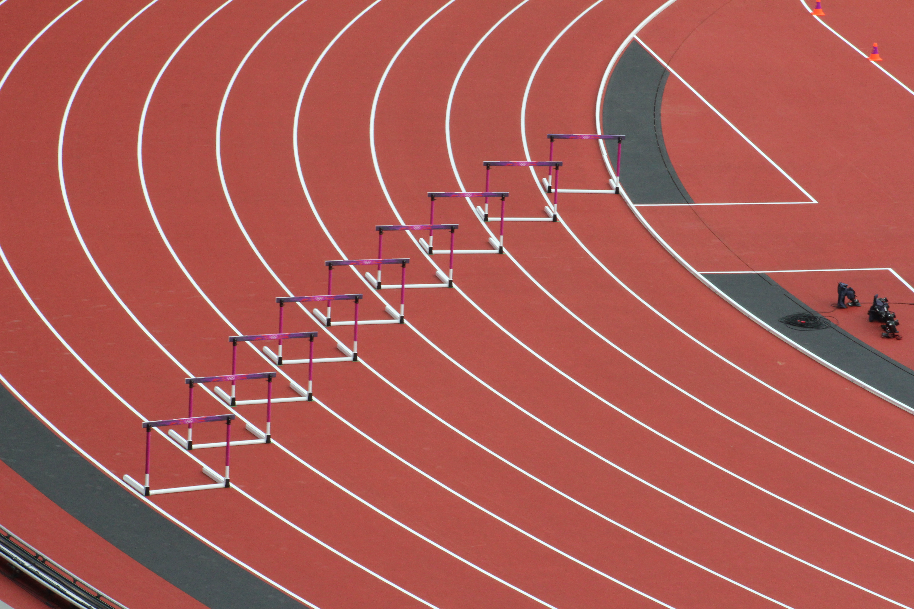
- Draw a diagram that shows the hurdles on the race track. Label all known measurements.
- How far are the hurdles from one another? Explain or show your reasoning.
- A professional runner takes 3 strides between each pair of hurdles. The runner leaves the ground 2.2 meters before the hurdle and returns to the ground 1 meter after the hurdle.
- About how long are each of the runner’s strides between the hurdles? Show your reasoning.

4 Examining a Tennis Court (Optional)

Student Task Statement
Here is a diagram of a tennis court.
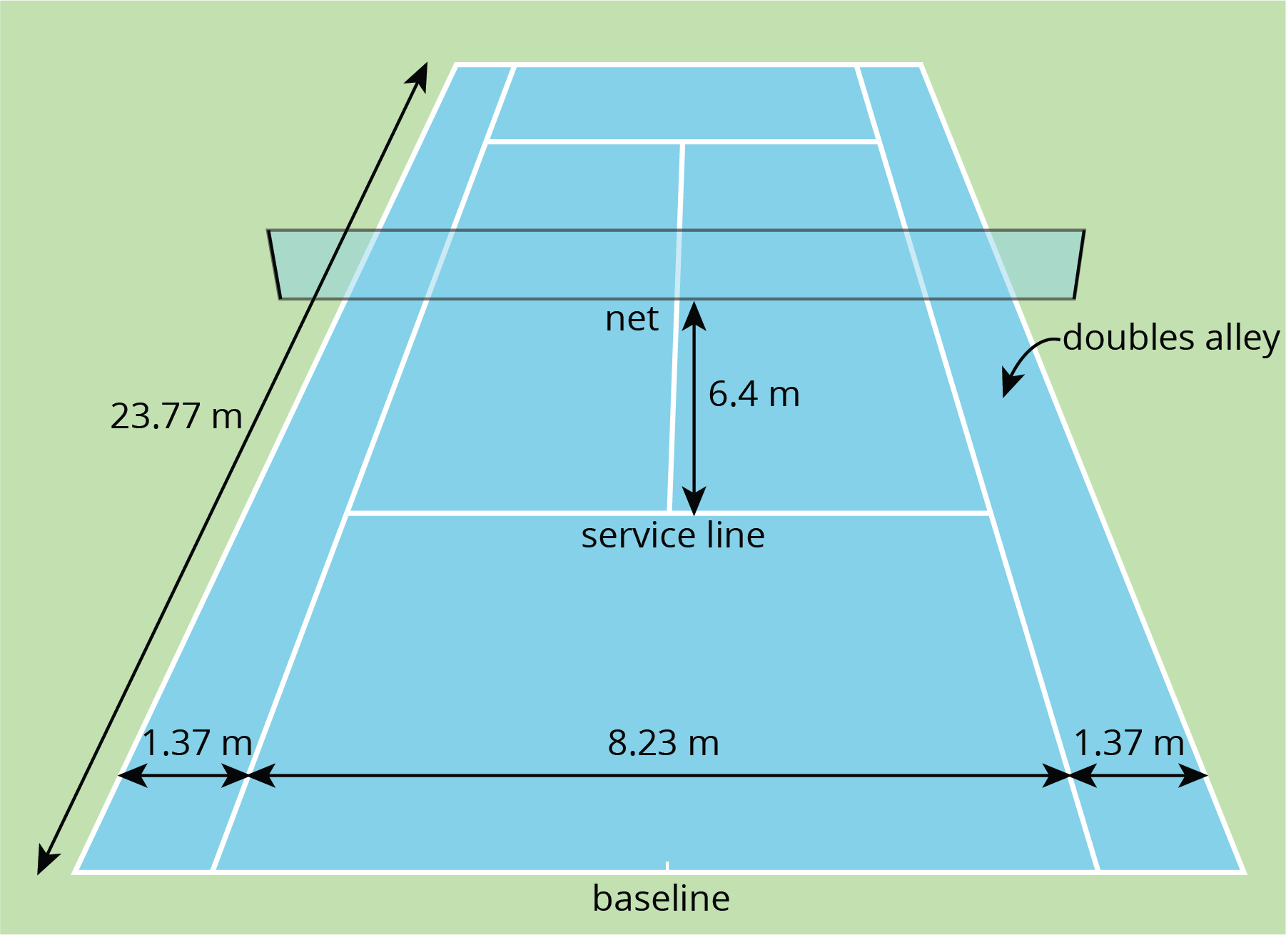
The full tennis court, used for doubles, is a rectangle. All of the angles made by the line segments in the diagram are right angles.
- The net partitions the tennis court into two halves. Is each half a square? Explain your reasoning.
- Is the service line halfway between the net and the baseline? Explain your reasoning.
- Lines painted on a tennis court are 5 cm wide. A painter made markings to show the length and width of the court, then painted the lines to the outside of the markings.
  - Did the painter’s mistake increase or decrease the overall size of the tennis court? Explain how you know.
  - By how many square meters did the court’s size change? Explain your reasoning.

Activity Synthesis
© CC BY Open Up Resources. Adaptations CC BY IM.

