Unit 5 Lesson 2: Slicing Solids

1 Slice This (Warm up)

Student Task Statement
Imagine slicing a cylinder with a straight cut. The flat surface you sliced along is called a cross section. Try to sketch all the possible kinds of cross sections of a cylinder.

2 Slice That

Student Task Statement
Your teacher will give your group a three-dimensional solid to analyze.
- Sketch predictions of all the kinds of cross sections that could be created from your solid.
- Slice your solid to confirm your predictions. Sketch any new cross sections you find after slicing.

3 Stack ‘Em Up

Student Task Statement
Each question shows several parallel cross-sectional slabs of the same three-dimensional solid. Name each solid.
- 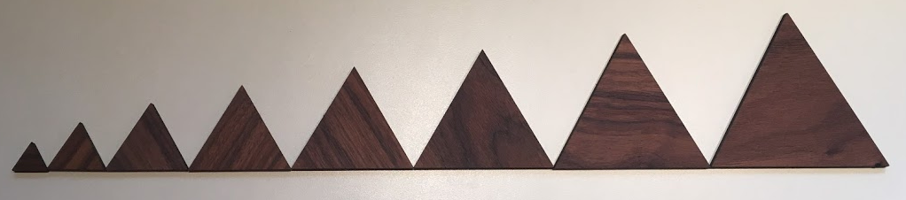
- 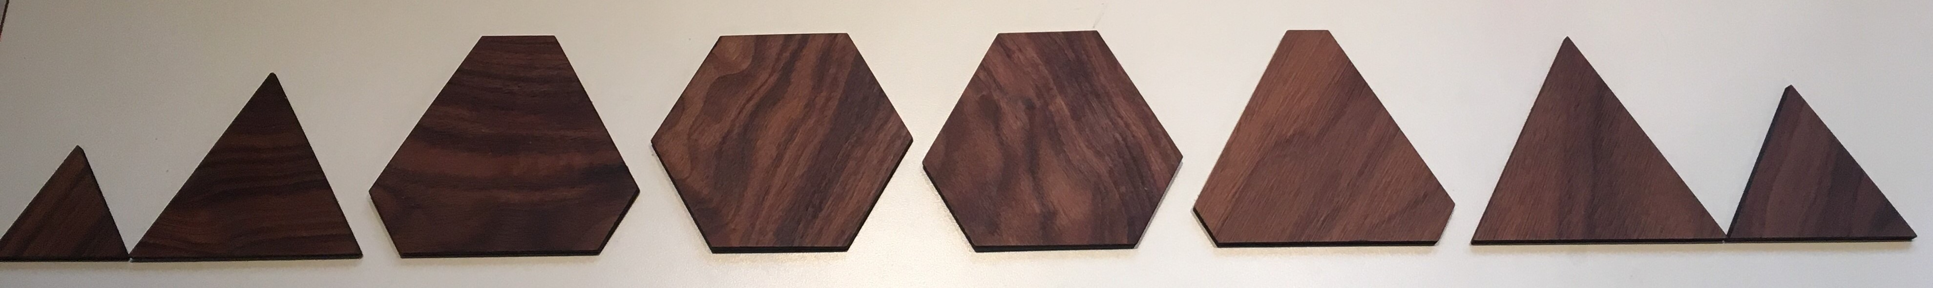
- 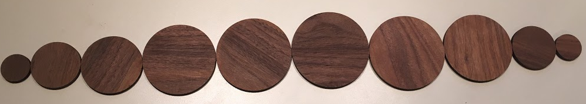

Activity Synthesis
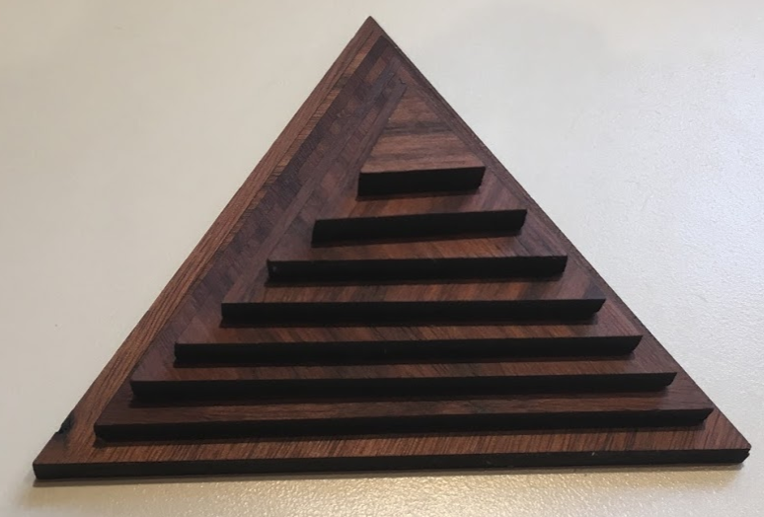
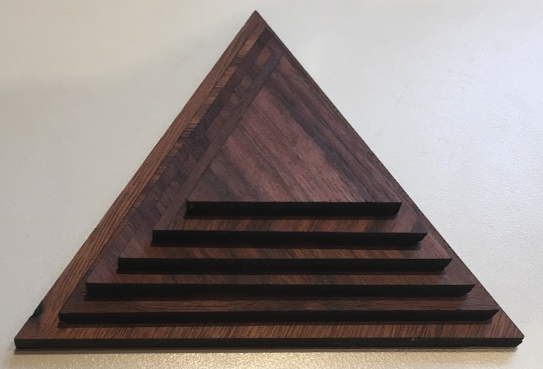
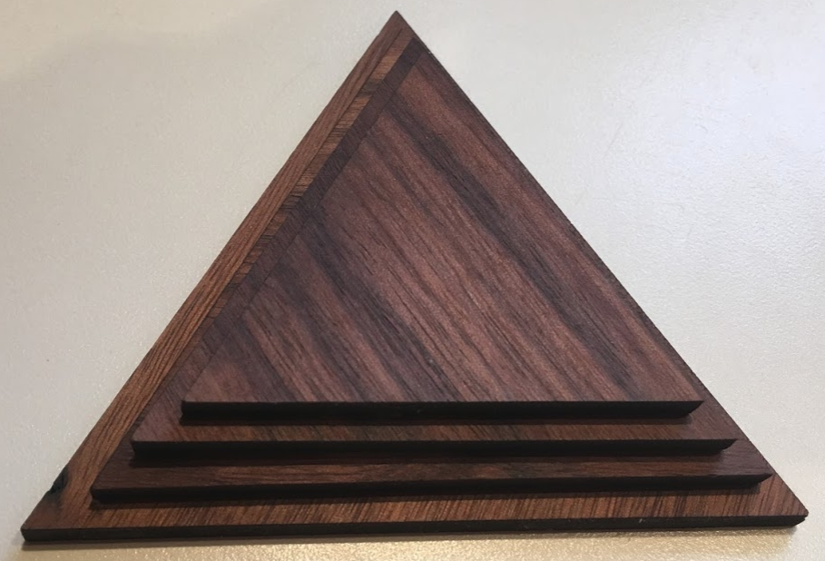
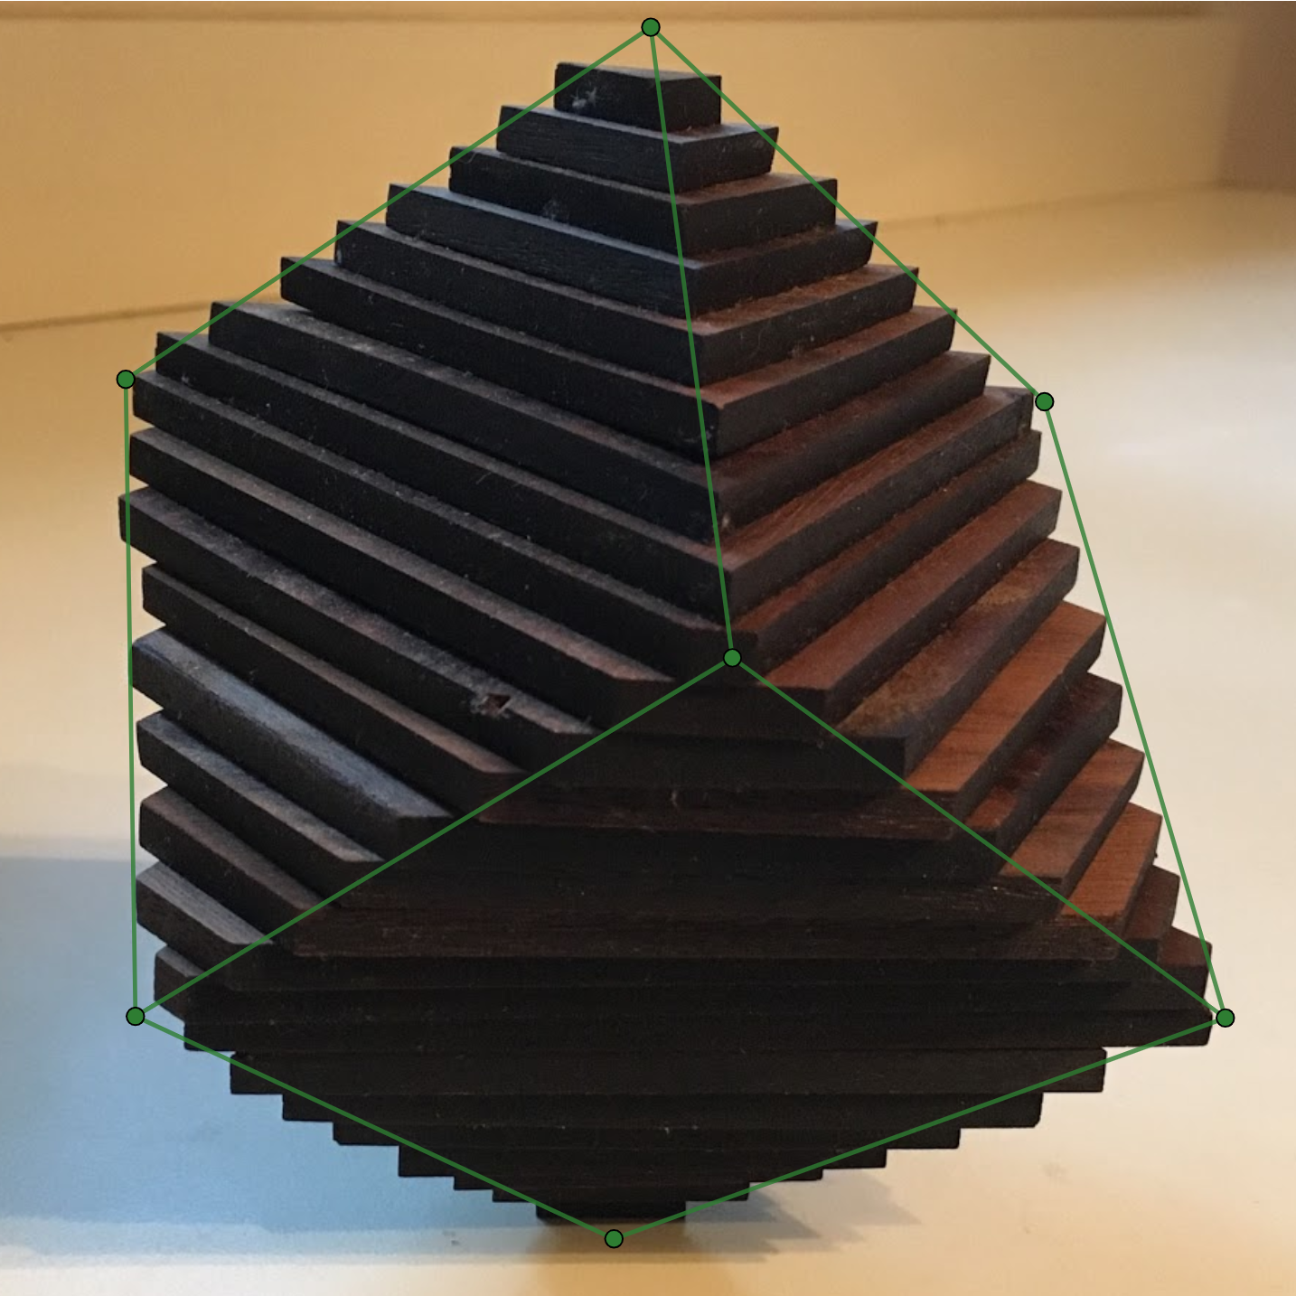
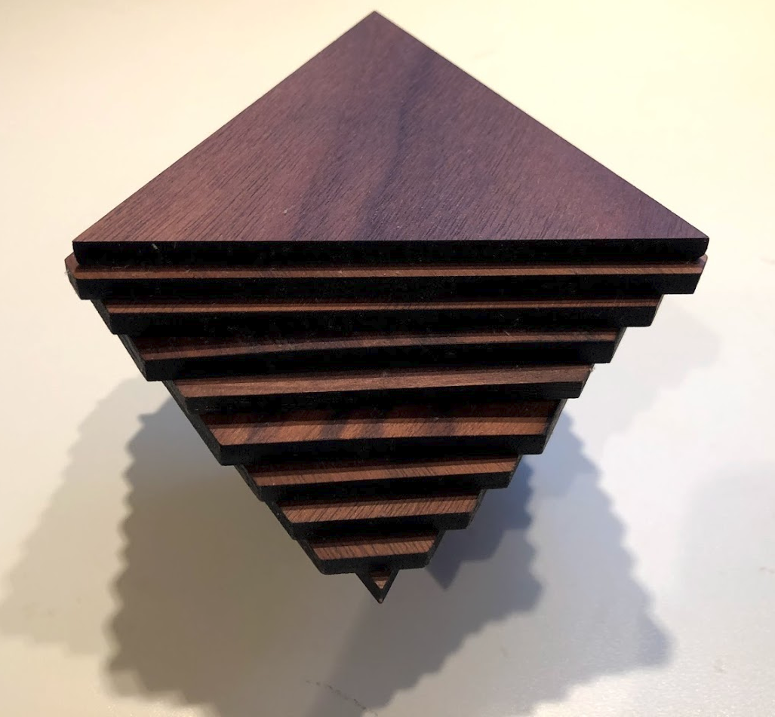
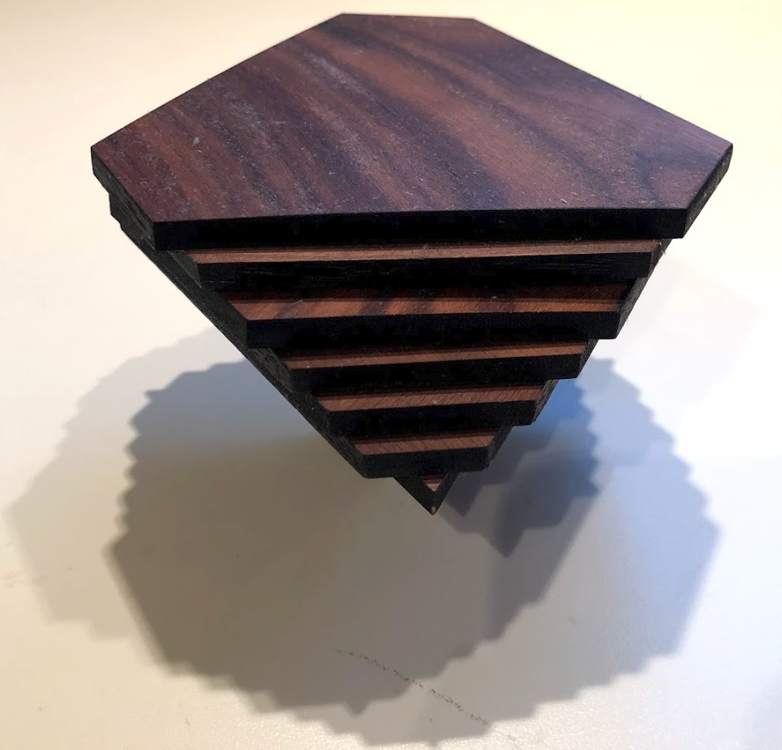
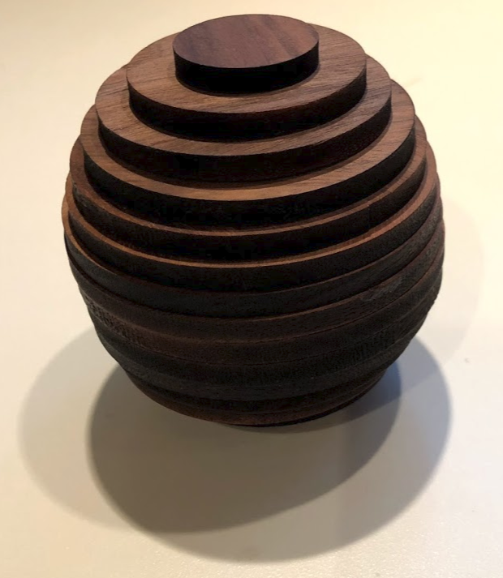
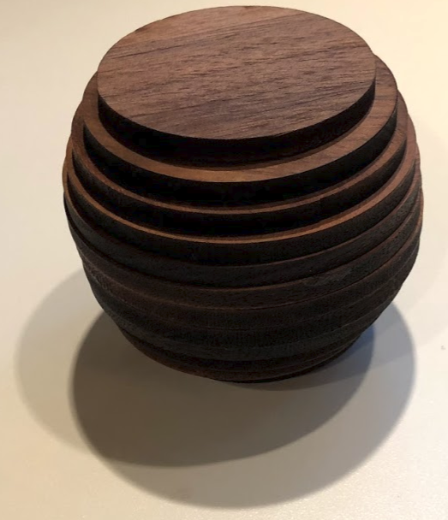
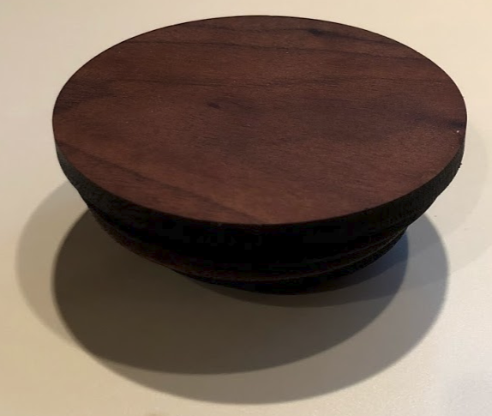
© CC BY 2019 by Illustrative Mathematics®

