Lesson 23 Practice Problems
- Here is a graph of a quadratic function $f\left(x\right)$. What is the minimum value of $f\left(x\right)$?
- 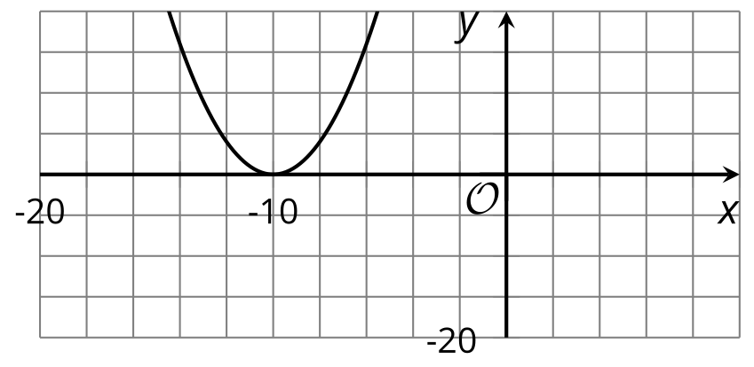
- This problem is from an earlier lesson
- The graph that represents $f\left(x\right)={\left(x+1\right)}^{2}−4$ has its vertex at $\left(\text{-}1,\text{-}4\right)$.
- Explain how we can tell from the expression ${\left(x+1\right)}^{2}−4$ that -4 is the minimum value of $f$ rather than the maximum value.
- Each expression here defines a quadratic function. Find the vertex of the graph of the function. Then, state whether the vertex corresponds to the maximum or the minimum value of the function.
  - ${\left(x−5\right)}^{2}+6$
  - ${\left(x+5\right)}^{2}−1$
  - $\text{-}2{\left(x+3\right)}^{2}−10$
  - $3{\left(x−7\right)}^{2}+11$
  - $\text{-}{\left(x−2\right)}^{2}−2$
  - ${\left(x+1\right)}^{2}$
- Consider the equation $x^{2}=12x$.
  - Can we use the quadratic formula to solve this equation? Explain or show how you know.
  - Is it easier to solve this equation by completing the square or by rewriting it in factored form and using the zero product property? Explain or show your reasoning.
- (From Unit 7, Lesson 19.)
- Match each equation to the number of solutions it has.
  - $\left(x−1\right)\left(x−5\right)=5$
  - $x^{2}−2x=\text{-}1$
  - ${\left(x−5\right)}^{2}=\text{-}25$
  - no solutions
  - 1 solution
  - 2 solutions
- (From Unit 7, Lesson 17.)
- Which equation has irrational solutions?
  - $100x^{2}=9$
  - $9{\left(x−1\right)}^{2}=4$
  - $4x^{2}−1=0$
  - $9{\left(x+3\right)}^{2}=27$
- (From Unit 7, Lesson 20.)
- Let $I$ represent an irrational number and let $R$ represent a rational number. Decide if each statement is true or false. Explain your thinking.
  - $R⋅I$ can be rational.
  - $I⋅I$ can be rational.
  - $R⋅R$ can be rational.
- (From Unit 7, Lesson 21.)
- Here are graphs of the equations $y=x^{2}$, $y={\left(x−3\right)}^{2}$, and $y={\left(x−3\right)}^{2}+7$.
  - How do the 3 graphs compare?
  - 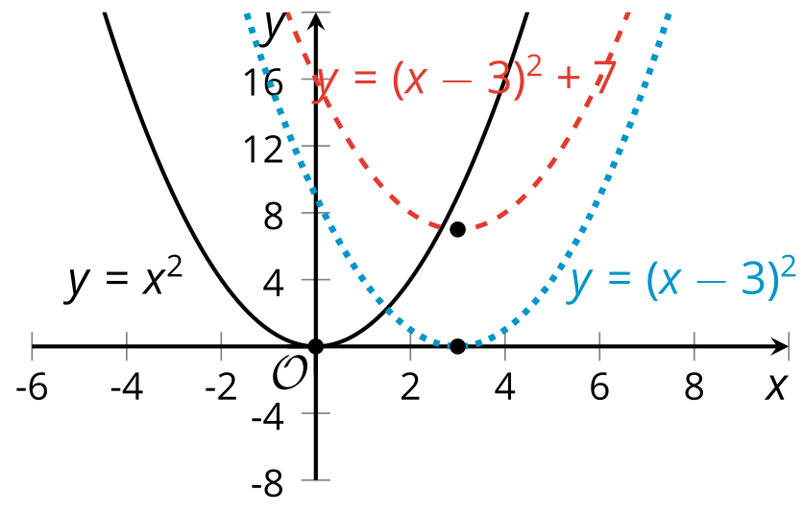
  - How does the -3 in ${\left(x−3\right)}^{2}$ affect the graph?
  - How does the +7 in ${\left(x−3\right)}^{2}+7$ affect the graph?
- (From Unit 6, Lesson 17.)
- Three $5,000 loans have different annual interest rates. Loan A charges 10.5% annual interest, Loan B charges 15.75%, and Loan C charges 18.25%.
  - If we graph the amount owed as a function of years without payment, what would the three graphs look like? Describe or sketch your prediction.
  - Use technology to graph each function. Based on your graphs, if no payments are made, about how many years will it take for the unpaid balance of each loan to triple?
- (From Unit 5, Lesson 15.)
© CC BY 2019 by Illustrative Mathematics®

