Lesson 7: Accurate Representations
- Let’s represent situations precisely.

7.1: Possible Rectangles
A rectangle has a perimeter of 40 centimeters.
Here are some lengths in centimeters. Determine if each one could be a length of this rectangle. Be prepared to explain your reasoning.
- 10
- 4.5
- 20
- 32
- -10
- 0
- $\frac{21}{4}$

7.2: Which Graph Represents It the Best?
For each situation, several graphs are given. Which graph represents the situation the best? Be prepared to explain your reasoning.
- The fine for an overdue book at the library is $0.25 per day, up to a maximum of $6. $x$ represents time in days, $y$ represents the fine in dollars.

- A
- 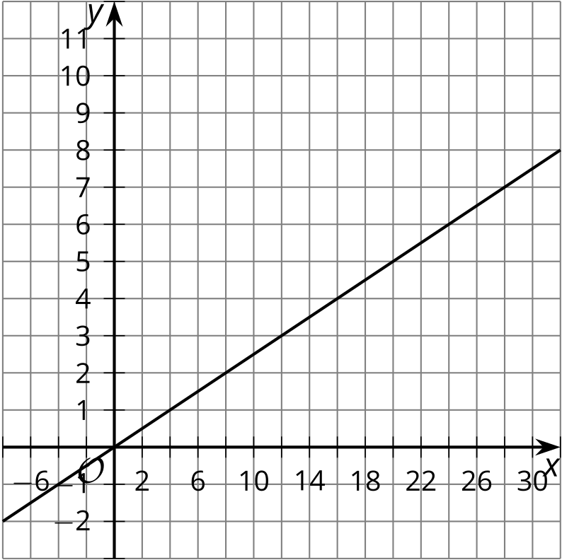

- B
- 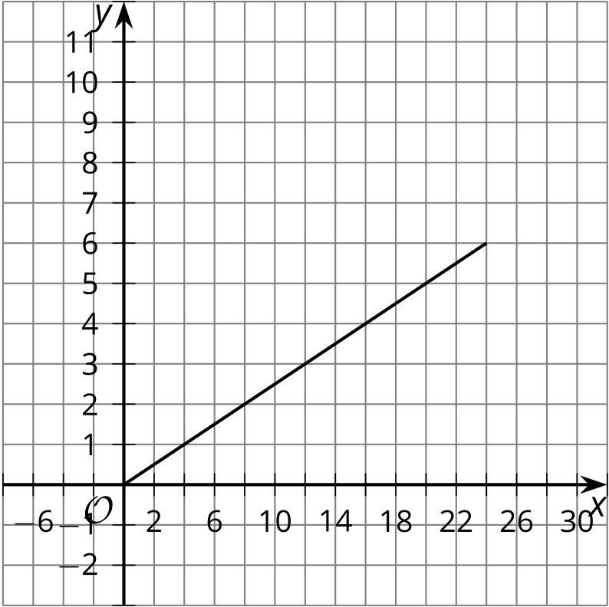

- C
- 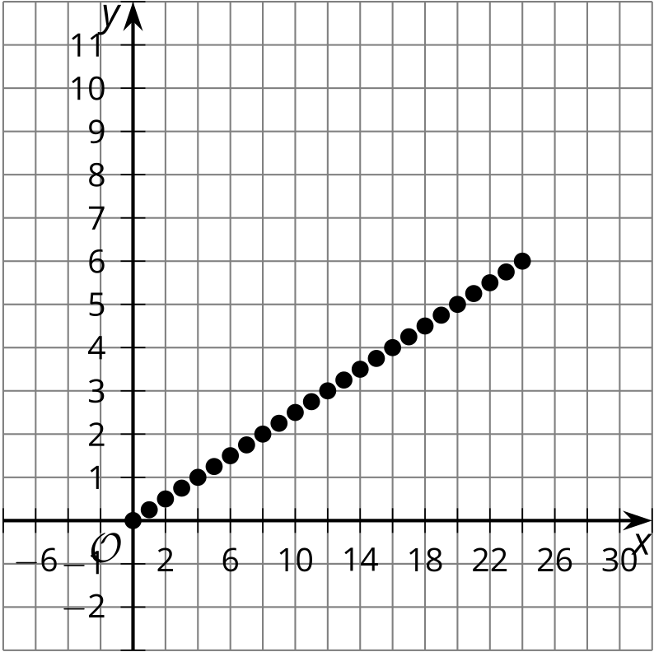

- D
- 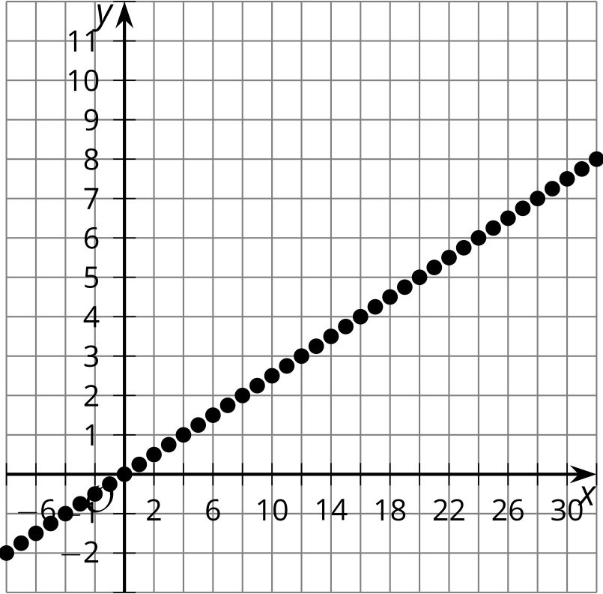
- A tank that starts with 25 gallons of water drains at a rate of 2 gallons per minute. $x$ represents time in minutes, and $y$ represents volume of water in tank in gallons.

- A
- 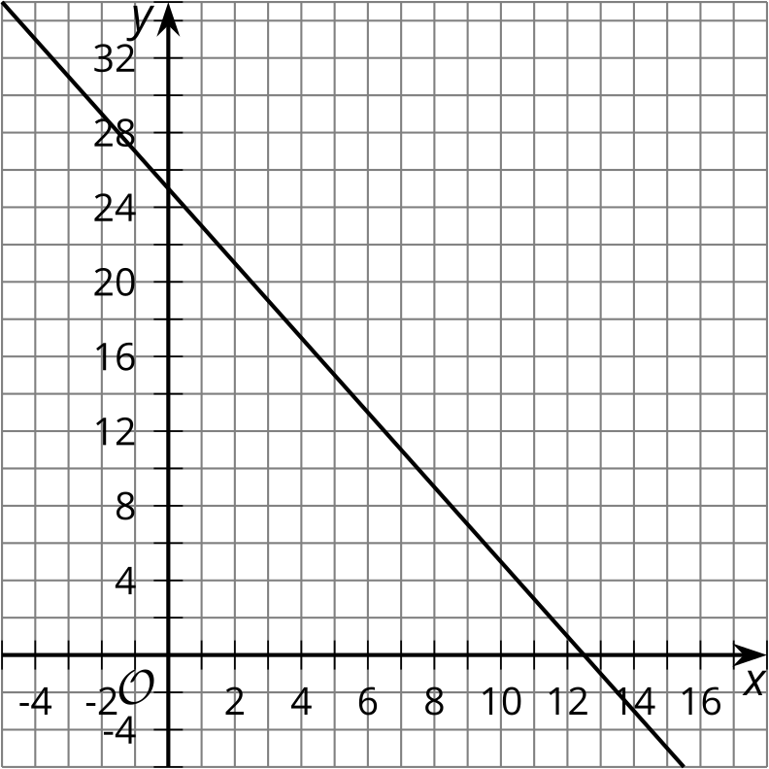

- B
- 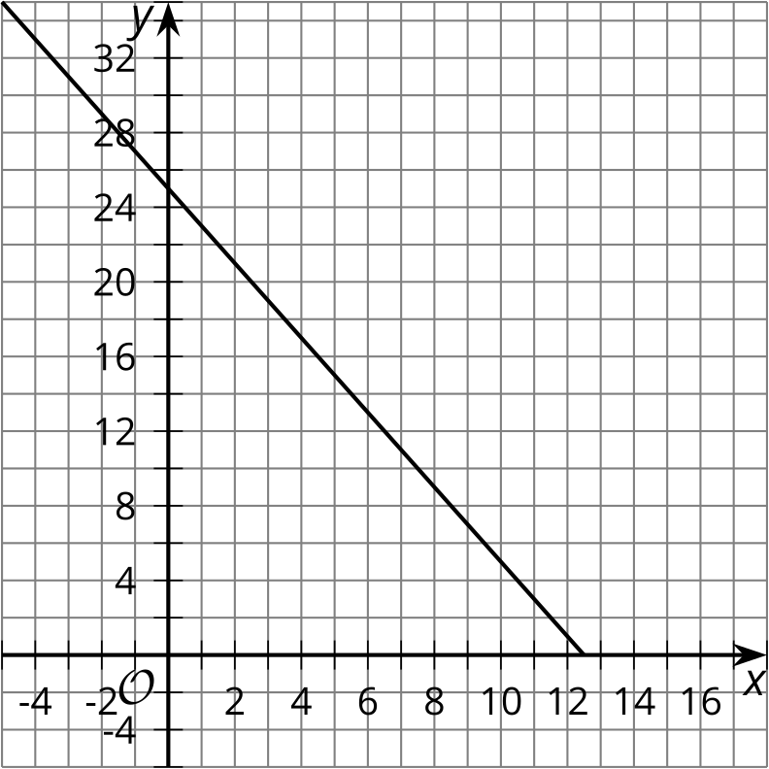

- C
- 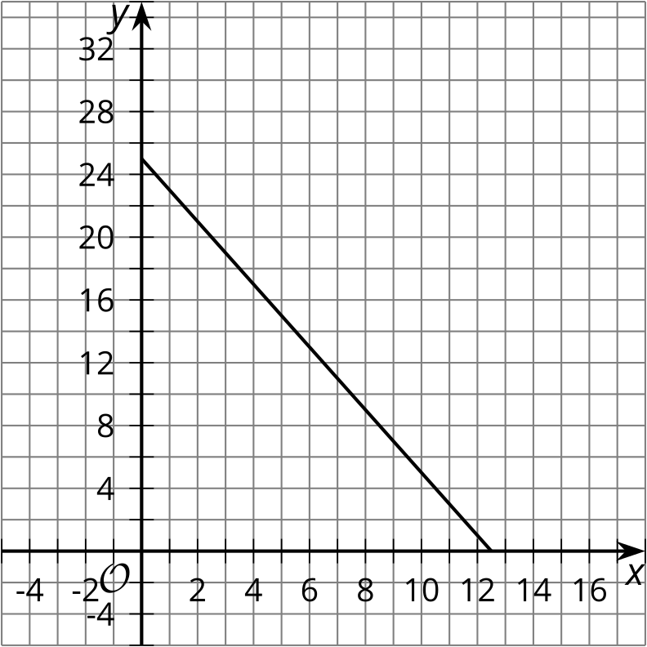

- D
- 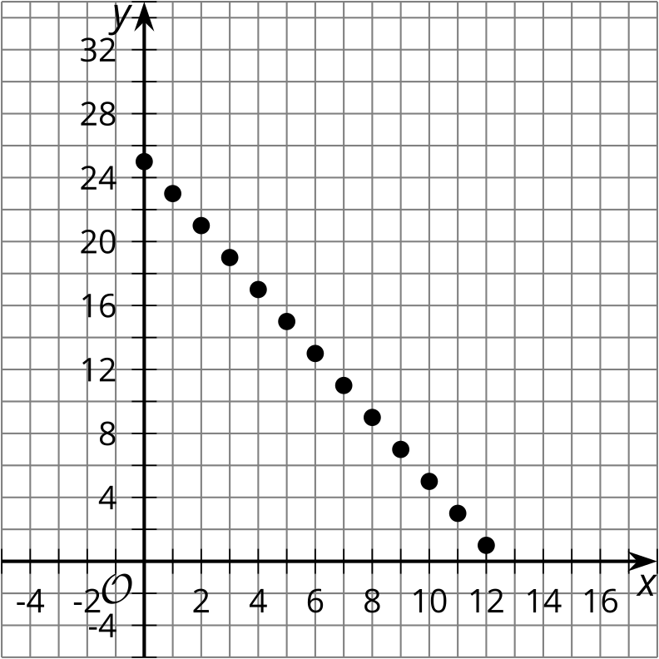
- Someone folds a paper in half, then in half again repeatedly. After each fold, the thickness of the folded paper increases. $x$ represents number of folds, and $y$ represents thickness in layers.

- A
- 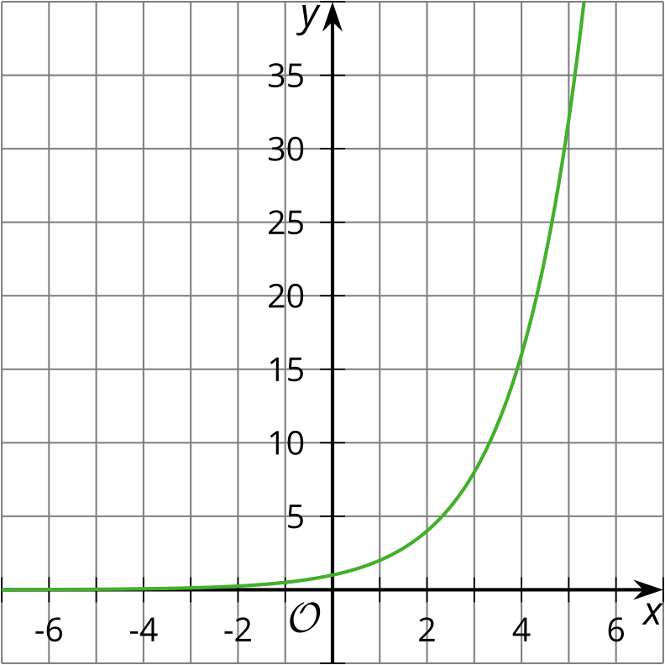

- B
- 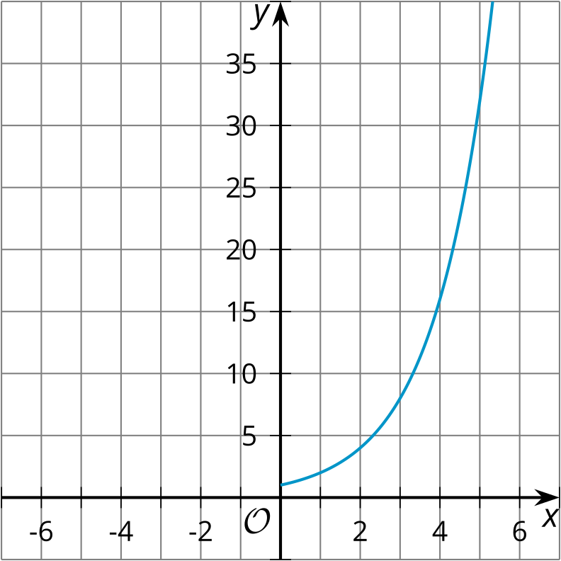

- C
- 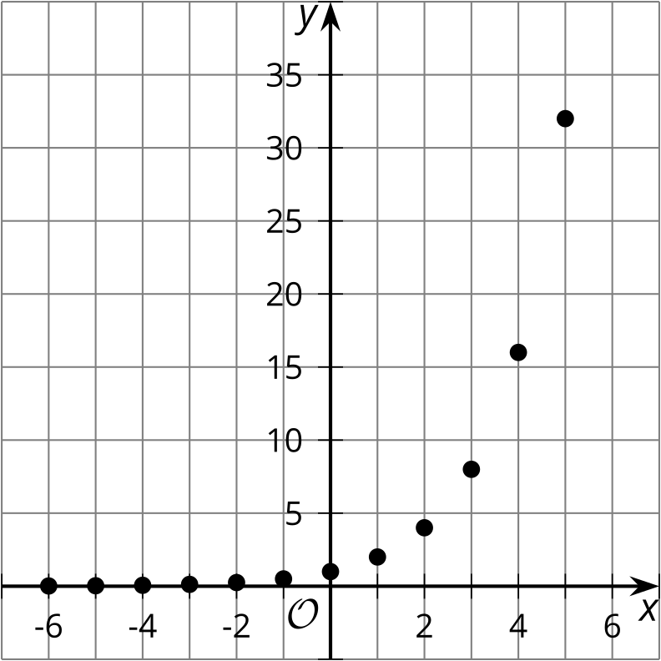

- D
- 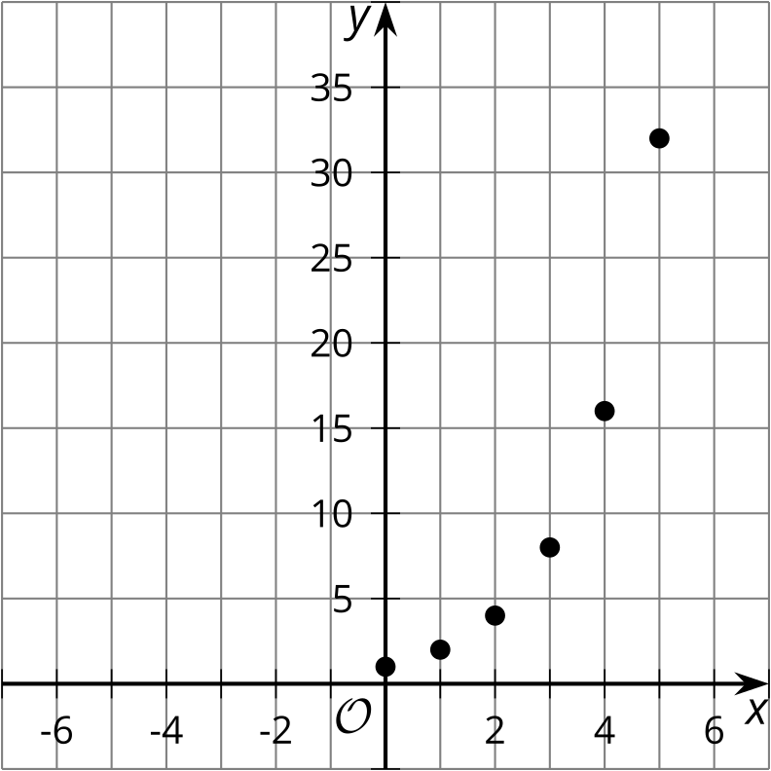
- A t-shirt company offers deals on bulk purchases. Shirts cost $5 each if you purchase less than 10, and they cost $4 each if you purchase 10 or more. $x$ represents number of shirts purchased, and $y$ represents cost of shirts in dollars.

- A
- 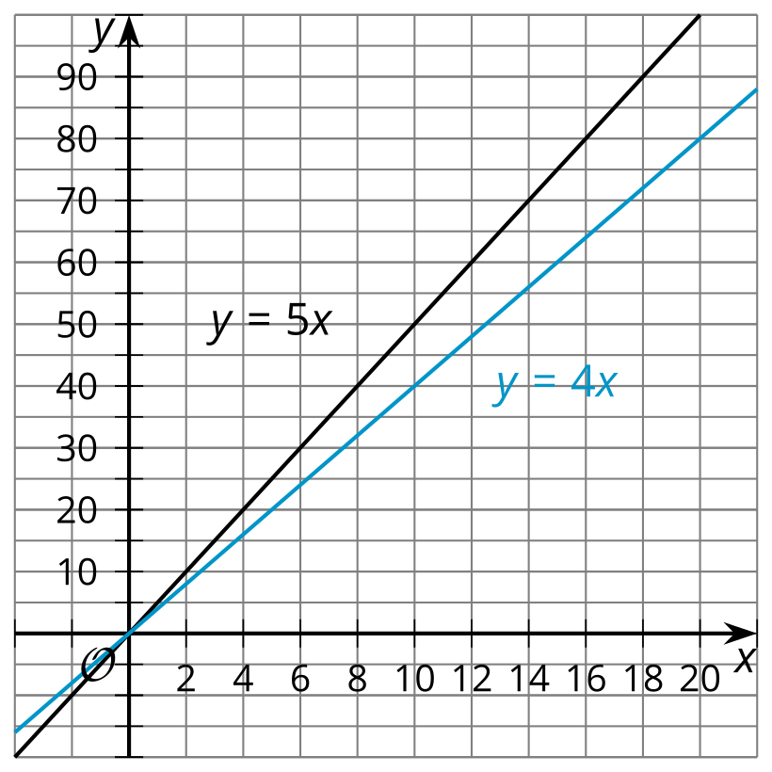

- B
- 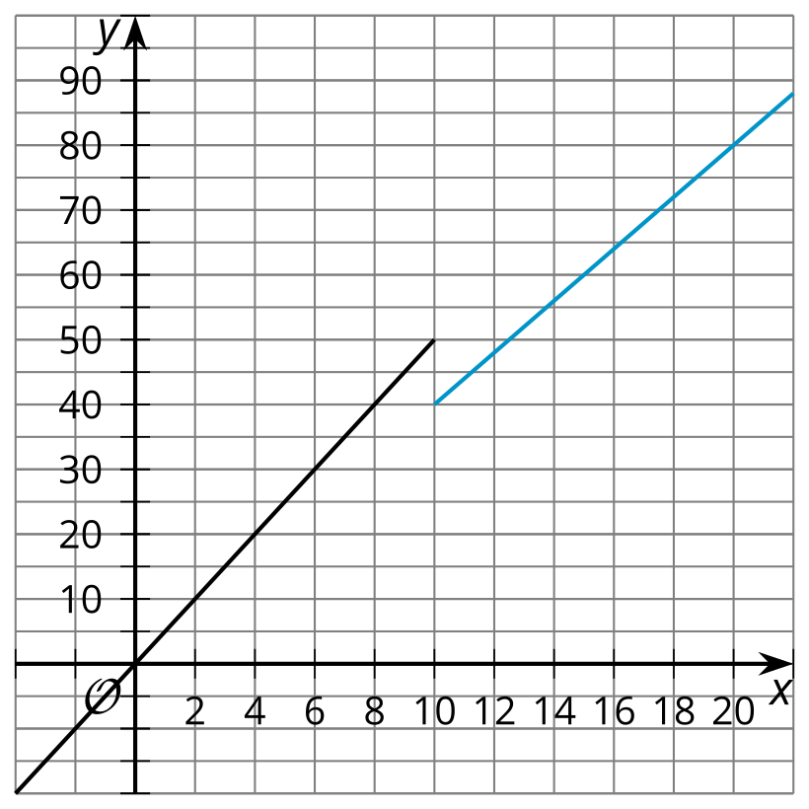

- C
- 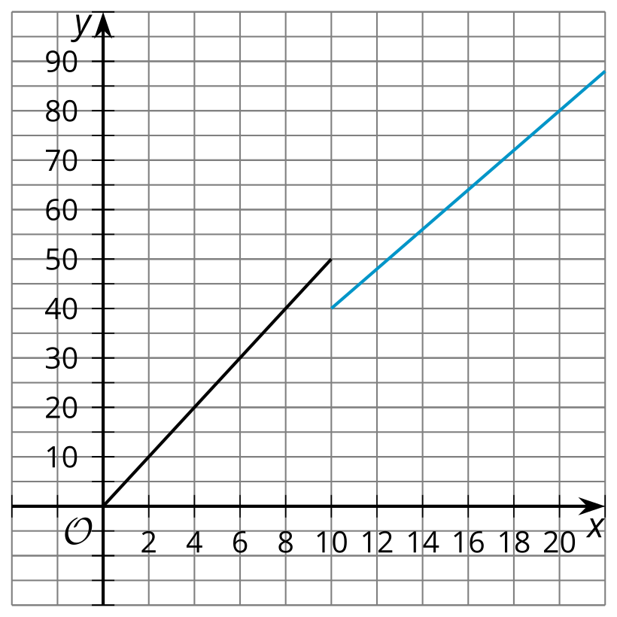

- D
- 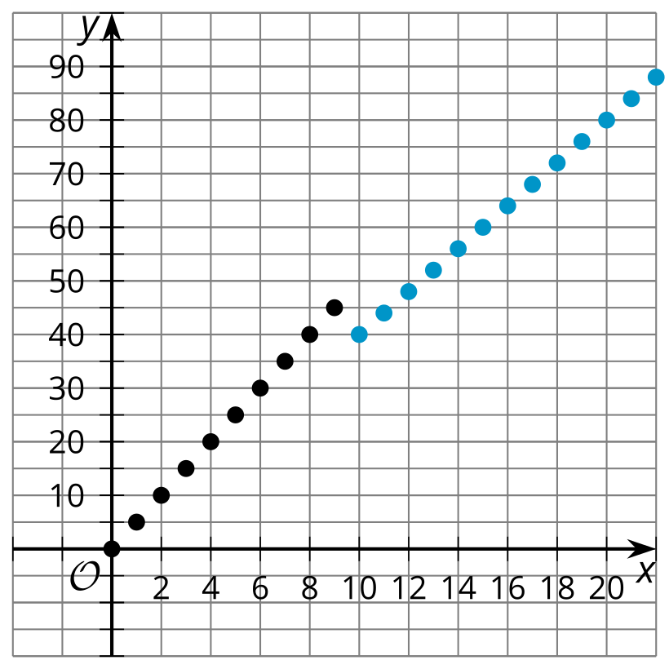

7.3: Refining the Representation
- At the concession stand, popcorn costs $2 and bananas cost $1. Clare spent $16 on popcorn and bananas for her family.
- 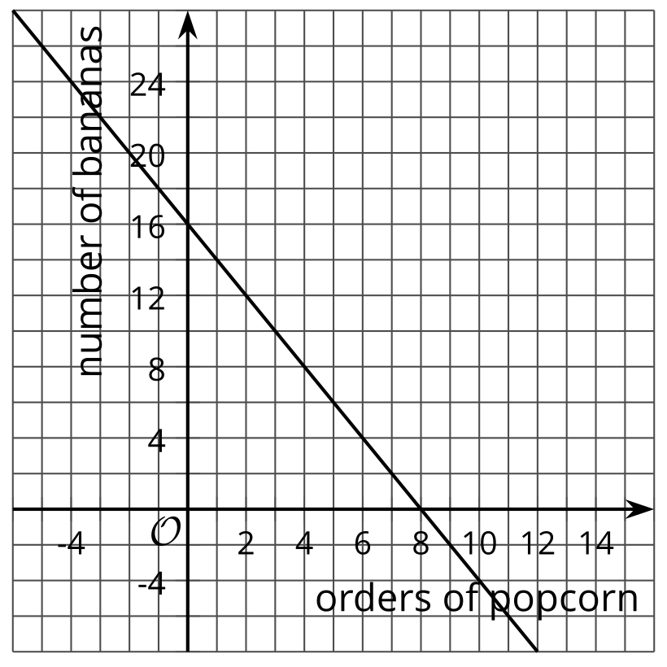
  - Explain why each of these points on the graph do not make sense in the situation:
    - $\left(\text{-}2,20\right)$
    - $\left(1.5,13\right)$
    - $\left(10,\text{-}4\right)$
  - Sketch a graph that better represents the situation. Explain your reasoning.
  - 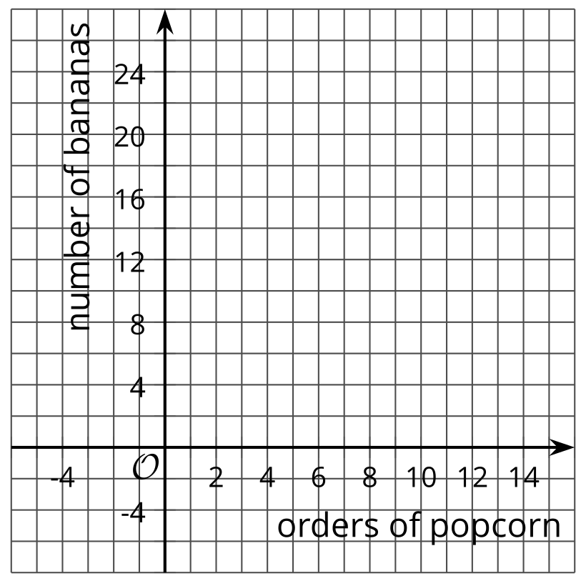
  - ​​​​​​
- The height in feet of a baseball over time, in seconds, is modeled by the function $h$ given by the equation $h\left(t\right)=3+60t−16t^{2}$. A graph of the function is shown.
- 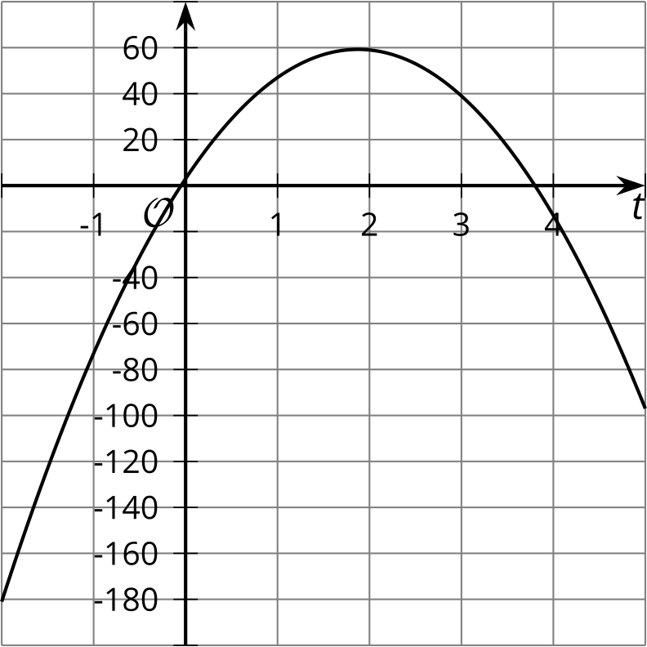
  - Choose two points that are on the graph but do not make sense with the context. Explain your reasoning.
  - Sketch a graph that better represents the situation.
  - 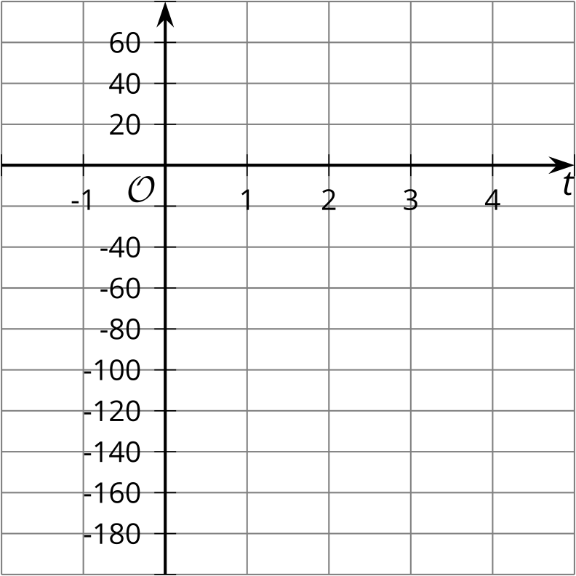
  - What point represents the baseball landing on the ground?
© CC BY 2019 by Illustrative Mathematics®

