Unit 5 Lesson 13: Dividing Decimals by Decimals

1 Same Values (Warm up)

Student Task Statement
- Use long division to find the value of $5.04÷7$.

- Select all of the quotients that have the same value as $5.04÷7$. Be prepared to explain how you know.
  - $5.04÷70$
  - $50.4÷70$
  - $504,​000÷700$
  - $504,​000÷700,​000$

2 Placing Decimal Points in Quotients

Student Task Statement
- Think of one or more ways to find $3÷0.12$. Show your reasoning.
- Find $1.8÷0.004$. Show your reasoning. If you get stuck, think about what equivalent division expression you could write.
- Diego said, “To divide decimals, we can start by moving the decimal point in both the dividend and divisor by the same number of places and in the same direction. Then we find the quotient of the resulting numbers.”
- Do you agree with Diego? Use the division expression $7.5÷1.25$ to support your answer.

3 Two Ways to Calculate Quotients of Decimals (Optional)

Student Task Statement
- Here are two calculations of $48.78÷9$. Work with your partner to answer the following questions.
- 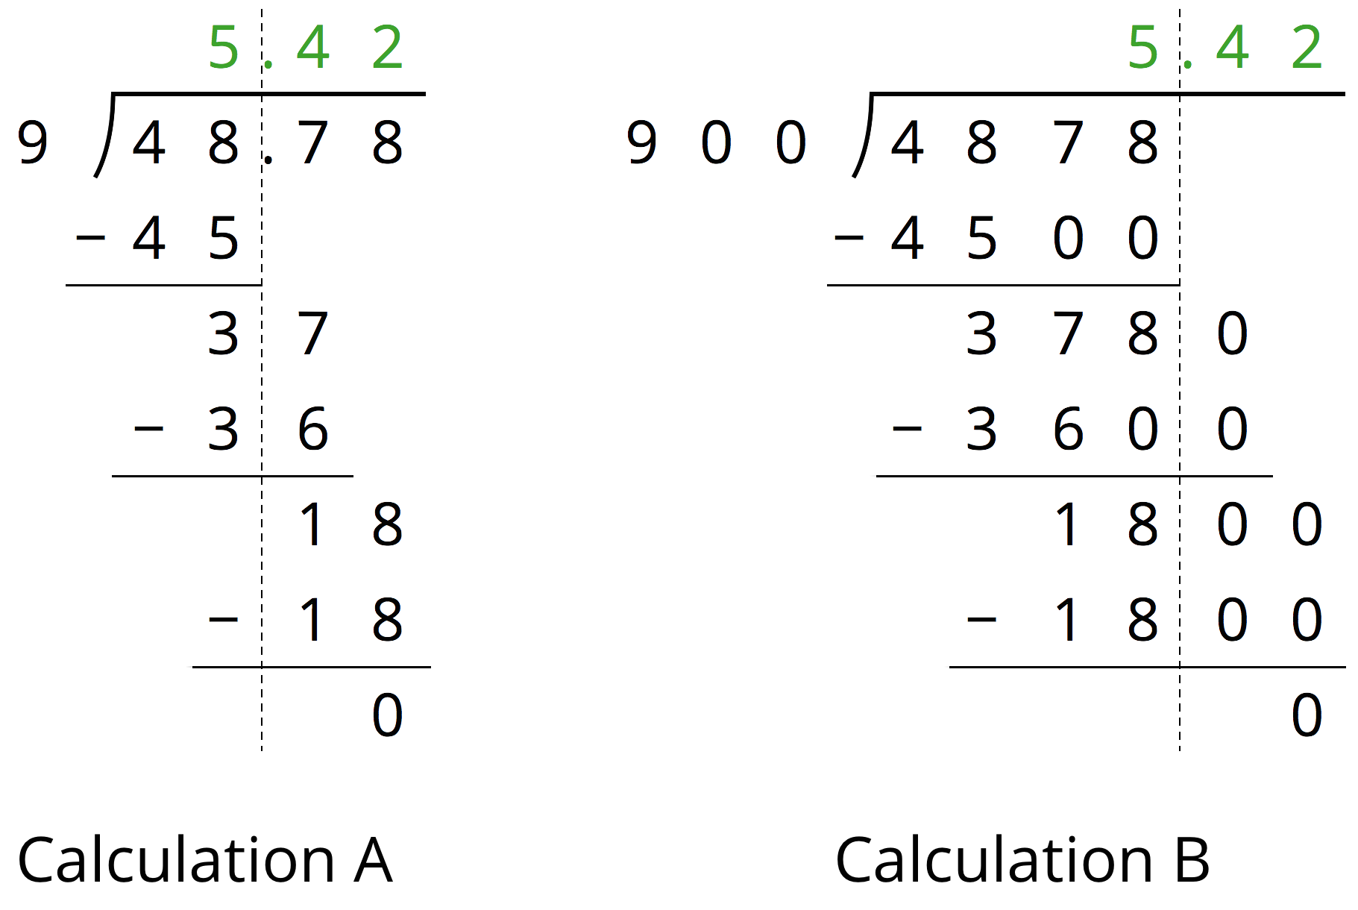
  - How are the two calculations the same? How are they different?
  - Look at Calculation A. Explain how you can tell that the 36 means “36 tenths” and the 18 means “18 hundredths.”
  - Look at Calculation B. What do the 3600 and 1800 mean?
  - We can think of $48.78÷9=5.42$ as saying, “There are 9 groups of 5.42 in 48.78.” We can think of $4878÷900=5.42$ as saying, “There are 900 groups of 5.42 in 4878.” How might we show that both statements are true?

  - Explain why $51.2÷6.4$ has the same value as $5.12÷0.64$.
  - Write a division expression that has the same value as $51.2÷6.4$ but is easier to use to find the value. Then, find the value using long division.

4 Practicing Division with Decimals

Student Task Statement
Find each quotient. Discuss your quotients with your group and agree on the correct answers. Consult your teacher if the group can't agree.
- $106.5÷3$
- $58.8÷0.7$
- $257.4÷1.1$
- Mai is making friendship bracelets. Each bracelet is made from 24.3 cm of string. If she has 170.1 cm of string, how many bracelets can she make? Explain or show your reasoning.
© CC BY Open Up Resources. Adaptations CC BY IM.

