Lesson 10 Practice Problems
- Priya is sharing 24 apples equally with some friends. She uses division to determine how many people can have a share if each person gets a particular number of apples. For example, $24÷4=6$ means that if each person gets 4 apples, then 6 people can have apples. Here are some other calculations:
- $24÷4=6$
- $24÷2=12$
- $24÷1=24$
- $24÷\frac{1}{2}=?$
  - Priya thinks the “?” represents a number less than 24. Do you agree? Explain or show your reasoning.
  - In the case of $24÷\frac{1}{2}=?$, how many people can have apples?
- Here is a centimeter ruler.
  - Use the ruler to find $1÷\frac{1}{10}$ and $4÷\frac{1}{10}$.
  - What calculation did you do each time?
  - Use this pattern to find $18÷\frac{1}{10}$.
  - Explain how you could find $4÷\frac{2}{10}$ and $4÷\frac{8}{10}$.
- 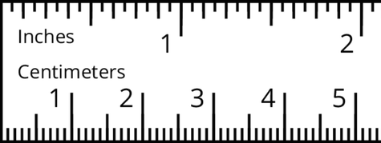
- Find each quotient.
  - $5÷\frac{1}{10}$
  - $5÷\frac{3}{10}$
  - $5÷\frac{9}{10}$
- Use the fact that $2\frac{1}{2}÷\frac{1}{8}=20$ to find $2\frac{1}{2}÷\frac{5}{8}$. Explain or show your reasoning.
- Consider the problem: It takes one week for a crew of workers to pave $\frac{3}{5}$ kilometer of a road. At that rate, how long will it take to pave 1 kilometer?
- Write a multiplication equation and a division equation to represent the question. Then find the answer and show your reasoning.
- (From Unit 4, Lesson 9.)
- A box contains $1\frac{3}{4}$ pounds of pancake mix. Jada used $\frac{7}{8}$ pound for a recipe. What fraction of the pancake mix in the box did she use? Explain or show your reasoning. Draw a diagram, if needed.
- (From Unit 4, Lesson 7.)
- Calculate each percentage mentally.
  - 25% of 400
  - 50% of 90
  - 75% of 200
  - 10% of 8,000
  - 5% of 20
- (From Unit 3, Lesson 14.)
© CC BY Open Up Resources. Adaptations CC BY IM.

