Unit 1 Lesson 10: What is Surface Area?

1 Covering the Cabinet (Part 1) (Warm up)

Images for Launch
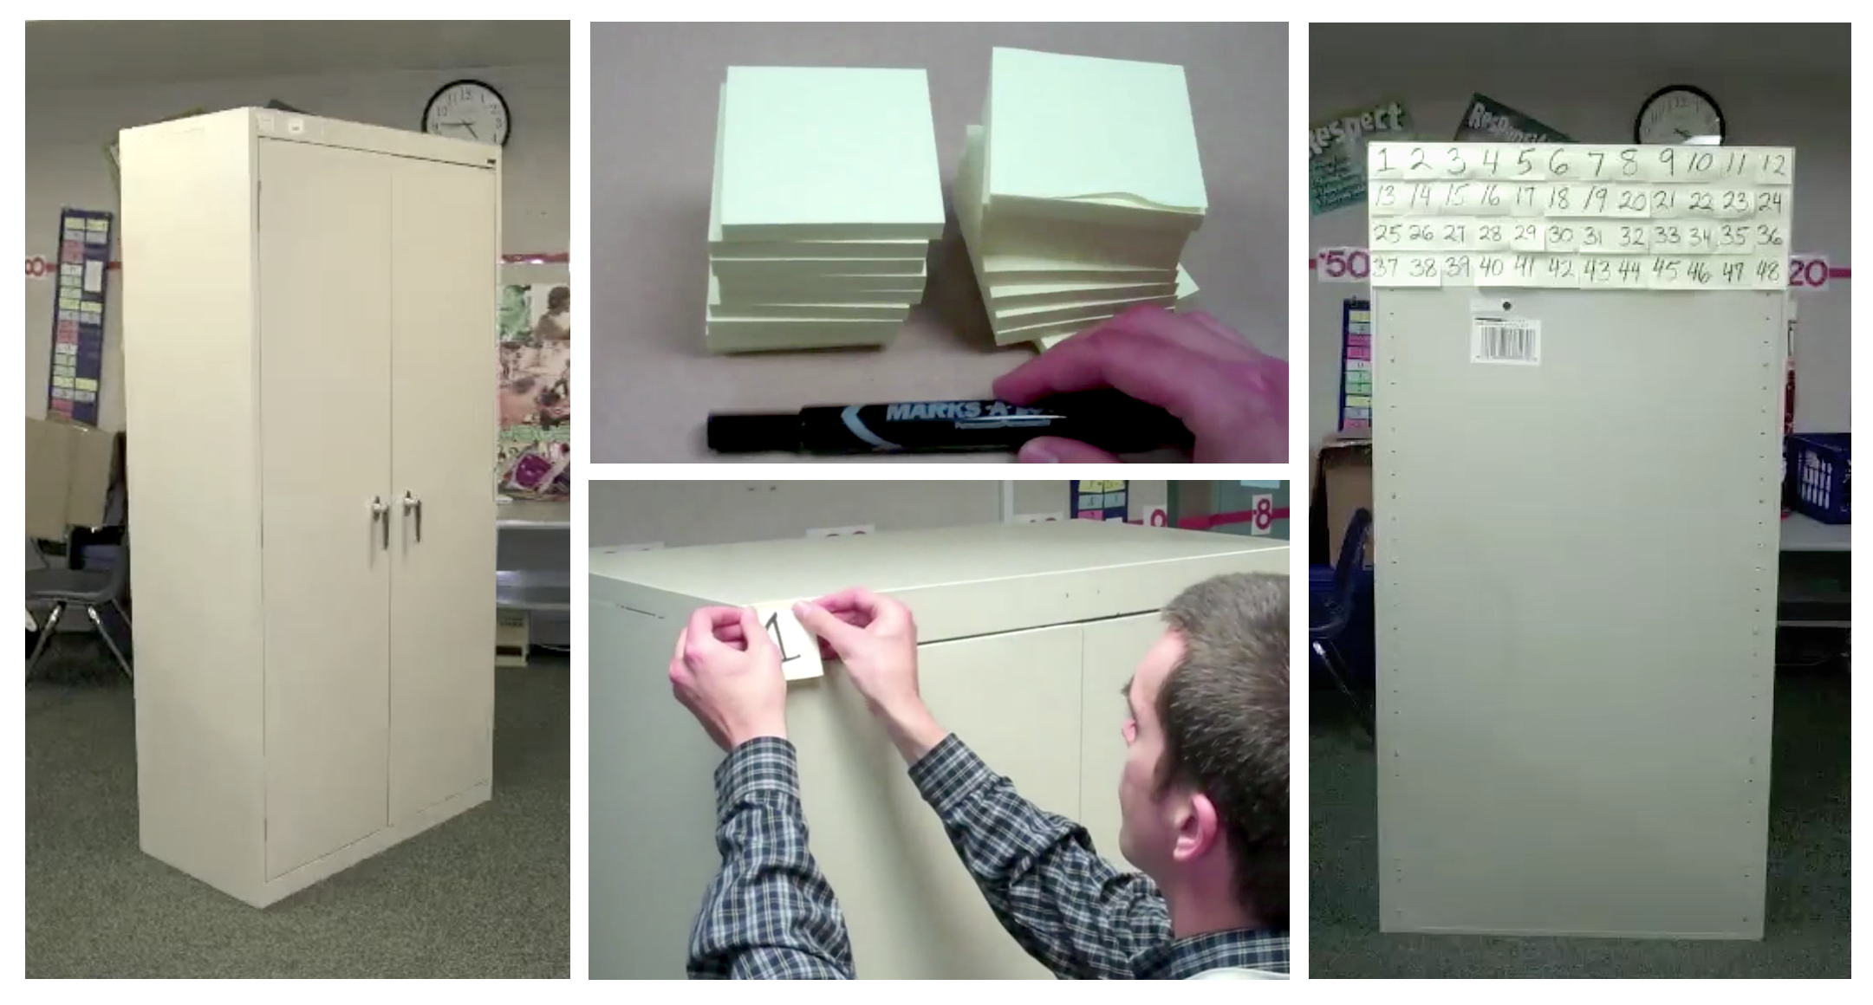

Student Task Statement
Your teacher will show you a video about a cabinet or some pictures of it.
Estimate an answer to the question: How many sticky notes would it take to cover the cabinet, excluding the bottom?

2 Covering the Cabinet (Part 2)

Student Task Statement
Earlier, you learned about a cabinet being covered with sticky notes.
- How could you find the actual number of sticky notes it will take to cover the cabinet, excluding the bottom? What information would you need to know?
- Use the information you have to find the number of sticky notes to cover the cabinet. Show your reasoning.

3 Building with Snap Cubes

Student Task Statement
Here is a sketch of a rectangular prism built from 12 cubes:
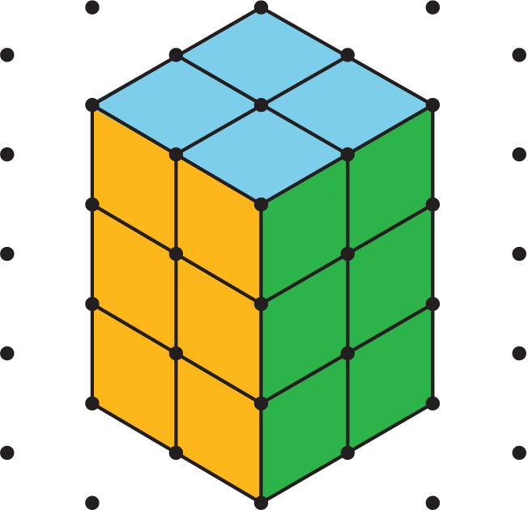
It has six faces, but you can only see three of them in the sketch. It has a surface area of 32 square units.
Your teacher will give you 12 snap cubes. Use all of your snap cubes to build a different rectangular prism (with different edge lengths than the prism shown here).
- How many faces does your figure have?
- What is the surface area of your figure in square units?
- Draw your figure on isometric dot paper. Color each face a different color.
© CC BY Open Up Resources. Adaptations CC BY IM.

