Lesson 4 Practice Problems
- A quadrilateral $ABCD$ has the given angle measures. Select all measurements which could come from a cyclic quadrilateral.
  - angle $A$ is 90$​^{∘}$, angle $B$ is 90$​^{∘}$, angle $C$ is 90$​^{∘}$, and angle $D$ is 90$​^{∘}$
  - angle $A$ is 80$​^{∘}$, angle $B$ is 80$​^{∘}$, angle $C$ is 100$​^{∘}$, and angle $D$ is 100$​^{∘}$
  - angle $A$ is 70$​^{∘}$, angle $B$ is 110$​^{∘}$, angle $C$ is 70$​^{∘}$, and angle $D$ is 110$​^{∘}$
  - angle $A$ is 60$​^{∘}$, angle $B$ is 50$​^{∘}$, angle $C$ is 120$​^{∘}$, and angle $D$ is 130$​^{∘}$
  - angle $A$ is 50$​^{∘}$, angle $B$ is 40$​^{∘}$, angle $C$ is 120$​^{∘}$, and angle $D$ is 150$​^{∘}$
- Quadrilateral $ABCD$ is cyclic with given angle measures.
  - What is the measure of angle $C$?
  - What is the measure of angle $D$?
- 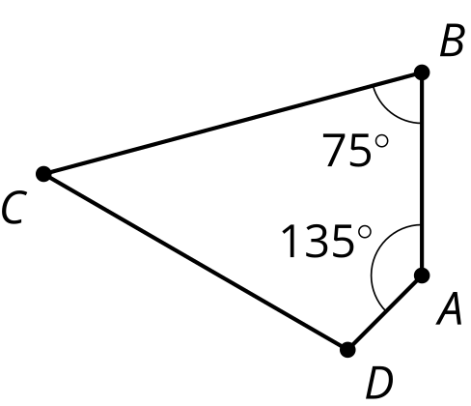

- Lin is looking at cyclic quadrilateral $ABCD$. She says, “I’m not convinced that opposite angles of cyclic quadrilaterals always add up to 180 degrees. For example, in this diagram, suppose we moved point $A$ to a different spot on the circle. Angle $BCD$ would still measure 100 degrees, but now angle $BAD$ would have a different measure, and they wouldn’t add up to 180.”
- Do you agree with Lin? Explain or show your reasoning.
- 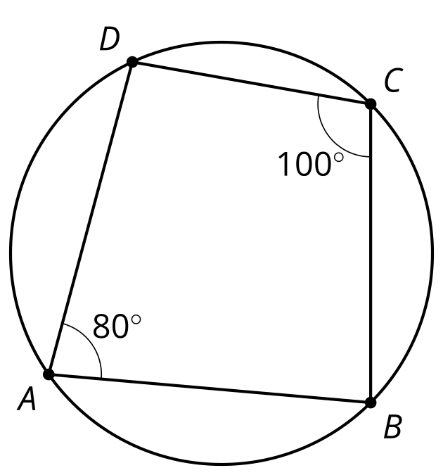
- Line $AC$ is tangent to the circle centered at $O$ with radius 3 units. The length of segment $AC$ is 4.5 units. Find the length of segment $AB$.
- 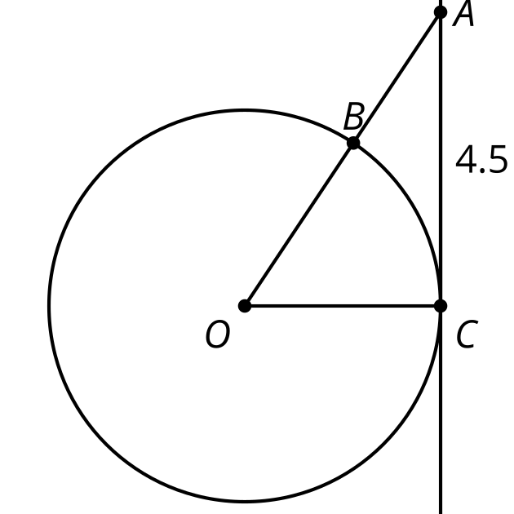
  - $3+\sqrt{29.25}$ units
  - $\sqrt{29.25}$ units
  - $\text{-}3+\sqrt{29.25}$ units
  - 26.25 units
- (From Unit 7, Lesson 3.)
- Technology required. Line $PD$ is tangent to a circle of radius 1 inch centered at $O$. The length of segment $PD$ is 1.2 inches. The length of segment $AB$ is 1.7 inches. Han is trying to figure out if $C$ or $B$ is closer to $P$. He uses the Pythagorean Theorem to find the length of $OP$. Then he subtracts 1 from the length of $OP$ to determine how far $C$ is from point $P$.
  - How far is $B$ from point $P$?
  - Which point is closest to $P$? Explain your reasoning.
- 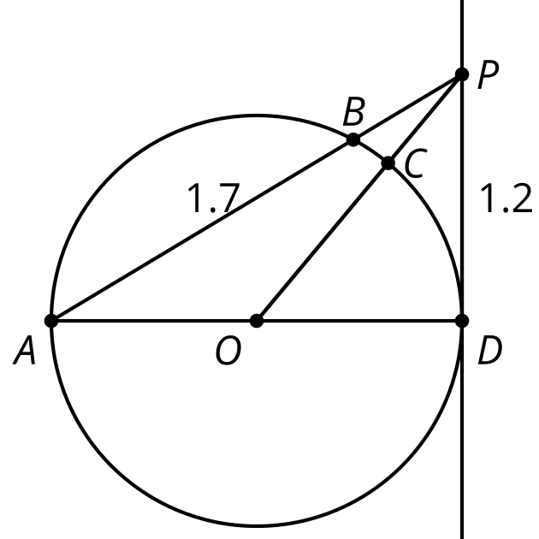

- (From Unit 7, Lesson 3.)
- In the diagram, the measure of angle $ACB$ is 25 degrees. What is the measure of angle $AOB$?
- 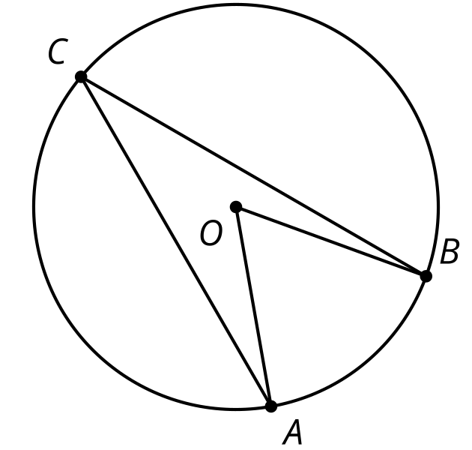
- (From Unit 7, Lesson 2.)
- Which statement must be true?
  - A diameter is a chord.
  - A chord is a radius.
  - A chord is a diameter.
  - A central angle’s vertex is on the circle.
- (From Unit 7, Lesson 1.)
- A circle and line are drawn. How many intersection points are possible? Select all possible answers.
  - 0
  - 1
  - 2
  - 3
  - 4
- (From Unit 6, Lesson 13.)
© CC BY 2019 by Illustrative Mathematics®

