Lesson 21 Practice Problems
- Match each expression to an equivalent expression.
  - $\sqrt{5}±\sqrt{3}$
  - $1±\sqrt{3}$
  - $\sqrt{3}±1$
  - $5±\text{-}2$
  - $\text{-}3±\text{-}3$
  - 3 and 7
  - $\sqrt{5}+\sqrt{3}$ and $\sqrt{5}−\sqrt{3}$
  - -6 and 0
  - $\sqrt{3}+1$ and $\sqrt{3}−1$
  - $1+\sqrt{3}$ and $1−\sqrt{3}$
- (From Unit 7, Lesson 15.)
- Consider the statement: "An irrational number multiplied by an irrational number always makes an irrational product."
- Select all the examples that show that this statement is false.
  - $\sqrt{4}⋅\sqrt{5}$
  - $\sqrt{4}⋅\sqrt{4}$
  - $\sqrt{7}⋅\sqrt{7}$
  - $\frac{1}{\sqrt{5}}⋅\sqrt{5}$
  - $\sqrt{0}⋅\sqrt{7}$
  - $\text{-}\sqrt{5}⋅\sqrt{5}$
  - $\sqrt{5}⋅\sqrt{7}$

  - Where is the vertex of the graph that represents $y={\left(x−3\right)}^{2}+5$?
  - Does the graph open up or down? Explain how you know.
- (From Unit 6, Lesson 15.)
- Here are the solutions to some quadratic equations. Decide if the solutions are rational or irrational.
- $3±\sqrt{2}$
- $\sqrt{9}±1$
- $\frac{1}{2}±\frac{3}{2}$
- $10±0.3$
- $\frac{1±\sqrt{8}}{2}$
- $\text{-}7±\sqrt{\frac{4}{9}}$

- Find an example that shows that the statement is false.
  - An irrational number multiplied by an irrational number always makes an irrational product.
  - A rational number multiplied by an irrational number never gives a rational product.
  - Adding an irrational number to an irrational number always gives an irrational sum.
- Which equation is equivalent to $x^{2}−3x=\frac{7}{4}$ but has a perfect square on one side?
  - $x^{2}−3x+3=\frac{19}{4}$
  - $x^{2}−3x+\frac{3}{4}=\frac{10}{4}$
  - $x^{2}−3x+\frac{9}{4}=\frac{16}{4}$
  - $x^{2}−3x+\frac{9}{4}=\frac{7}{4}$
- (From Unit 7, Lesson 13.)
- A student who used the quadratic formula to solve $2x^{2}−8x=2$ said that the solutions are $x=2+\sqrt{5}$ and $x=2−\sqrt{5}$.
  - What equations can we graph to check those solutions? What features of the graph do we analyze?
  - How do we look for $2+\sqrt{5}$ and $2−\sqrt{5}$ on a graph?
- (From Unit 7, Lesson 18.)
- Here are 4 graphs. Match each graph with a quadratic equation that it represents.

- Graph A
- 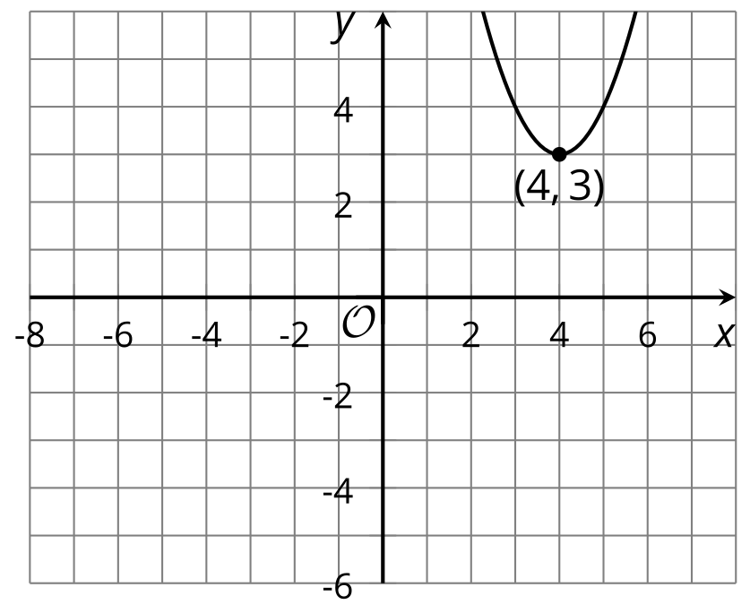

- Graph B
- 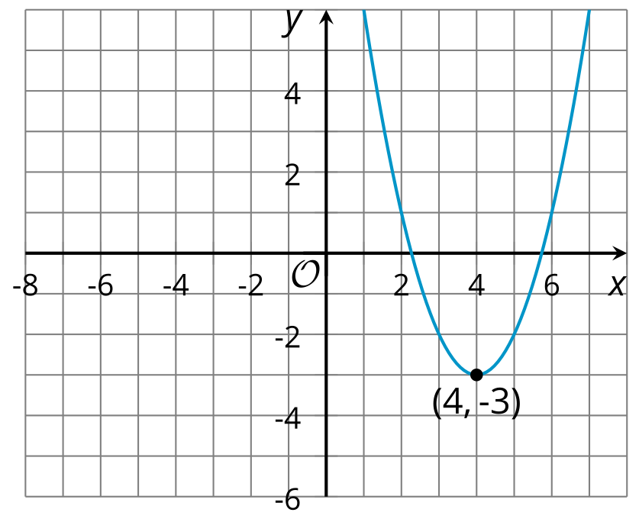

- Graph C
- 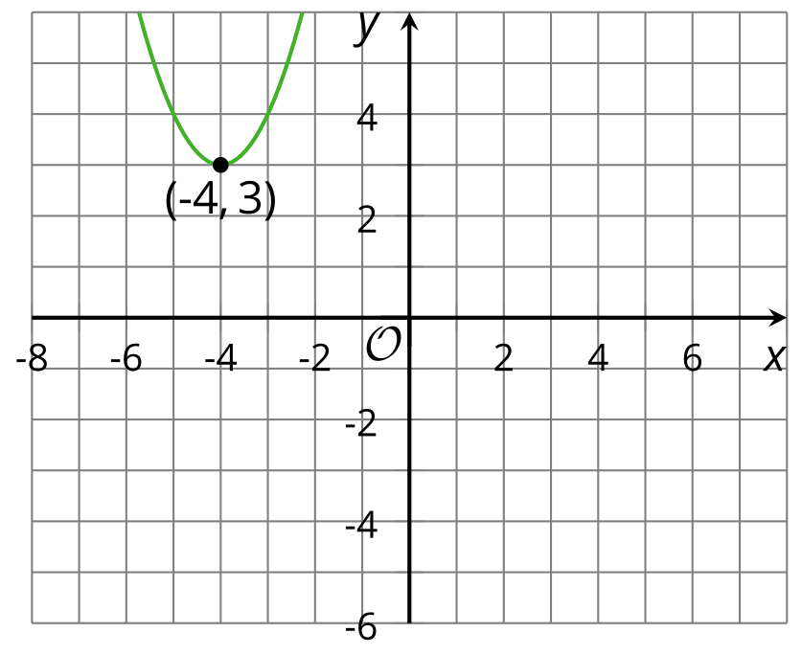

- Graph D
- 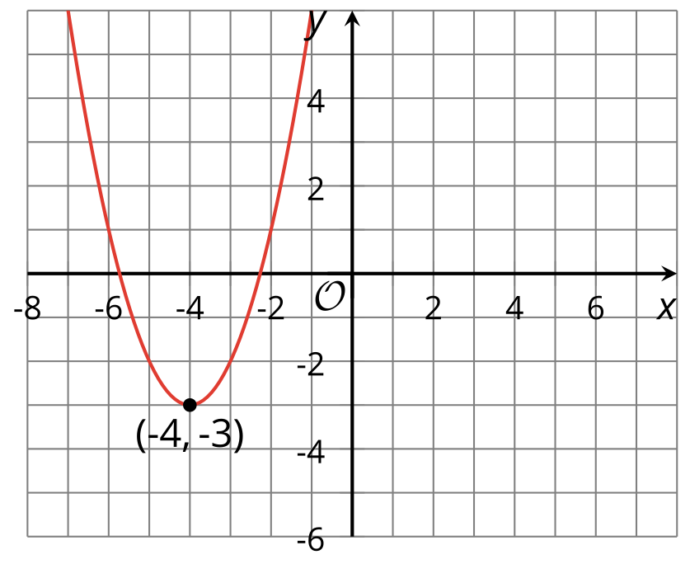
  - Graph A
  - Graph B
  - Graph C
  - Graph D
  - $y={\left(x+4\right)}^{2}−3$
  - $y={\left(x−4\right)}^{2}−3$
  - $y={\left(x+4\right)}^{2}+3$
  - $y={\left(x−4\right)}^{2}+3$
- (From Unit 6, Lesson 15.)
© CC BY 2019 by Illustrative Mathematics®

