Lesson 7 Practice Problems
- Triangle $ABC$ is shown with its incenter at $D$. The inscribed circle’s radius measures 2 units. The length of $AB$ is 9 units. The length of $BC$ is 10 units. The length of $AC$ is 17 units.
- 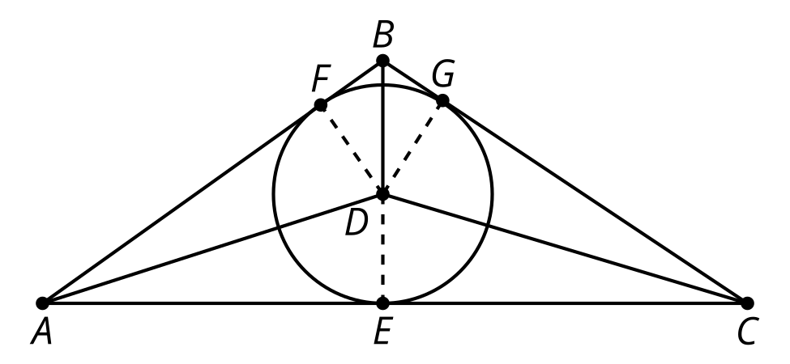
  - What is the area of triangle $ACD$?
  - What is the area of triangle $ABC$?
- Triangle $ABC$ is shown with an inscribed circle of radius 4 units centered at point $D$. The inscribed circle is tangent to side $AB$ at the point $G$. The length of $AG$ is 6 units and the length of $BG$ is 8 units. What is the measure of angle $A$?
- 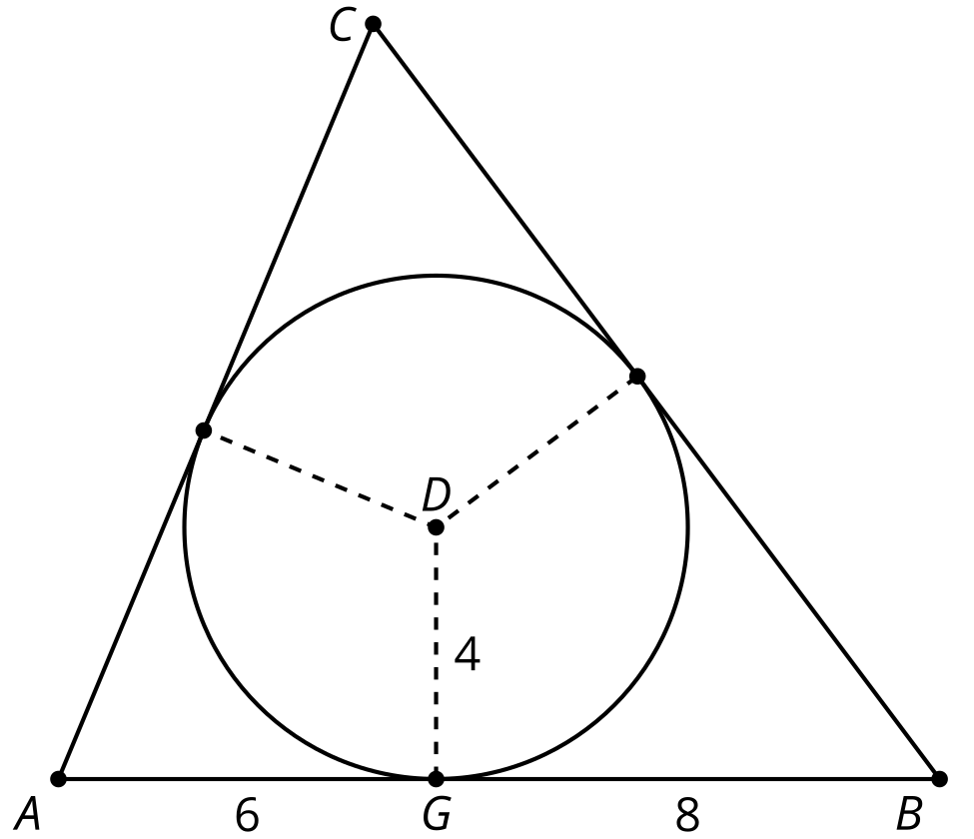
  - $arctan\left(\frac{2}{3}\right)$
  - $2arctan\left(\frac{2}{3}\right)$
  - $arcsin\left(\frac{2}{3}\right)$
  - $2arccos\left(\frac{2}{3}\right)$
- Construct the inscribed circle for the triangle.
- 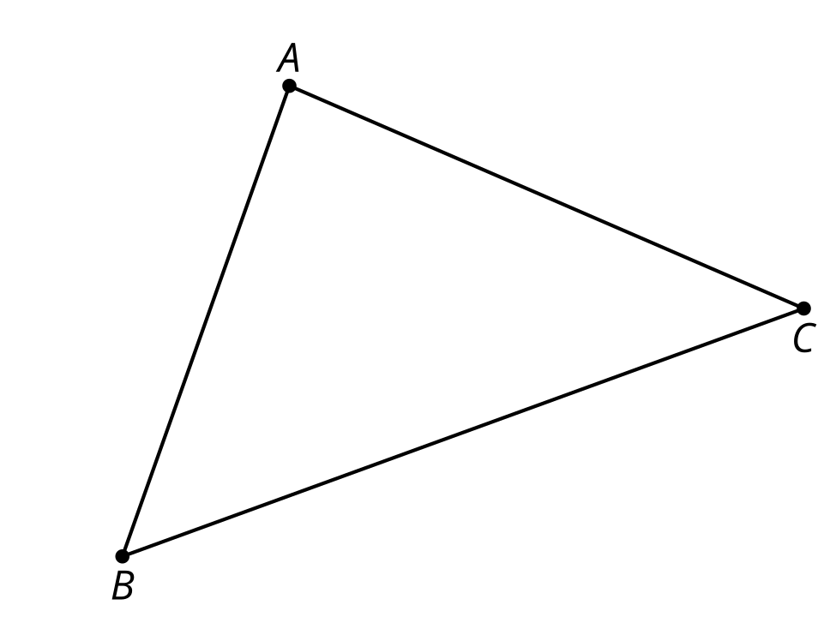
- Point $D$ lies on the angle bisector of angle $ACB$. Point $E$ lies on the perpendicular bisector of side $AB$.
  - What can we say about the distance between point $D$ and the sides and vertices of triangle $ABC$?
  - What can we say about the distance between point $E$ and the sides and vertices of triangle $ABC$?
- 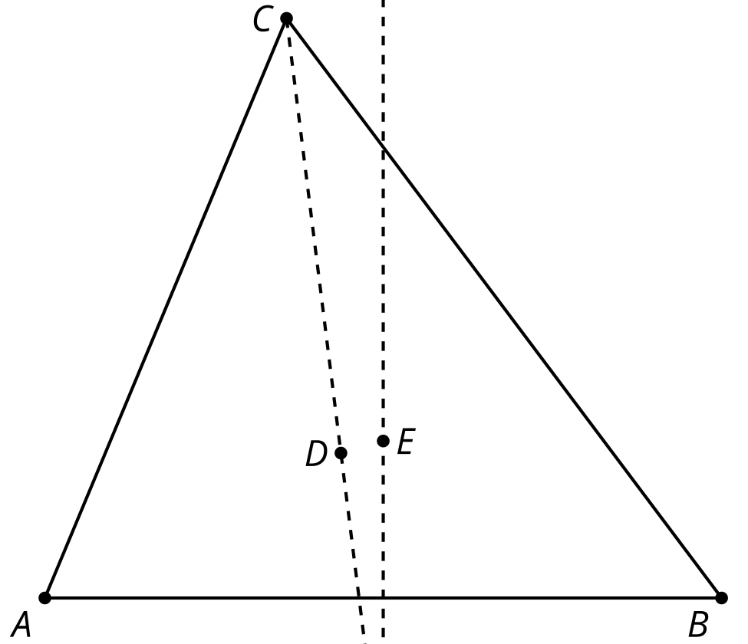

- (From Unit 7, Lesson 6.)
- Construct the incenter of the triangle. Explain your reasoning.
- 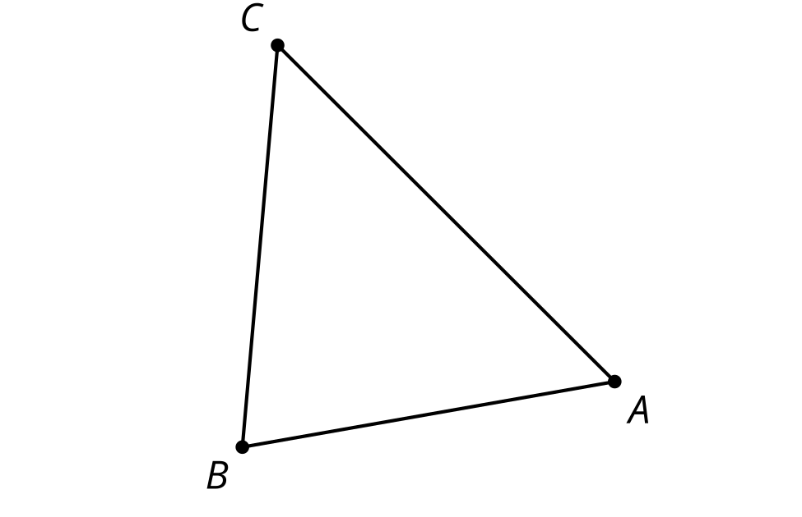
- (From Unit 7, Lesson 6.)
- The angles of triangle $ABC$ measure 30 degrees, 40 degrees, and 110 degrees. Will its circumcenter fall inside the triangle, on the triangle, or outside the triangle? Explain your reasoning.
- (From Unit 7, Lesson 5.)
- The images show 2 possible blueprints for a park. The park planners want to build a water fountain that is equidistant from each of the corners of the park. Is this possible for either park? Explain or show your reasoning.

- park A
- 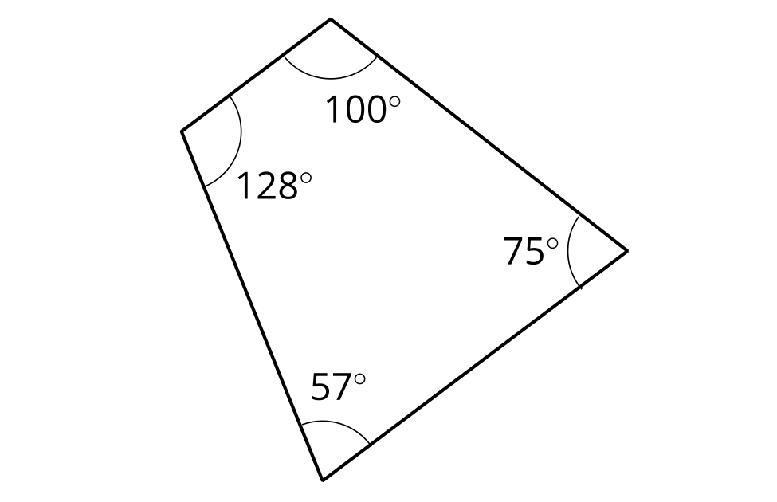

- park B
- 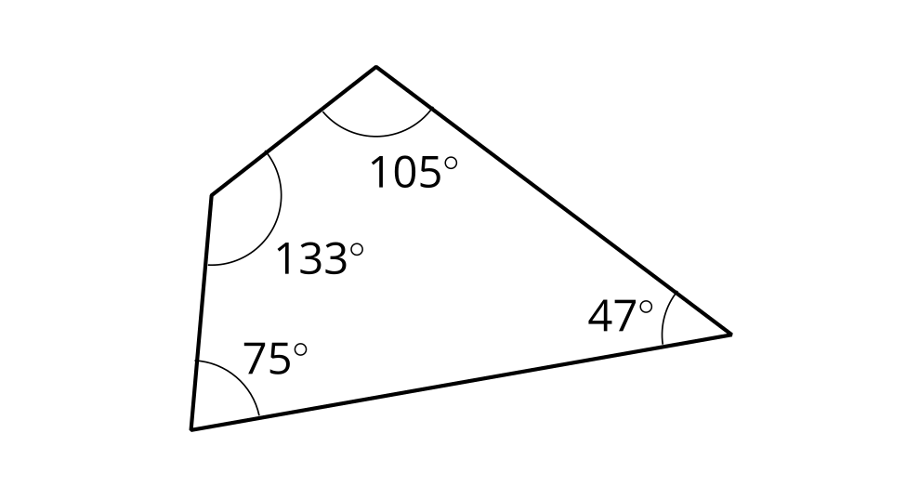

- (From Unit 7, Lesson 4.)
- Triangle $ABC$ has vertices at $\left(\text{-}8,2\right),\left(2,6\right),$ and $\left(10,2\right)$. What is the point of intersection of the triangle’s medians?
- (From Unit 6, Lesson 16.)
© CC BY 2019 by Illustrative Mathematics®

