Unit 5 Lesson 3: Creating Cross Sections by Dilating

1 Dilating, Again (Warm up)

Student Task Statement
Dilate triangle $BCD$ using center $P$ and a scale factor of 2.
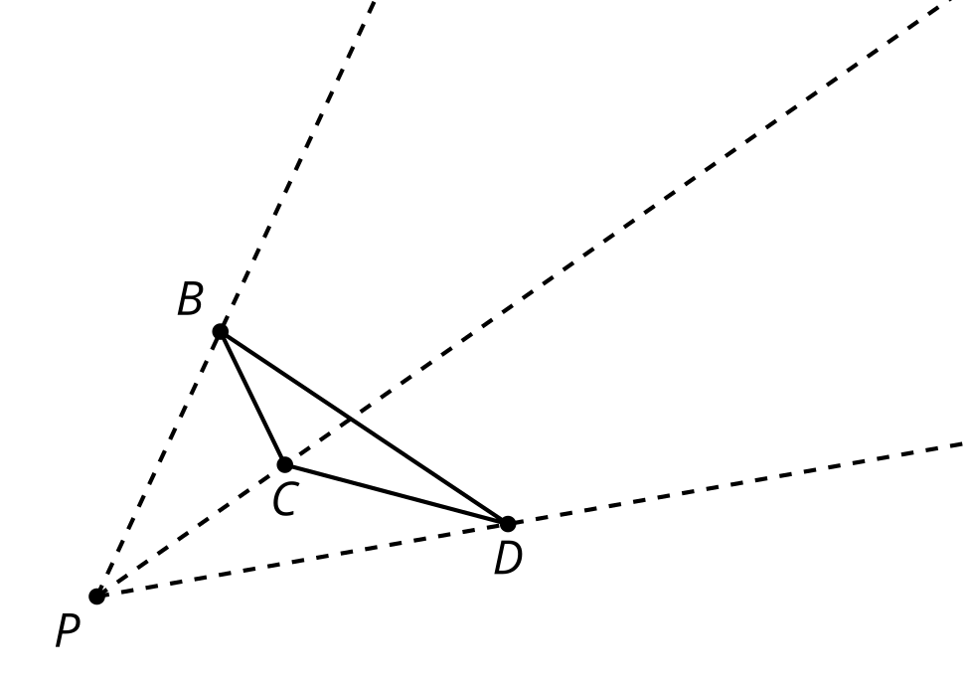
Look at your drawing. What do you notice? What do you wonder?

2 Pyramid Mobile

Images for Launch
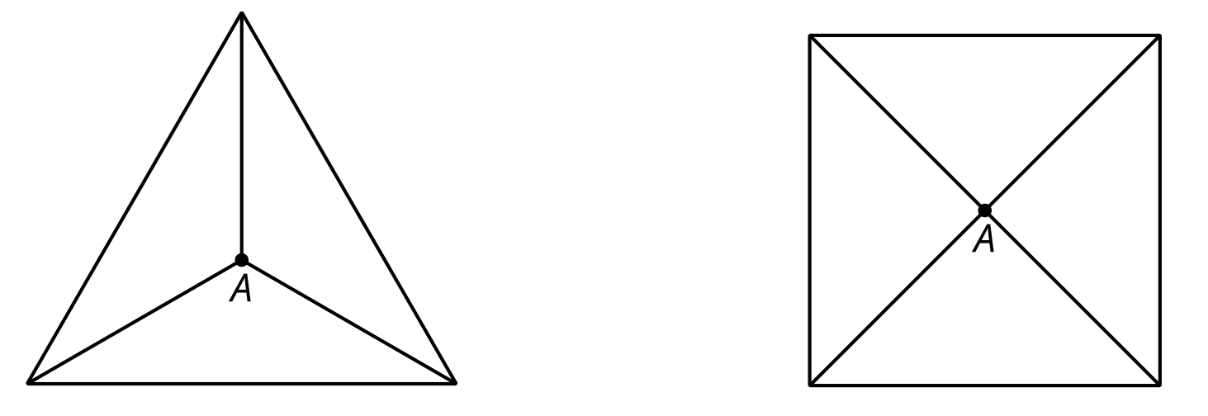
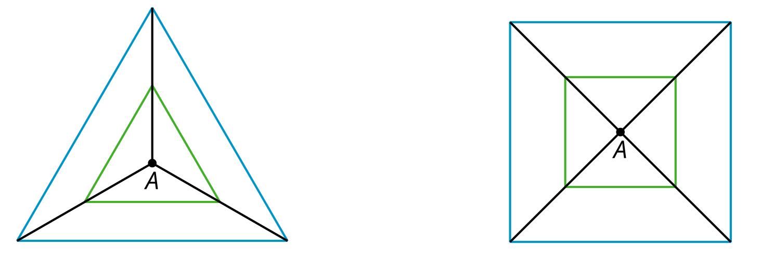

Student Task Statement
Your teacher will give you sheets of paper. Each student in the group should take one sheet of paper and complete these steps:
- Locate and mark the center of your sheet of paper by drawing diagonals or another method.
- Each student should choose one scale factor from the table. On your paper, draw a dilation of the entire sheet of paper, using the center you marked as the center of dilation.
- Measure the length and width of your dilated rectangle and calculate its area. Record the data in the table.
- Cut out your dilated rectangle and make a small hole in the center.
scale factor, $k$ | length of scaled rectangle | width of scaled rectangle | area of scaled rectangle
$k=0.25$
$k=0.5$
$k=0.75$
$k=1$
Now the group as a whole should complete the remaining steps:
- Cut 1 long piece of string (more than 30 centimeters) and 4 shorter pieces of string. Make 4 marks on the long piece of string an equal distance apart.
- Thread the long piece of string through the hole in the largest rectangle. Tie a shorter piece of string beneath it where you made the first mark on the string. This will hold up the rectangle.
- Thread the remaining pieces of paper onto the string from largest to smallest, tying a short piece of string beneath each one at the marks you made.
- Hold up the end of the string to make your cross sections resemble a pyramid. As a group, you may have to steady the cross sections for the pyramid to clearly appear.
© CC BY 2019 by Illustrative Mathematics®

