Unit 4 Lesson 6: Features of Graphs

1 Walking Home (Warm up)

Student Task Statement
Diego is walking home from school at a constant rate. This graph represents function $d$, which gives his distance from home, in kilometers, $m$ minutes since leaving the school.
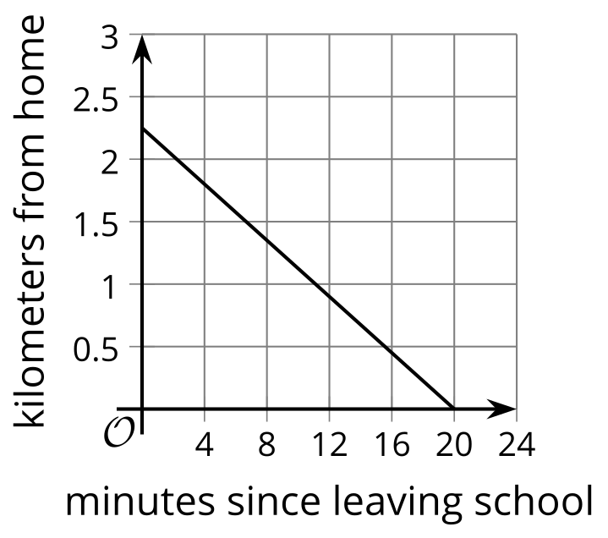
Use the graph to find or estimate:
- $d\left(0\right)$
- $d\left(12\right)$
- the solution to $d\left(m\right)=1$
- the solution to $d\left(m\right)=0$

2 A Toy Rocket and a Drone

Student Task Statement
A toy rocket and a drone were launched at the same time.
Here are the graphs that represent the heights of two objects as a function of time since they were launched.
Height is measured in meters above the ground and time is measured in seconds since launch.
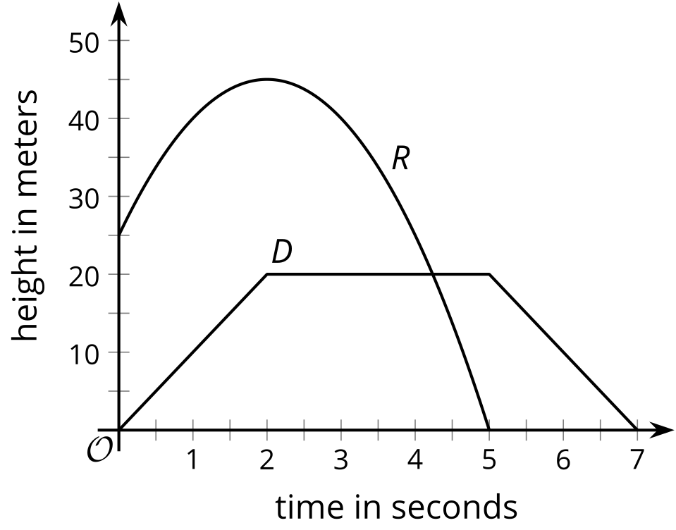
- Analyze the graphs and describe—as precisely as you can—what was happening with each object. ​​Your descriptions should be complete and precise enough that someone who is not looking at the graph could visualize how the objects were behaving.
- Which parts or features of the graphs show important information about each object’s movement? List the features or mark them on the graphs.

Activity Synthesis
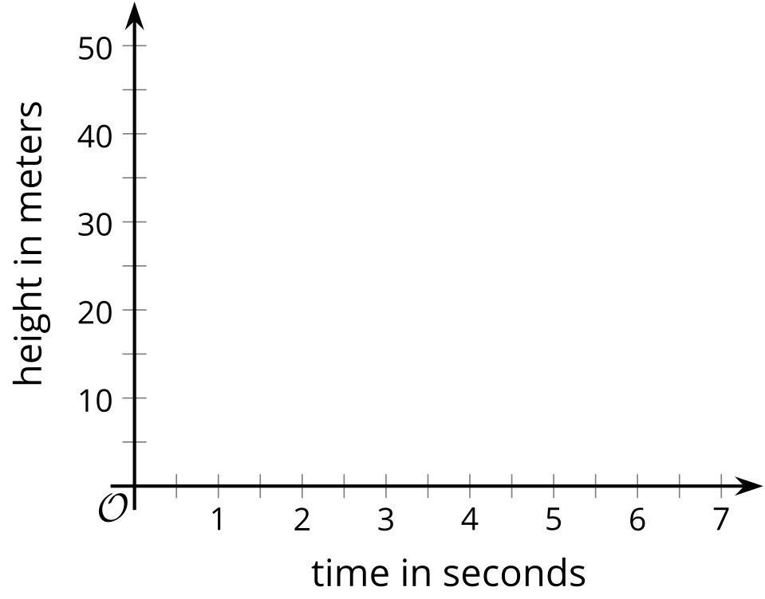

3 The Jump

Student Task Statement
In a bungee jump, the height of the jumper is a function of time since the jump begins.
Function $h$ defines the height, in meters, of a jumper above a river, $t$ seconds since leaving the platform.
Here is a graph of function $h$, followed by five expressions or equations and five graphical features.
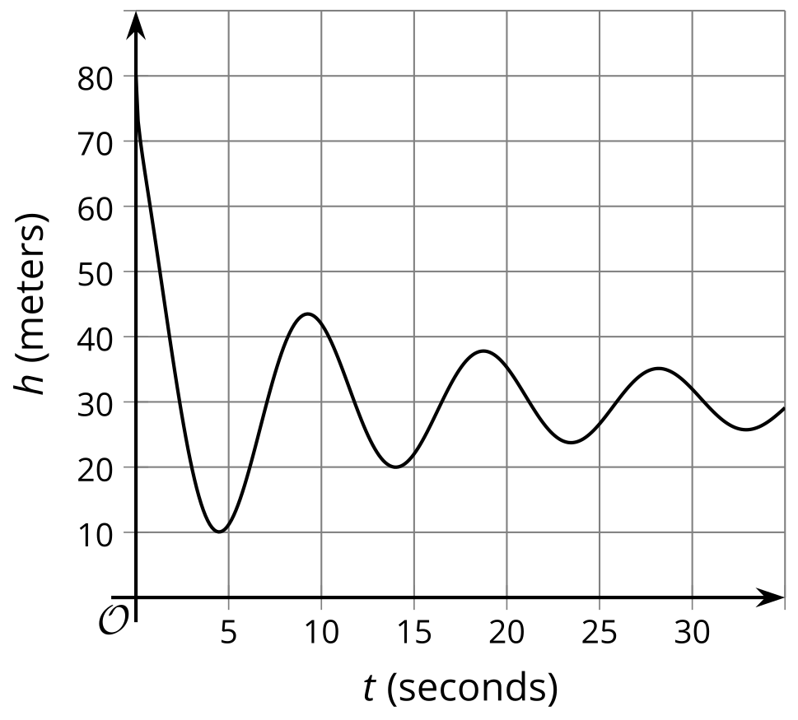
$h\left(0\right)$
$h\left(t\right)=0$
$h\left(4\right)$
$h\left(t\right)=80$
$h\left(t\right)=45$
- first dip in the graph
- vertical intercept
- first peak in the graph
- horizontal intercept
- maximum
- Match each description about the jump to a corresponding expression or equation and to a feature on the graph.
- One expression or equation does not have a matching verbal description. Its corresponding graphical feature is also not shown on the graph. Interpret that expression or equation in terms of the jump and in terms of the graph of the function. Record your interpretation in the last row of the table.
- description of jump | - expression  or equation | - feature of graph
- a. the greatest height that the jumper is from the river
- b. the height from which the jumper was jumping
- c. the time at which the jumper reached the highest point after the first bounce
- d. the lowest point that the jumper reached in the entire jump
- e.
- Use the graph to:
  - estimate $h\left(0\right)$ and $h\left(4\right)$
  - estimate the solutions to $h\left(t\right)=45$ and $h\left(t\right)=0$

Images for Activity Synthesis
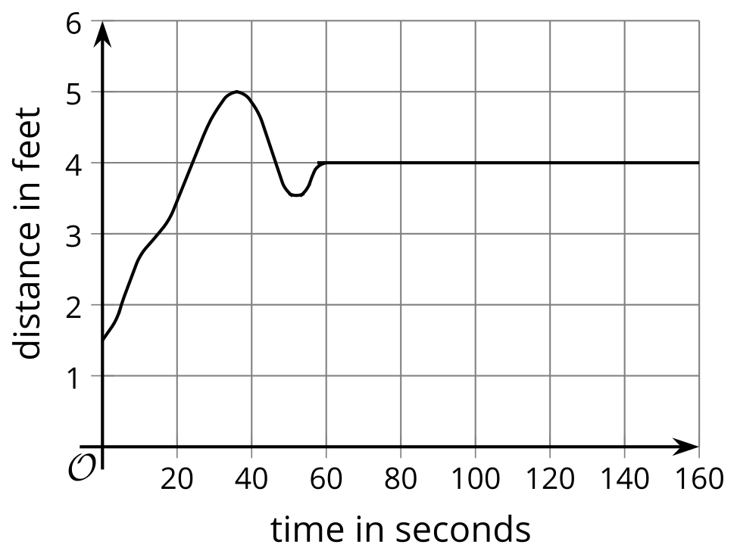
© CC BY 2019 by Illustrative Mathematics®

