Unit 7 Lesson 20: Quadratics and Irrationals

1 Where is $\sqrt{21}$? (Warm up)

Student Task Statement
Which number line accurately plots the value of $\sqrt{21}$? Explain your reasoning.

A

B

C

D

2 Some Rational Properties

Student Task Statement
Rational numbers are fractions and their opposites.
- All of these numbers are rational numbers. Show that they are rational by writing them in the form $\frac{a}{b}$ or $\text{-}\frac{a}{b}$ for integers $a$ and $b$.
  - 6.28
  - $\text{-}\sqrt{81}$
  - $\sqrt{\frac{4}{121}}$
  - -7.1234
  - $0.\overset{¯}{3}$
  - $\frac{1.1}{13}$
- All rational numbers have decimal representations, too. Find the decimal representation of each of these rational numbers.
  - $\frac{47}{1,000}$
  - $\text{-}\frac{12}{5}$
  - $\frac{\sqrt{9}}{6}$
  - $\frac{53}{9}$
  - $\frac{1}{7}$
- What do you notice about the decimal representations of rational numbers?

3 Approximating Irrational Values

Student Task Statement
Although $\sqrt{2}$ is irrational, we can approximate its value by considering values near it.
- How can we know that $\sqrt{2}$ is between 1 and 2?
- How can we know that $\sqrt{2}$ is between 1.4 and 1.5?
- Approximate the next decimal place for $\sqrt{2}$.
- Use a similar process to approximate the $\sqrt{5}$ to the thousandths place.

Activity Synthesis
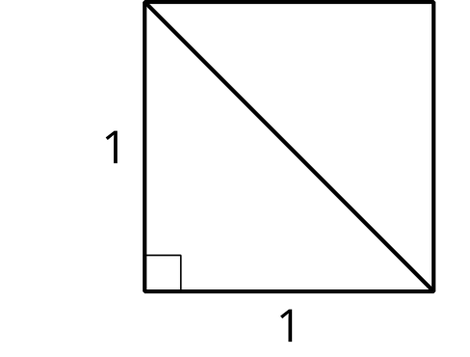
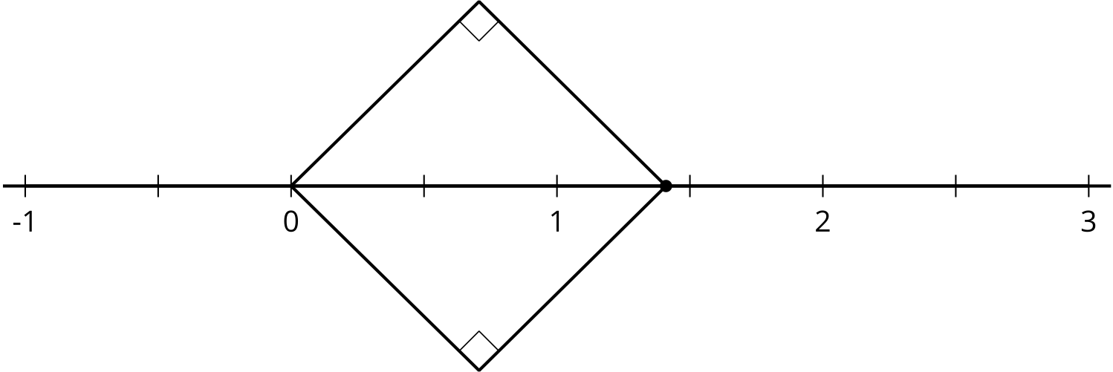
© CC BY 2019 by Illustrative Mathematics®

