Unit 9 Lesson 1: Fermi Problems

1 Ant Trek (Optional)

Student Task Statement
How long would it take an ant to run from Los Angeles to New York City?

2 Stacks and Stacks of Cereal Boxes (Optional)

Student Task Statement
Imagine a warehouse that has a rectangular floor and that contains all of the boxes of breakfast cereal bought in the United States in one year.
If the warehouse is 10 feet tall, what could the side lengths of the floor be?

3 Covering the Washington Monument (Optional)

Images for Launch
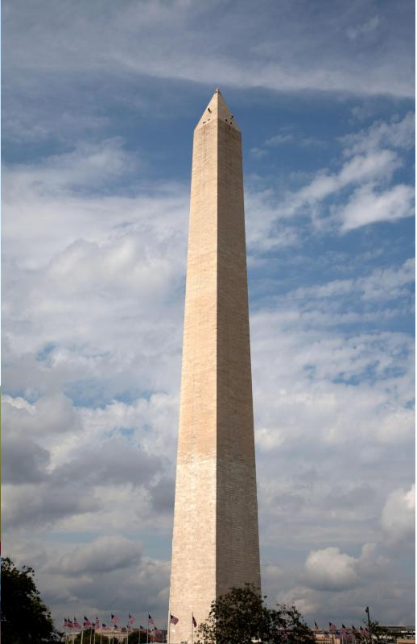
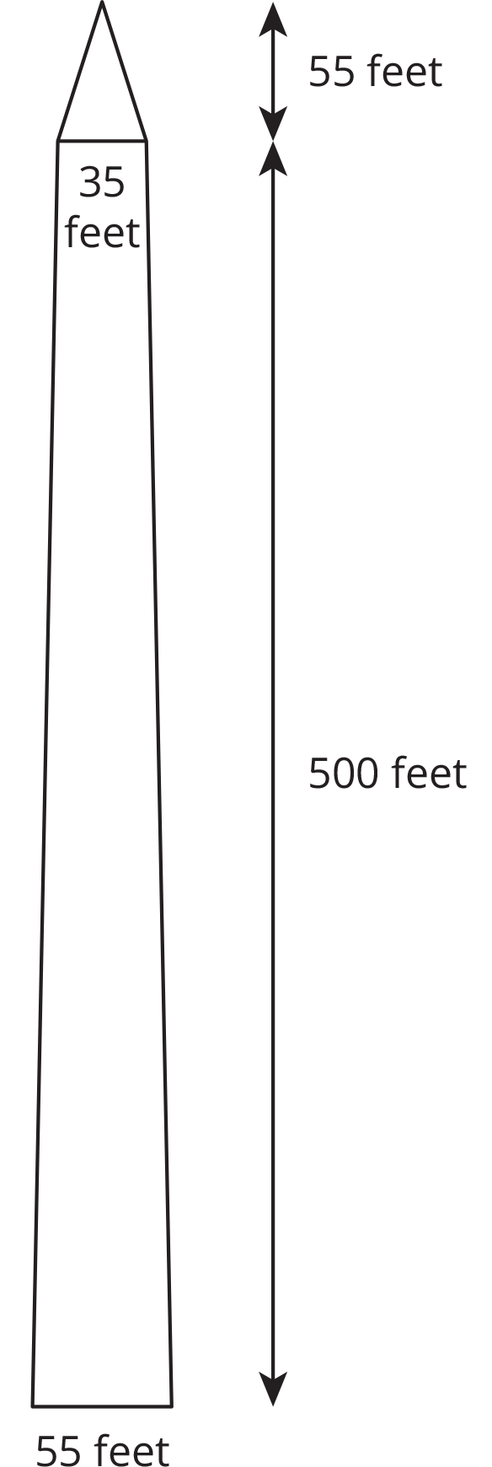

Student Task Statement
How many tiles would it take to cover the Washington Monument?
© CC BY Open Up Resources. Adaptations CC BY IM.

